北京市西城区2010—2011学年度第一学期期末试卷
九年级英语 2011.1
听力理解（共24分）
一、听对话，从下面各题所给的A、B、C三幅图片中选择与对话内容相符的图片。每段对话读两遍。（共4分，每小题1分）
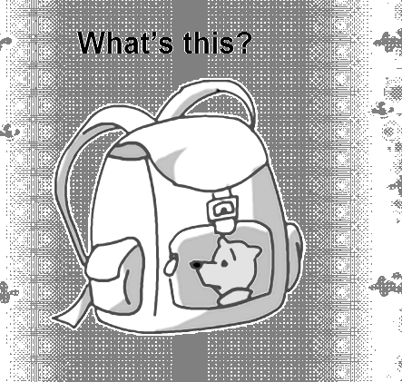


1.
A. B. C.

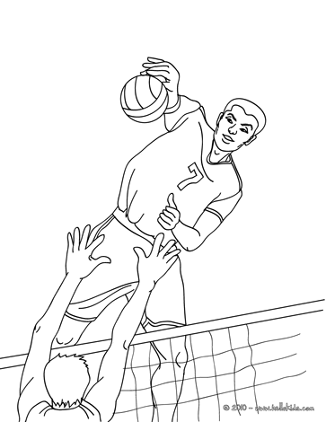
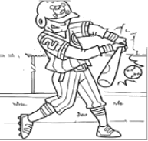
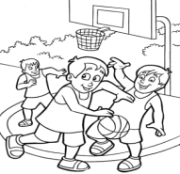
2.
A. B. C.

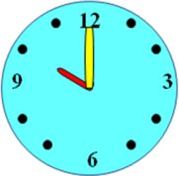
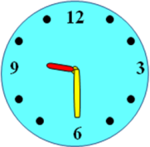
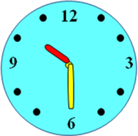
3.
A. B. C.

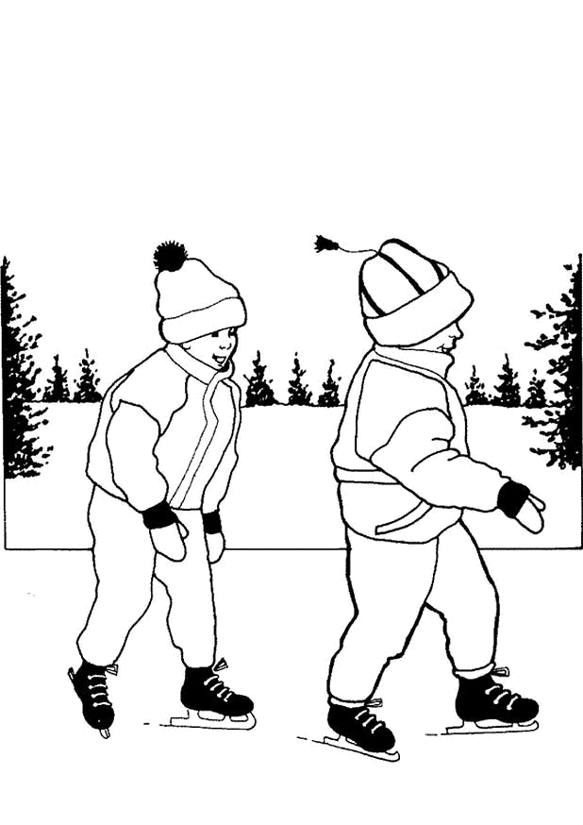
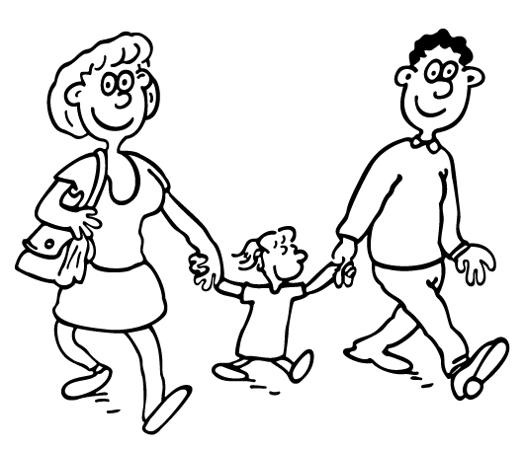
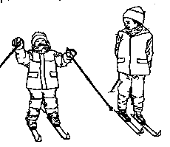
4.
A. B. C.

二、听对话或独白，根据对话或独白内容，从下面各题所给的A、B、C三个
选项中选择最佳选项。每段对话或独白读两遍。（共12分，每小题1分）
请听一段对话，完成第5至第6小题。
5. What room does the woman want?
A. A single room. B. A double room. C. A family room.
6. How long will the woman stay there?
A. Two days. B. Three days. C. Four days.
请听一段对话，完成第7至第8小题。
7. How will Peter go to Beijing?
A. By car. B. By train. C. By plane.
8. What does the woman think of travelling by train?
A. Cheap and safe. B. A waste of time. C. Tiring.
请听一段对话，完成第9至第11小题。
9. What’s the man asking about?
A. How to join the library.
B. How to fill in a form.
C. How to borrow records.
10. What can’t be taken out of the library?
A. Magazines. B. Books. C. Newspapers.
11. What can the man do if he wants to keep the books longer?
A. Come to the library. B. Make a phone call. C. Send an email.
请听一段对话，完成第12至第13小题。
12. Why did Michael leave the jazz band?
A. Because he could never take part in the performances.
B. Because he couldn’t practice with the band every night.
C. Because he failed his midterm examinations.
13. What will Michael probably do in Charlie’s band?
A. A pianist. B. A guitar player. C. A singer.
请听一段独白，完成第14至第16小题。
14. Who set up the Boy Scouts (童子军) of America?
A. Robert. B. William. C. Allison.
15. What do the Boy Scouts teach kids?
A. Friendship and money making.
B. Outdoor skills and leadership.
C. Outdoor skills and study skills.
16. What is the passage mainly about?
A. A story of a Boy Scout.
B. William’s trip to London.
C. The Boy Scouts of America.

三、听对话，根据所听到的对话内容和提示词语，记录关键信息。对话读两遍。（共8分，每小题2分）

Application Form
Name: Amy 17
Job: a 18
Phone number: 19
Work experience: a waitress from 20 2006 to April 2008

知识运用（共27分）
四、单项填空（共15分，每小题1分）
从下面各题所给的A、B、C、D四个选项中，选择可以填入空白处的最佳选项。
21. — Jack, is this your coat?
— Yes, it’s _______. Thank you.
A. me B. my C. mine D. myself
22. — When will Russia hold the World Cup?
— _______ 2018.
A. On B. In C. From D. At
23. — Mum, my classmates all call me “Small Potato”. I hate it!
— There _______ potatoes and potatoes. A small potato can do a big business.
A. are B. is C. was D. were
24. — _______ I ask you a question, sir?
— Sure. Go ahead.
A. Need B. Must C. May D. Should
25. — Did you watch the film Harry Potter VII last weekend?
— Yes. It’s very exciting, _______ I missed the beginning.
A. but B. and C. so D. or
26. I have two hands. One is for helping myself, _______ is for helping others.
A. other B. another C. others D. the other
27. — Guess what! We received _______ photos for the competition than last year.
— You bet. They are nicer as well.
A. much B. many C. more D. most
28. — Dad, we are late! Why is the traffic here getting so bad?
— You know, _______ new cars are on the road every day.
A. hundred B. hundredth C. hundreds D. hundreds of
29. — I didn’t see you at the party last night. Why?
— I _______ my lessons at that time.
A. review B. reviewed
C. have reviewed D. was reviewing
30. The Science Museum interests me a lot. I enjoy _______ there.
A. to go B. going C. goes D. go
31. — Sir, could you tell me the difference between “home” and “house”?
— A house _______ of walls, while a home is built with love.
A. makes B. made C. is made D. will make
32. — Where is the ice-cream in the fridge?
— Mum, don’t worry. I _______it in the stomach, very safe.
A. kept B. have kept C. am keeping D. will keep
33. — Selina is in hospital now.
— Oh, I ______ know that. Is it serious?
A. don’t B. didn’t C. won’t D. wasn’t
34. Jamie Oliver is a cook _______ wants to improve the school dinners in Britain.
A. who B. whose C. which D. whom
35. — Bob, could you tell me _______ in the advertisement ?
— Oh, Do It Yourself.
A. what does DIY stand for B. what DIY stands for
C. what did DIY stand for D. what DIY stood for

五、完形填空（共12分，每小题1分）
阅读下面短文，掌握其大意，然后从短文后各题所给的A、B、C、D四个选项
中，选择最佳选项。
In our home it was natural to fear our father. Even our mother was 36 of him. As children, my sister and I thought every family was like that. Every family had an unpredictable alcoholic (喜怒无常的酒鬼) who was impossible to 37 and a Mom who was there to protect the children. We were good children and Mom was always telling us we were, 38 Daddy couldn’t see it. Part of this was because we dared not do anything, 39 when Daddy was home.
Then came the day we found something new and fun to do. We knew it would not upset (惹恼) anyone. On a wooden door, we drew lots of pretty pictures with chalk. It 40 us to see how gifted we were. These pictures were good! We knew Mom would just love it. But the praise we expected did not come. Instead of seeing the 41 in our work, all Mom could see was the time and effort she would need to clean it off. She was mad and we knew we were in big trouble!
Off we ran to our wooden yard for there we could find 42 . Together we hid behind a tree quietly. Soon we heard Mom and our neighbors calling out to us. Still we did not move. As it got dark, those around us became more worried and we became more 43 . Mom called the police. We could tell something was happening because we could hear all the voices 44 together in a group. Then the search was on again.
Suddenly we heard another voice — our Daddy. But there was something 45 different about his voice. In it we heard something we had never heard before. Was that our Daddy on his knees, with tears running down, promising God that he would give his life to Him if He would safely return his girls?
Nothing in our lives had 46 us for this kind of shock (震惊). Neither of us remembered how we came out to him. What we do remember are those crying and strong loving arms holding 47 like we were precious (被珍爱的).
Things were different after that. We had a new Daddy. Mom always told us that life is full of miracles (奇迹). I guess she was right. Our whole family was changed with a piece of chalk.

36. A. proud B. tired C. sure D. afraid
37. A. live with B. please C. believe in D. move
38. A. even though B. as if C. as long as D. as far as
39. A. usually B. nearly C. especially D. probably
40. A. allowed B. encouraged C. surprised D. promised
41. A. pictures B. chalk C. love D. beauty
42. A. comfort B. quietness C. safety D. freedom
43. A. frightened B. lonely C. impatient D. hopeless
44. A. drawn B. grew C. matched D. brought
45. A. greatly B. strangely C. specially D. completely
46. A. thanked B. got C. trained D. prepared
47. A. him B. us C. them D. me

阅读理解（共44分）
六、阅读下列短文，根据短文内容，从短文后各题所给的A、B、C、D四个选项中，
选择最佳选项。（共26分，每小题2分）

A
Welcome to the Natural History Museum at Tring
Discover the amazing animals here. It is home to the world-class research and collections.
Opening times: The Museum is open every day except December 24 — 26.
Monday to Saturday 10:00 — 17:00
Sunday 14:00 — 17:00
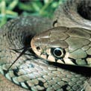 | Snake Sock Puppets (木偶)  October 26, 2010 10:15 — 12:15, 14:00 — 15:00  Interested in different kinds of snakes? Try making and decorating a snake sock puppet of your own.  Ticket price £1.50
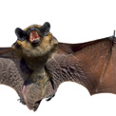 | Go Batty  October 27, 2010 10:15 — 12:15, 14:00 — 15:00  Drop in and check out the bats on show in Gallery 6 and make your own bat out of paper to fly home with you.  Ticket price £1.50
 | Animals After School  November 11, 2010 15:45 — 16:30  December 9, 2010 15:45 — 16:30  Looking for after-school activities? Get the most out of your Museum—find out about some amazing animals and make something to take home.  Ticket price £1.50
 | Wildlife Photographer Exhibition  November 26, 2010 to January 9, 2011  This wonderful photographic exhibition returns with many kinds of pictures from around the world.  Free exhibition

48. The museum is closed on _______.
A. October 26 B. November 11
C. December 9 D. December 25
49. At Animals After School, children can _______ .
A. decorate a snake sock puppet B. make their bats out of paper
C. make something to take home D. take photos of many birds
50. Which exhibition or activity is free?
A. Snake Sock Puppets B. Go Batty
C. Animals After School D. Wildlife Photographer Exhibition

B
The average (平均) temperature around the world is rising. However, people living in the US Midwest might find this fact hard to believe. A new study shows that in that area, summers are now cooler and wetter than they were in years past. The scientists suggest that the climate change may have happened because of farming.
The study was led by David Changnon, a climatologist at Northern Illinois University. Changnon and his team find that since 1970, the average temperature in the Midwest during July and August has gone down — by up to one degree ℉. Their study also shows that the average rainfall in that area during those two months has increased. Between 1970 and 2009, about 0.33 inches more rain fell than between 1930 and 1969.
These two changes — lower temperatures and more rainfall — may be connected by moisture (水分), Changnon says. So where did the extra (额外的) moisture in the air come from? Changnon points to farms in the area. As plants grow, they pull moisture from the ground and release (释放) it into the air. And among plants, soybean and corn release a lot. Midwestern farms now plant more soybeans and corn than in the past, with 97 percent of farmland today planted with these two crops (庄稼).
These results by Changnon and his team are the first step to understand a change in the weather.

51. Summers in the Midwest of the US are becoming ______ now.
A. sunnier and drier B. cooler and wetter
C. warmer and windier D. cloudier and rainier
52. According to the passage, there was more rainfall _______.
A. between 1930 and 1969 B. before 1930
C. between 1970 and 2009 D. after 2009
53. The climate change happened in the Midwest because ______.
A. more moisture was released because of farming
B. more and more farmers moved to the area
C. Changnon and his team studied the climate change there
D. the average temperature around the world is rising
C
Valle asked a few questions to Joe, an experienced education consultant (顾问) who works with Chinese students applying to study abroad. Here are the questions and answers.
Question 1: What are the main reasons Chinese youth choose to study abroad?
Answer 1: There are many reasons. First of all, there are kids who simply want the best education possible. These are super achievers who generally want to go to top 10 US schools. Their parents are usually very successful, and have high hopes for their children. If you get them into Cornell early and they want to apply Columbia. Get Columbia and they want Harvard. These kids have been pushed to be Number 1 as long as they can remember.
Then, there are those who aren’t going to get a good enough Gaokao to get into a top 10 Chinese university. Their parents see studying abroad as a way to get a fresh start.
Last, there are those who want a bigger worldview. Sometimes it’s the kids, sometimes it’s the parents, but they usually don’t know much about the US education system and the complexities (复杂) and costs.
Question 2: Are more students leaving for High School as well?
Answer 2: We are seeing more and more interest in high school because some parents think in China too much importance is given to the Gaokao. Moreover, parents see American boarding schools (寄宿学校) as a way to help their children get into top 10 US schools. Yet, parents are less willing to send away their children at so young an age.
Question 3: What are the main countries of interest when choosing to study abroad?
Answer 3: The United States is by far favored, with England and Australia tied for second. It may be that there are so many more top universities in America. Personally, I would guess it’s that there are more “name” schools that parents can be proud of.
Question 4: What is the largest factor (因素) in choosing universities abroad?
Answer 4: It’s impossible to explain what “good fit” or “educational culture” is to some of Chinese parents. They are paying top dollar for tuition (学费). In fact they want something to brag about, which brings them a stronger sense of happiness while talking with others.

54. According to the passage, Chinese students go abroad to study mainly
because________.
A. they like to make their parents feel very proud of them
B. they share with their parents that it’s a way to help grow better
C. they want to show they are good at Gaokao and study abroad
D. they hope to experience different lifestyles in foreign countries
55. To Joe, Chinese students prefer universities in US just because _______.
A. their parents think the universities are more famous
B. the students want to be famous and successful in the future
C. there are more good universities than in other countries
D. American boarding schools offer great service
56. The underlined sentence probably means the parents want _______.
A. to show they are able and special B. to express they care little about money
C. to push their child to study harder D. to attract attention from other people

D
Children need friends. The best kind of friends are other children, sharing the same kind of experiences.
Many children in public schools have learned to “fit” and they have the markings of “fitting” — the clothes, rock stars, the cool words… Many have afterschool sports, lessons and finally part time jobs. They don’t have the social need — in fact, they probably need some time alone to think and daydream.
But for homeschoolers, things were not like that.
Homeschoolers can be way ahead academically (学业上), but it hardly makes up for poor social skills. I don’t think it has to be this way. If mothers would put some of the effort into creating a good social environment for their homeschooling children, everyone would be happier.
What can a mother do to help her homeschooling children fill the social need?
I have had the most success in creating activities for others to attend. Most mothers are happy to take their children to enjoy the company of other homeschoolers. They are usually very willing to drive them to your house. Sometimes, they offer to have the activity at their house too.
Group school is another good way to meet the social need. All it takes is one other family with similar aged children. You can meet once a week or just once a month to ‘do school’ together. Group school can be tiring as it requires (要求) that you not only plan for homeschool, but that you have to create lesson plans for other children as well. You often feel like you have to make it extra fun. This takes effort! But, of all the things we’ve done, my children have loved group school the best.
Field trips, picnics and other out-of-home outings are a good way to get to know another family. I usually just invite one family and most often, our children hit it off and make friends. This doesn’t take much effort, and becomes an expected event for my children.
Teenage parties at our house once a month, with food and games, has been a good way for my teenagers to get to become good friends with other homeschoolers. Teenagers are uneasy at first, but most of them don’t have a lot of contact with other homeschoolers, so it is a treat to share their company. They have so much in common that friendships form easily.
All of these activities take energy and planning on mother’s part, and often it feels like just one more thing in an already fixed timetable. I do feel it needs to be done first, because it makes such a difference in the success of your homeschooling experience.
Do yourself and your children a favor. Make your homeschool successful, not just academically, but socially also. It will be a great blessing (祝福) to your children’s lives!

57. The passage is written for_________.
A. parents who have homeschoolers
B. children who learn at home
C. teachers who help homeschoolers
D. people who organize group schools
58. How many activities are mentioned to help with children’s social need?
A. 3. B. 4. C. 5. D. 6.
59. What can we infer from the passage?
A. Homeschoolers are likely to be more successful academically.
B. Group school is the most popular activity among homeschoolers.
C. Not all parents know how to homeschool children well.
D. Homeschooling is becoming more and more popular.
60. Which one would be the best title for the passage?
A. Social Life: The Real Need
B. Friendship: A Must for Children
C. Homeschooling: A Good but Hard Choice
D. Creating Activities: A New Job for Mothers

七、阅读短文，根据短文内容，从短文后的五个选项中选出能填入空白处的最佳选项。
选项中有一项为多余选项。（共8分，每小题2分）
Do you feel so nervous in exams? Do you have trouble writing answers that you knew last night? If so, you likely have test anxiety (焦虑) . Believe it or not, a little nervousness can help you do better. 61
Here are some ideas that may help you out:
62 When you feel a storm of anxiety coming on, stop what you are doing for a minute and take a deep breath. This may get your mind off the stress (压力).
Second, think of being at a place of comfort and let your body relax. As you continue the test, find easy questions and answer them first. 63 .
64 In fact, everyone makes mistakes and they are part of your learning.
Finally, start test preparation early. After all, good study habits and skills will give you the feeling that you are in control.
A. First, learn to stop.
B. Study hard and have a hard try.
C. This will build up your confidence (自信心).
D. Another thing you can do is to learn to accept mistakes.
E. However, too much nervousness can make you act poorly.

八、阅读短文，根据短文内容回答问题。（共10分，每小题2分）
Mattie Stepanek is very busy. He speaks at meetings. He has been a guest on television shows in Chicago and New York City. He has written two number-one best-sellers.
Although this sounds like an exciting life, Mattie has to deal with many hardships as well. Mattie is an 11-year-old boy with a very serious illness causing breathing difficulty. For the past five years, Mattie has made the same three wishes: to have some of his poems published, to meet one of his heroes, former U.S. president Jimmy Carter, and to have his poems read on television.
Mattie’s first wish came true in July, 2001. Some of his poems were printed in a book entitled Heartsongs. His second book, Journey Through Heartsongs, was published in October, 2001.
While Mattie was in the hospital in Washington, D.C., another wish came true. He spoke on the telephone with Jimmy Carter. During their conversation Mattie didn’t mention his illness. Instead, he and Mr. Carter talked of bringing peace to countries at war.
On October 19, 2001, his third wish came true. Mattie was a guest on Oprah Winfrey’s talk show. He talked with Ms. Winfrey about his hope for peace in the world. She read several of Mattie’s poems on television. Most of his poems are about hope and peace.
Although he has received many honors, Mattie feels that his greatest achievement is being alive today. Mattie continues to spread his message of peace and goodwill.
Mattie tries to live his life by three ideas. The first is to play in the puddles (水坑) after every storm. The second is to celebrate life every day. The third is to never give up trying to reach what you want. Mattie’s life is certainly a perfect example of these principles (原则).
65. Did Mattie realize all his three wishes?
66. When were his poems first printed?
67. What did Mattie and Jimmy Carter talk about, his illness or world peace?
68. Who read Mattie’s poems on the talk show?
69. How did Mattie spread his message of peace and goodwill?

书面表达（25分）
九、完成句子（共10分，每小题2分）
根据中文意思完成句子。
70. 你最好修理一下这台电视机，别把它扔掉。
____________ repair the TV set instead of throwing it away.
- 今天早上公交车太挤了，我都没上去。
The bus was ____________ crowded for me ____________ this morning.
72. 我到那儿时，很高兴地看到他已经融入了新班级。
I ____________ see him fit in his new class when I got there.
73. 尽量多地回收和再利用是很有必要的。
____________ reuse and recycle ____________.
74. 虽然参加志愿者活动会占用一些时间，但我们仍然应该尽力坚持去做。
____________ the volunteer activities, ____________.

十、文段表达（15分）
根据中文提示和英文书信内容，写一封意思连贯、符合逻辑、不少于60词的回信，信
的开头和结尾已给出，其词数不计入所完成的回信内。请不要写出你的校名和姓名。
75. 假如你是Mike，收到一封你的朋友Sam发来的电子邮件。请阅读后，写一封回信，回答他的问题，谈谈你对他更换手机的看法，并提出你的建议。

Dear Mike,
How’s everything? I’ve seen a new mobile phone. It’s fast and fashionable with some fantastic new games. How I dream I can get one like that! I’ve had my mobile phone for half a year. It works well, but it’s out. My mother doesn’t agree to buy me a new one. I am mad. Now I’m thinking about throwing the old one away and telling my mum I’ve lost it. Am I right to do so?
Write to me soon!
Yours,
Sam

Dear Sam,
I’m happy to hear from you.

Yours,
Mike

北京市西城区2010—2011学年度第一学期期末试卷
九年级英语试卷参考答案及评分标准 2011.1
听力理解（共24分）
一、听对话选图。（共4分，每小题1分）
1. A 2. B 3. C 4. A
二、听对话或独白选择答案。（共12分，每小题1分）
5. B 6. B 7. C 8. A 9. A 10. C
11. A 12. B 13. C 14. A 15. B 16. C
三、听对话记录关键信息。（共8分，每小题2分）
17. Pierce 18. cleaner 19. 647872 20. May
知识运用（共27分）
四、单项填空（共15分，每小题1分）
21. C 22. B 23. A 24. C 25. A 26. D 27. C
28. D 29. D 30. B 31. C 32. B 33. B 34. A 35. B
五、完形填空（共12分，每小题1分）
36. D 37. B 38. A 39. C 40. C 41. D
42. C 43. A 44. A 45. B 46. D 47. B
阅读理解 （共44分）
六、阅读短文，选择最佳选项。（共26分，每小题2分）
48. D 49. C 50. D 51. B 52. C 53. A
54. B 55. C 56. A 57. A 58. B 59. C 60. A
七、阅读短文，还原句子。（共8分，每小题2分）
61. E 62. A 63. C 64. D
八、阅读短文，回答问题。（共10分，每小题2分）
65. Yes.
66. In July, 2001.
67. World peace.
68. Ms. Winfrey. / Oprah Winfrey.
69. By talking in public and writing books / poems.

书面表达（25 分）
九、完成句子（共10分，每小题2分）
70. You’d better repair the TV set instead of throwing it away.
71. The bus was too crowded for me to get on this morning.
72. I was glad / happy / pleased to see him fit in his new class when I got there.
73. It’s necessary to reuse and recycle as much as possible.
74. Although / Though it takes time to take part in the volunteer activities, we should still try to
keep doing it.

十、文段表达（15分）
One possible version:
Dear Sam,
I’m happy to hear from you.
I understand your feelings, but I don’t think it right for you to do so. You should be honest.
In my opinion, it’s not necessary for you to change your mobile phone now. After all, it still works well. It’s not easy for your parents to make money. If you love them, please show it by saving the money they have earned. Besides, new mobile phones are coming all the time, so you can hardly follow the latest fashion. As a middle school student, you have many more meaningful things to care about.
I suggest you keep using it for a longer time.
Best wishes！
Yours,
Mike
书面表达评分标准
说明：先根据文章整体内容和语言表达确定档次，然后在该档次内评出分数。
第一档：（15—13分）
完全符合题目要求，表达思想清楚，内容丰富。使用多种语法结构和丰富的词汇，语言通顺，语意连贯，具有逻辑性。允许个别语言错误。
第二档：（12—9分）
符合题目要求，表达思想基本清楚，内容完整。语法结构和词汇基本满足文章需要。语言基本通顺，语意基本连贯。有少量语言错误，但不影响整体理解。
第三档：（8—5分）
部分内容符合题目要求，表达思想不清楚，内容不完整。语法结构和词汇错误较多，语言不通顺，影响整体理解。
第四档：（4—0分）
与题目有关的内容不多，不能表达出自己的思想。只是简单拼凑提示内容，所写内容难以理解。

听力原稿
1. M: What can I do for you, madam?
W: I’d like a T-shirt for my son.
2. W: Mike, what is your favorite sport?
M: Basketball. And I always play it with my friends.
3. M: Lily, when shall we meet tomorrow?
W: Let’s make it half past ten.
4. W: Shall we go out for a walk?
M: Good idea.
5. M: Hello, Cherry Hotel. May I help you?
W: Yes, I would like to book a room in your hotel.
M: What kind of rooms would you like, madam? We have single, double and family rooms.
W: How much is a double room?
M: Fifty dollars for a night.
W: OK. I’ll take one.
M: For how many days?
W: Three days, from May 16th to 18th.
M: OK, a double room for three days, from May 16th to 18th. Is that right?
W: Yes, thanks.
6. W: Hello, Peter, what’s your plan for the coming holiday?
M: I’m going to fly to Beijing this Sunday. Last time I drove to Dalian, but it was really
tiring. I hate it.
W: Have you ever thought of going there by train? You know trains are cheaper and safer.
M: Yes. You can walk around, open the windows and enjoy the views as well. But this time
I’ve got only five days off. I don’t want to waste time on the road.
7. M: I’d like to join the library, please.
W: Right. First of all, you’ll have to fill in this form. Here you are.
M: Thanks. Do I have to pay anything?
W: No, not for the books. But if you want to join the record library, you have to pay $5.
That’s for records and tapes.
M: I see. I love reading newspapers. Can I take them out?
W: I am afraid not. Newspapers can’t be taken out. But you can borrow books and
magazines.
M: How long can I keep the books or magazines?
W: For four weeks.
M: What happens if I want to keep them longer?
W: In that case, you need to come to the library.
M.: Can I make a phone call instead?
W: Sorry, I’m afraid not.
M: That’s OK. I’ll fill in the form right now.
8. W: Michael, I hear your jazz band is going to play at the Student Center. I’ll be there at that
time.
M: Oh, thanks, but I am not in the band any more.
W: That’s too bad. You’re such a great singer. Why did you leave the group?
M: I just couldn’t be a full-time student and practice with the band every night. I also
missed a couple of performances during my midterm exams. And I thought I’d better
leave so that I couldn’t influence the whole band.
W: Hey, you know my friend Charlie, don’t you? He plays the piano. He and some of his
friends are getting a band together. And they need a good singer.
M: I wouldn’t have time for that, either.
W: Oh, I don’t think they’ll practice very often. Charlie and his friends are all students. I’ll
give you his number and you can get in touch with him.
M: Thanks very much.
9. This year the Boy Scouts of America celebrates its 100th birthday in the hometown of the
founder, William Boyce. When William got to England in 1909, he found himself lost in
London, and a boy came to help him. When William offered him some money for his help,
the boy refused, saying that as a Boy Scout he couldn’t accept it and told him something about Boy Scouts, which was set up in England in 1907, by Robert Powell. Then, the boy took William to meet Robert Powell. They talked about the movement. After William returned to America, he founded the Boy Scouts of America on February 8, 1910.
Besides outdoor skills, Boy Scouts train young people many things like friendship, leadership and courage.
100 years later, the Boy Scouts are still very popular. Its influence is now spreading all over the world. There are more than 500 different programs for both boys and girls in 185 countries. A father of a Scout, Allison said, “Time has changed, but the beliefs have not changed.”
10. M: Hello. It’s Sammy’s Coffee Shop. Can I help you?
W: Yes, it’s Amy Pierce. I’m wondering whether your company still wants a cleaner. I’m
interested in it.
M: Yes. Could you tell me your last name, please?
W: Pierce. P-I-E-R-C-E.
M: P-I-E-R-C-E.
W: That’s right.
M: And your phone number?
W: It’s 647872.
M: 6-4-7-8-7-2. Right. Do you have any work experience?
W: Yes. I once worked as a waitress.
M: Could you tell me what restaurant you were working for?
W: Harbor Restaurant.
M: Harbor … Restaurant. And how long did you work there?
W: Well, I started working there in May 2006 … and I stayed there until April, 2008.

