二年级英语第二学期期中测试
学校 班级 姓名
………………………装……………………订………………………线………………………………
考试时间：40分钟
听力部分：70%
- 听录音，圈出听到的字母或字母组： 10%
1. Q O 2. p q 3. M N 4. F E 5. K A 6. gj jg
7. sx xs 8. OPQ QOP 9. acd aed 10. ILJ LIJ
- 听录音，勾出听到的图片： 10%
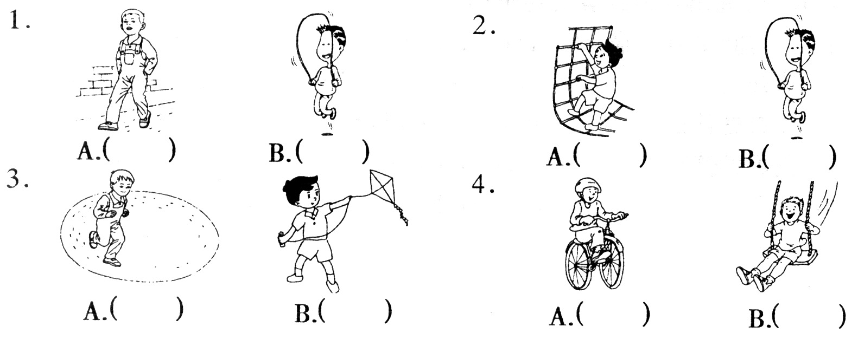
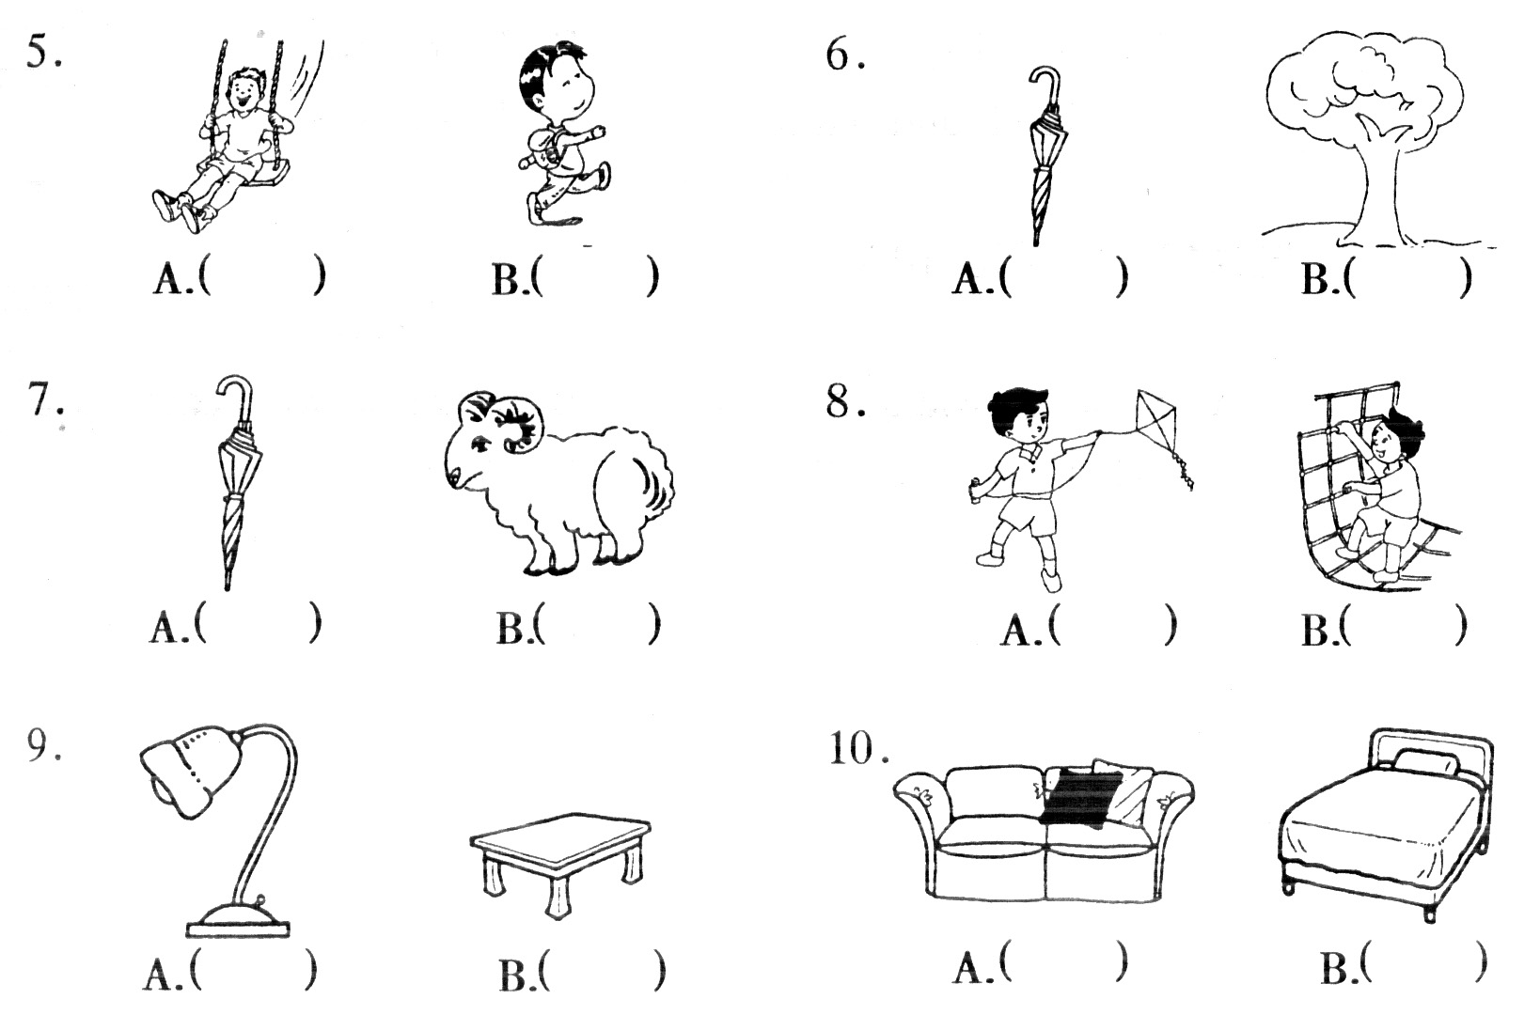
- 听录音，根据录音编号： 5%
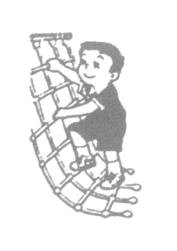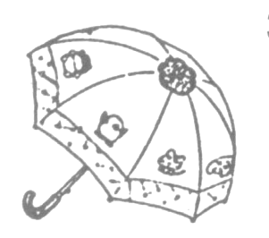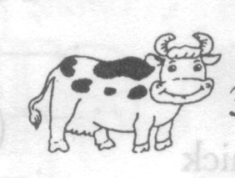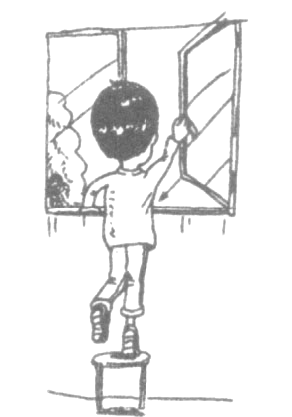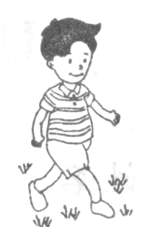
（ ） （ ） （ ） （ ） （ ）
- 听录音，圈出听到的单词： 10%
1. A. can B. can’t 2. A. my B. your
3. A. sheep B. she 4. A. tree B. sweet
5. A. panda B. pen 6. A. chick B. chicken
7. A. ride B. read 8. A. window B. walk
9. A. swing B. skip 10. A. bear B. here
- 听录音，圈出听到的句子： 5%
1. A. What can you hear? 2. A. Don’t walk on the grass.
B. What can you see? B. Don’t climb the tree.
3. A. Put on your dresses. 4. A. There is a table in the room.
B. Take off your dresses. B. There is a lamp on the table.
5. A. It’s big and brown.
B. It’s black and brown.
- 听录音，判断所给的内容，相同的用“√”、不相同的用“X”表示：10%
1.( ) I can ride a bicycle.
2.( ) Come here ,Lili.
3.( ) She has two red eyes.
4.( ) Don’t climb the tree.
5.( ) Close the window, please.
- 听录音，选择正确的应答句：10%
( ) 1. A: Yes, I can walk. B: No, I can’t swim.
( ) 2. A: I hear a dog. B: I see a cat.
( ) 3. A: I have got a hen . B: He has got a pig.
( ) 4. A: It’s red and white. B: It’s a red pencil.
( ) 5. A: Spotty can run. B: I can run.
- 听录音，选择合适的问句：10%
( ) 1. A: What can she do ? B: What can you do ?
( ) 2. A: What colour is it ? B: What is it ?
( ) 3. A: How old are you ? B: How are you ?
( ) 4. A: What has he got? B: What have you got?
( ) 5. A: Is he tall? B: Is he short?

笔试部分： 30%
一、写出所给字母的前后邻居（注意大小写）：5%
R ; n ; H ; P ; t

二、看图，选择正确的单词，把编号写在前面的括号内：6%
（ ） | 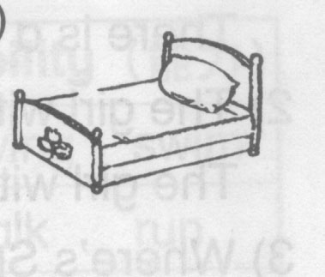  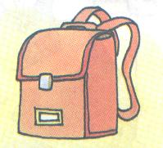  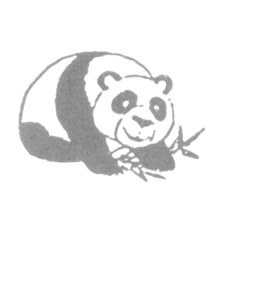  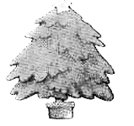   | 1． horse  2. panda  3. bird | ( ) |  | 1. skip  2. play  3. climb
（ ） |  | 1. bag  2. ruler  3. pencil | ( ) |  | 1. tree  2. flower  3. floor
（ ） |  | 1. bed  2. door  3. sofa | ( ) | 5 | 1. nine  2. five  3. four

三、填入所缺字母，完成单词：5%
l mp w k r m l phant c

四、选择填空，把编号写在前面的括号内：4%
( ) 1. I ____ skip. A: can B: is C: am
( ) 2. There are two ____ on the desk.
A: book B: books C: a bag
( ) 3. _____ the room, please.
A: Close B: Open C: Clean
( ) 4. Look ___ the bear---Big and brown.
A: at B: in C: on
五、根据答句选问句，将字母代号填入括号内：5%
( ) 1. Yes, it’s under the tree.
A: Is the star under the tree? B: Is the star on the tree?
( ) 2. I’m six.
A: How are you ? B: How old are you ?
( ) 3. She is my sister.
A: What is she? B: Who is she?
( ) 4. It is red and blue.
A: What is this? B: What colour is it?
( ) 5. May can see a rabbit.
A: What can May hear? B: What can May see?
六、根据情景，选择合适的句子，将代号填入括号内：5%
( ) 1.我不喜欢蛋糕。
A: I don’t like cakes. B: I don’t like sweets.
( ) 2.我有两只黑眼睛。
A: I have got two black eyes. B: He has got two black eyes.
( ) 3.包里有一把伞。
A: I have an umbrella in the bag. B: There is an umbrella in the bag.
( ) 4.不要在草地上走。
A: Don’t play on the grass. B: Don’t walk on the grass.
( ) 5. Spotty会荡秋千。
A: Spotty can swing. B: Spotty can climb.

