人教新起点2014秋二年级下册期中测试卷A
听力部分
一、听录音，选择听到的图片。
( ) 1. A.  B. 
( ) 2. A. 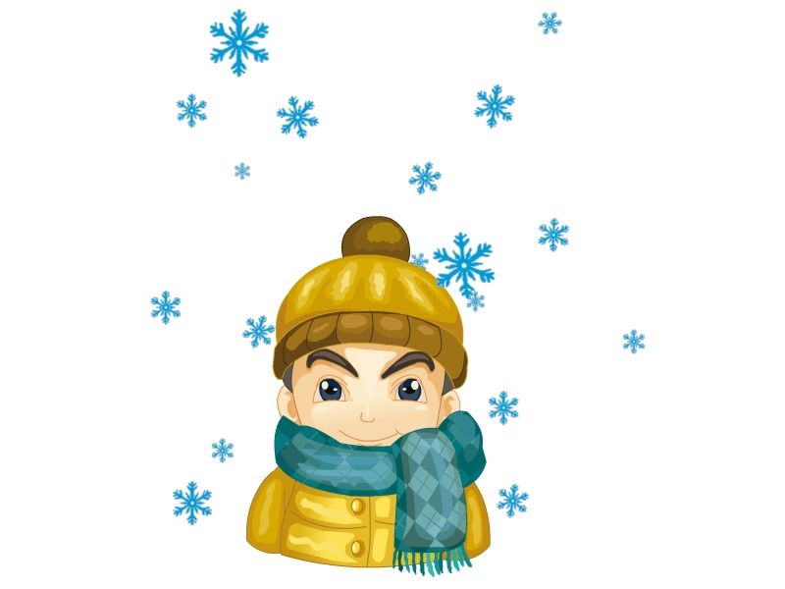 B. 
( ) 3. A.  B. 
( ) 4. A. 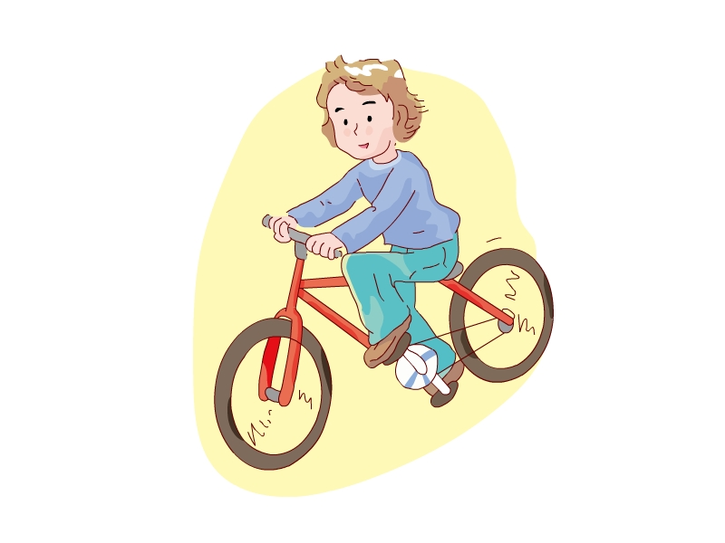 B. 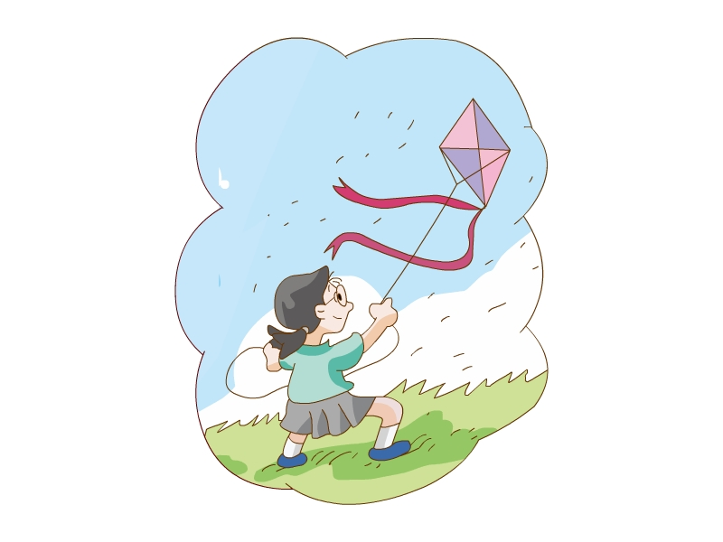
二、听录音，判断图片对错，用“√”或“×”表示。
( ) 1.  ( ) 2. 
( ) 3.  ( ) 4. 
( ) 5.
三、听录音，选择合适的词补全句子。
( ) 1. What’s the ________ like?
A. season B. weather C. winter
( ) 2. What’s your favorite ________?
A. weather B. windy C. season
( ) 3. Sorry, I ________.
A. can’t B. can C. am
( ) 4. It’s ________ and windy.
A. rainy B. sunny C. cloudy
( ) 5. I like ________. I can ride a bike.
A. spring B. autumn C. winter
四、听录音，选择听到的句子。
( ) 1. A. It’s windy and rainy. B. It’s hot and sunny.
( ) 2. A. It’s spring. B. It’s summer.
( ) 3. A. Can you play football? B. Can you ride a bike?
( ) 4. A. I want to swim. B. I want to eat.
( ) 5. A.What’s your favorite season? B. What’s the weather like today?
五、听录音，给下列字母排序。
A
b g i h k
( ) ( ) ( ) ( ) ( )
B
D J L B F
( ) ( ) ( ) ( ) ( )
笔试部分
一、看图，圈出正确的单词。
( ) 1. 
A. autumn B. summer
( ) 2.
A. windy B. cloudy
( ) 3.
A. bike B. kite
( ) 4.
A. rainy B. snowy
( ) 5. 
A. juice B. ice-cream
三、写出下列字母的左右邻居。
1. ________ Dd ________
2. ________ Hh ________
3. ________ Jj ________
4. ________ Ff ________
5. ________ Kk ________

参考答案
听力部分
听力材料
一、
1. dog 2. snowy 3. summer 4. fly a kite
二、
1. I can make a model plane.
2. It’s sunny.
3. It’s rainy.
4. I can play football.
5. It’s winter.
三、
1. What’s the weather like?
2. What’s your favorite season?
3. Sorry, I can’t.
4. It’s rainy and windy.
5. I like autumn. I can ride a bike.
四、
1. It’s windy and rainy.
2. It’s summer.
3. Can you ride a bike?
4. I want to swim.
5. What’s the weather like today?
五、
A: (l) g (2) k (3) I (4) h (5) b
B: (1) D (2) L (3) F (4) J (5) B
六、
1. a snowman 2. sunny 3. a kite 4. I can swim
听力答案
一、
1-4 BAAB
二、
1-5 ×√√××
三、
1-5 BCAAB
四、
1-5 ABBAB
五、
A: (1)-(5) 51342
B: (1) -(5) 14253
六、
1. a snowman 2. sunny 3. kite 4. swim
笔试部分
一、
略
二、
1-5 ABAAA
三、
1. Cc Ee 2. Gg Ii 3. Ii Kk 4. Ee Gg 5. Jj Ll

