人教新起点2014秋二年级下册期中测试卷B
听力部分
一、听录音，给下列图片排序。
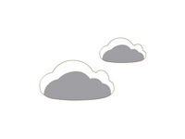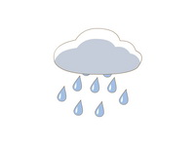
( ) ( ) ( )
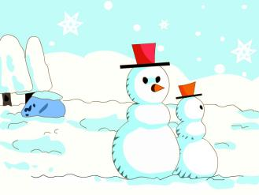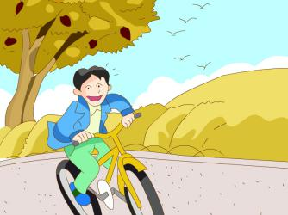
( ) ( )
二、听录音，给下列单词排序。
A B
( ) bike ( ) rainy
( ) kite ( ) sunny
( ) like ( ) hot
( ) make ( ) cool
( ) warm ( ) cold
三、听录音，判断图片是否正确，对的打“√”，错的画“×”。
( ) 1. ( ) 2. 
( ) 3. ( ) 4. 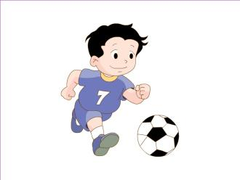
( ) 5. 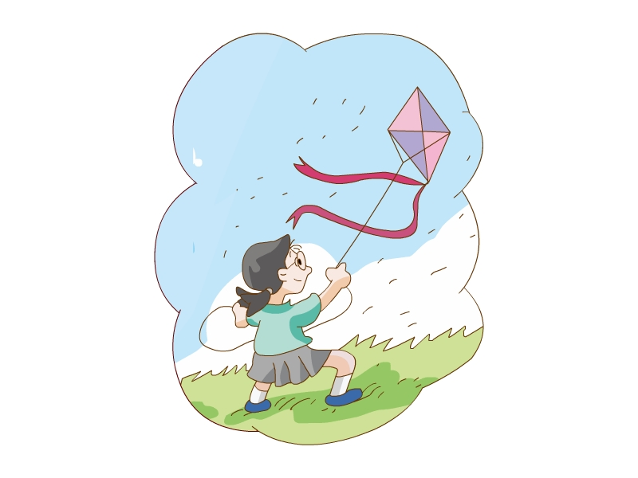
四、听录音，选择听到的句子。
( ) 1. A. Can you play football? B. Can you ride a bike?
( ) 2. A. It’s sunny and windy. B. It’s cool and windy.
( ) 3. A. What’s the weather like today? B. What’s your favorite season?
( ) 4. A. I can fly a kite in spring. B. I can swim in summer.
( ) 5. A. It’s very cold in winter. B. It’s very cool in autumn.
五、听录音，默写出大小写字母。
1. ________ 2. ________
3. ________ 4. ________
5. ________
六、听录音，选择正确的答句。
( ) 1. A. Yes, I do. B. Sorry, I can’t.
( ) 2. A. It’s winter. B. It’s rainy.
( ) 3. A. Spring. B. It’s sunny.
( ) 4. A. Yes, I can. B. Yes, I am.
( ) 5. A. It’s cool. B. It’s cold.
笔试部分
一、读一读，判断下列字母大小写是否一致，用“√”或“×”表示。
( ) 1. Ji ( ) 2. Lk
( ) 3. Gg ( ) 4. Hh
( ) 5. Ij
二、看图，判断下列句子对错，用“√”或“×”表示。
( ) 1. 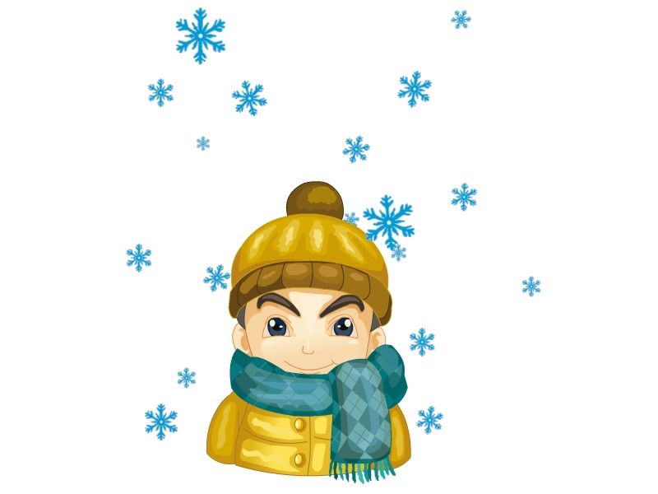 It’s cool and windy in this season.
( ) 2. 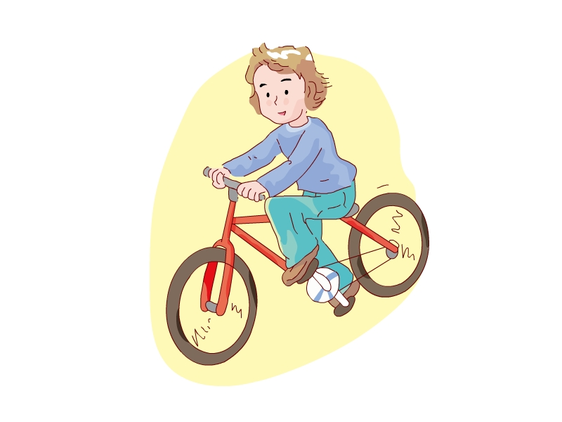 I can fly a kite.
( ) 3.  My favorite season is spring.
( ) 4. It’s winter now.
( ) 5. It’s windy today.
三、读一读，将下列句子排列成一段通顺的对话。
( ) It’s sunny.
( ) Can you play football?
( ) What’s the weather like today?
( ) Yes, I can. Let’s go and play football.
( ) Great! Let’s go.

参考答案
听力部分
听力材料
一、
1. It’s summer.
2. It’s rainy.
3. It’s cloudy.
4. It’s autumn.
5. It’s cold
二、
A: (l) warm (2) like (3) bike (4) make (5) kite
B: (l) sunny (2) cool (3) hot (4) cold (5) rainy
三、
1. It’s summer now.
2. It’s windy.
3. I can make a snowman.
4. I can swim.
5. I can ride a bike.
四、
1. Can you ride a bike?
2. It’s cool and windy.
3. What’s the weather like today?
4. I can fly a kite in spring.
5. It’s very cool in autumn.
五、
1. Jj 2. LI 3. Gg 4. Dd 5. Ii
六、
1. Can you swim?
2. What season is it now?
3. What’s the weather like today?
4. Can you play basketball?
5. What’s the weather like in autumn?
听力答案
一、
(1)-(5) 31254
二、
A: 35241
B: 51324
三、
1-5 ×√√××
四、
1-5 BBAAB
五、
1. Jj 2. Ll 3. Gg 4. Dd 5. li
六、
1-5 BABAA
笔试部分
一、
1-5 ××√√×
二、
1-5 ××√√×
三、
23145

