小学英语外研版(一年级起点)二年级下册期中测试卷 B
听力部分
一、听音，选择听到的图片。
( ) 1. A. 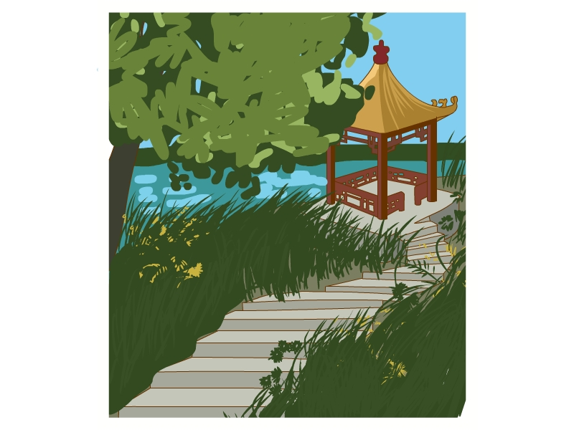 B. 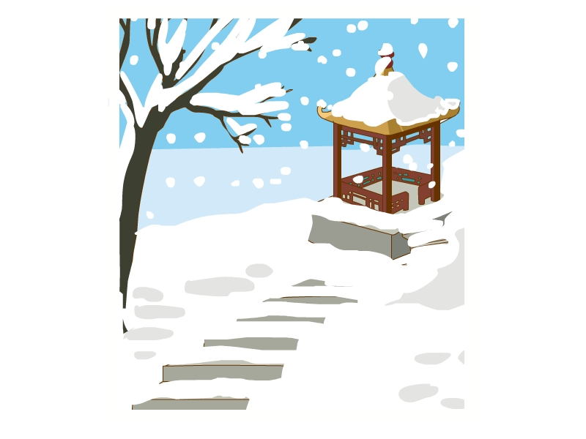
( ) 2. A. 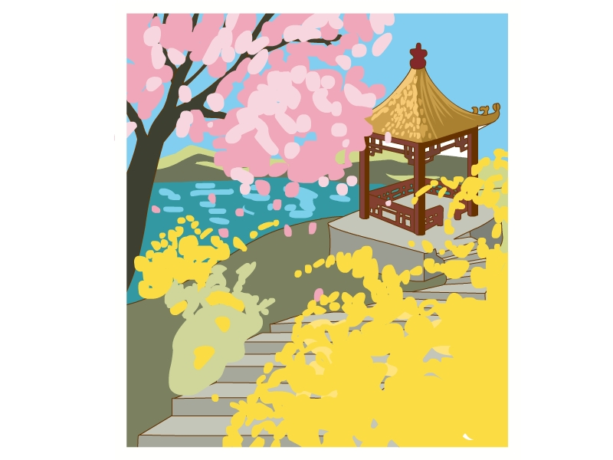 B. 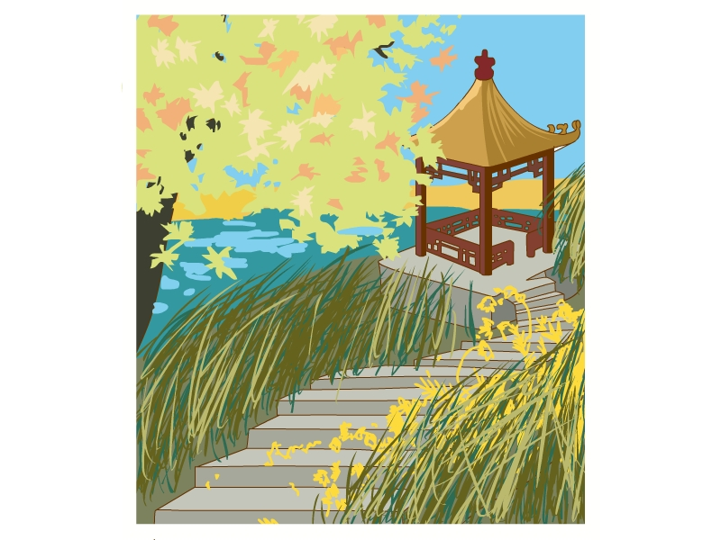
( ) 3. A.  B. 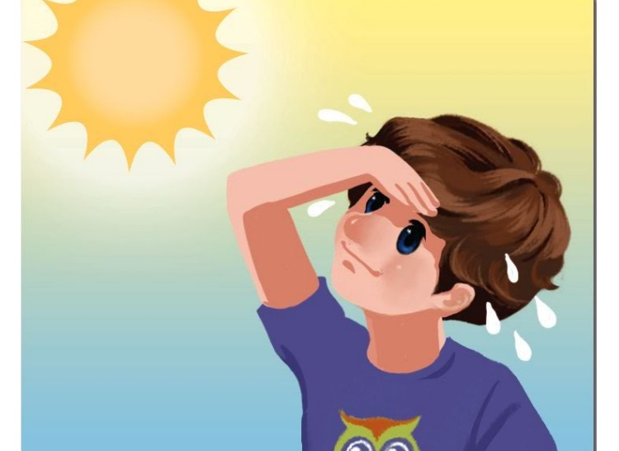
( ) 4. A.  B. 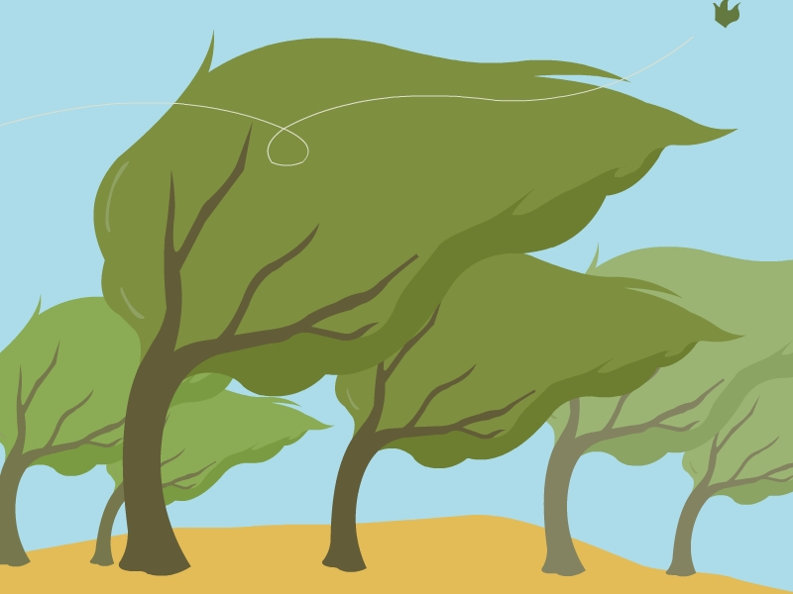
二、听音，判断。正确的打“√”，错误的打“×”。
1. 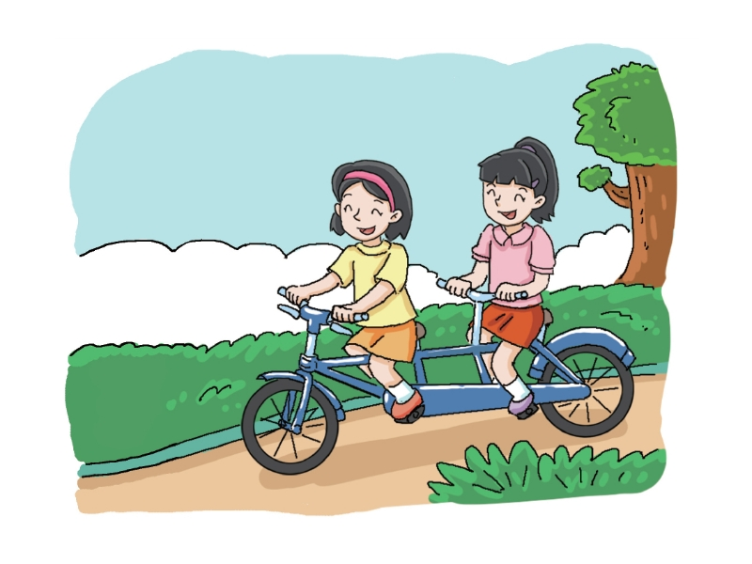 2. 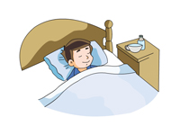 3. 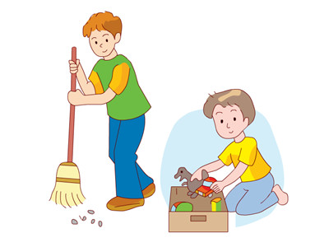
( ) ( ) ( )
4. 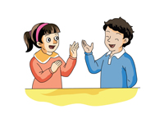 5. 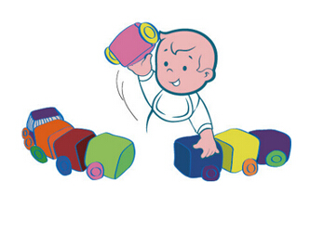 6. 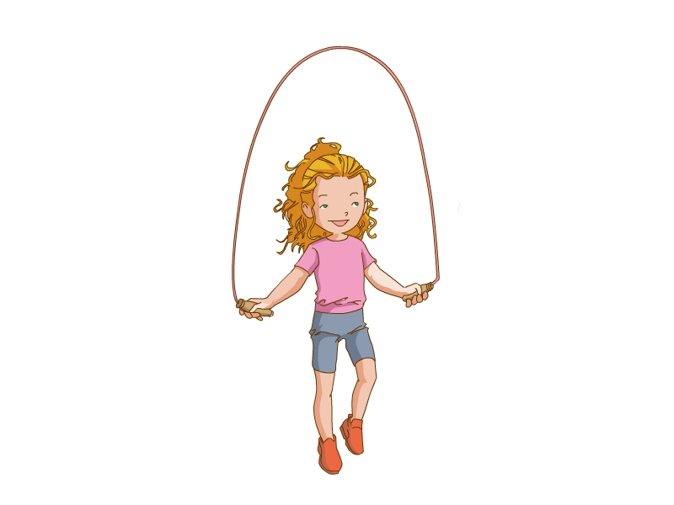
( ) ( ) ( )
笔试部分
一、看图，选择合适的短语。
(1)  A. tidy the room
(2) 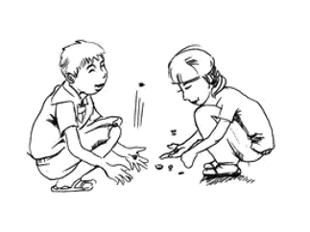 B. play clapping games
(3) 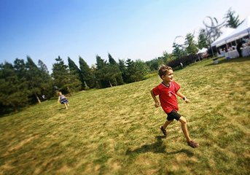 C. play catch
(4)  D. eat an apple
(5) 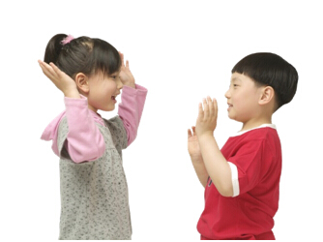 E. play five-stones
(6) 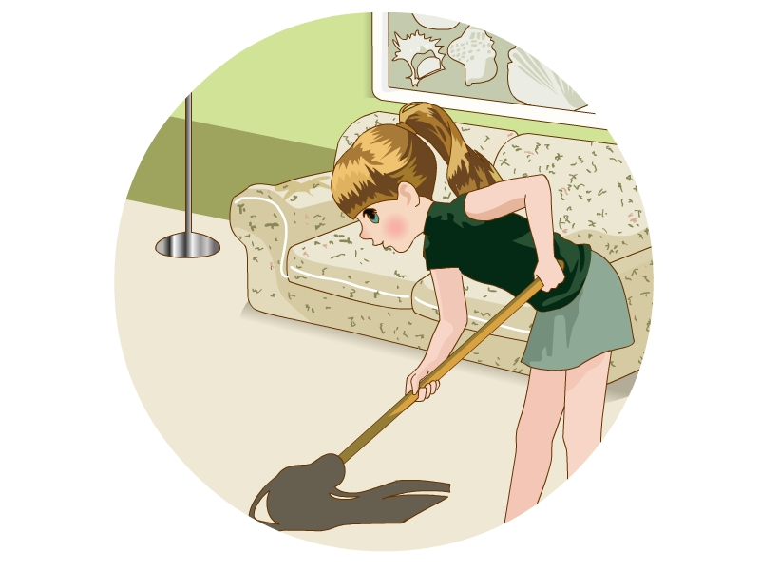 F. do homework
二、读一读，选一选。
( ) 1. —Are you eating? 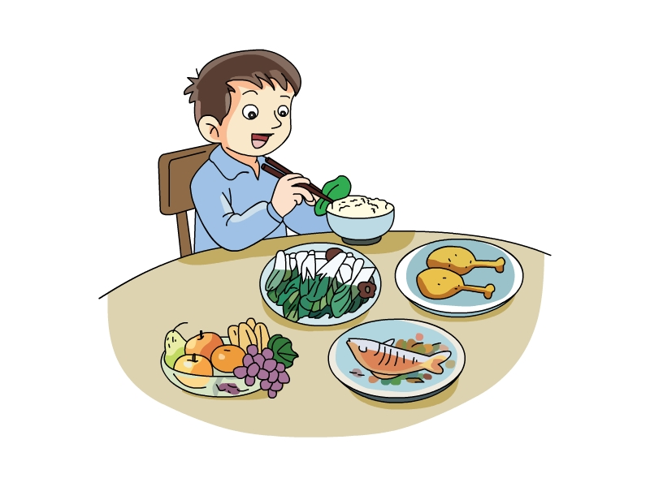
—________
A. Yes, I am. B. No, I’m not.
( ) 2. —Is she skipping? 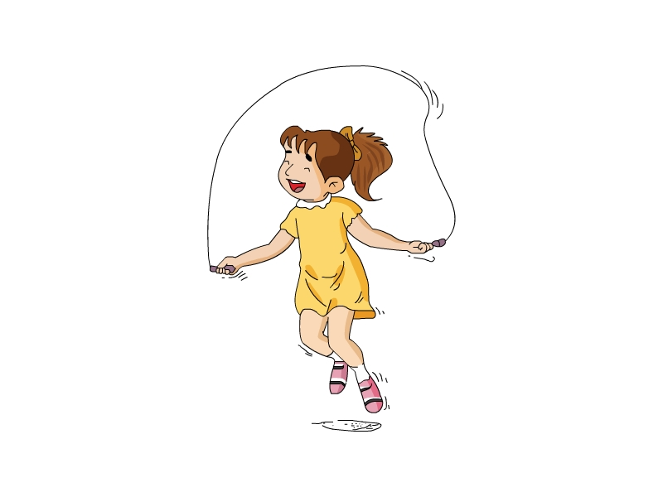
—________
A. Yes, she is. B. No, she isn’t.
( ) 3. —Is he drinking milk? 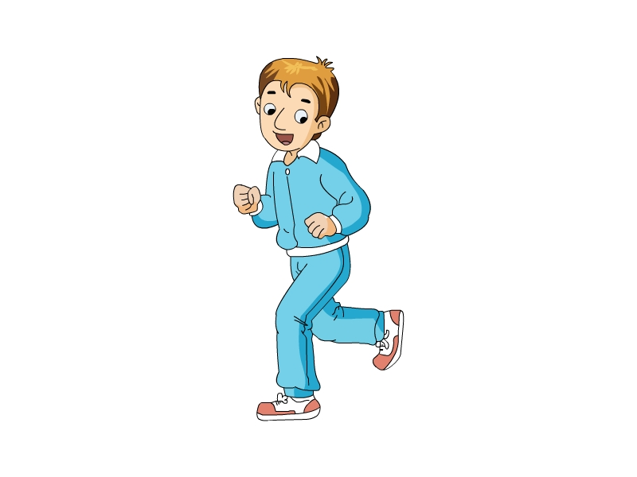
—________
A. Yes, he is. B. No, he isn’t.
( ) 4. —Is it swimming? 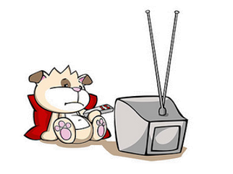
—________
A. Yes, it is. B. No, it isn’t.
( ) 5. —Are you drawing a picture? 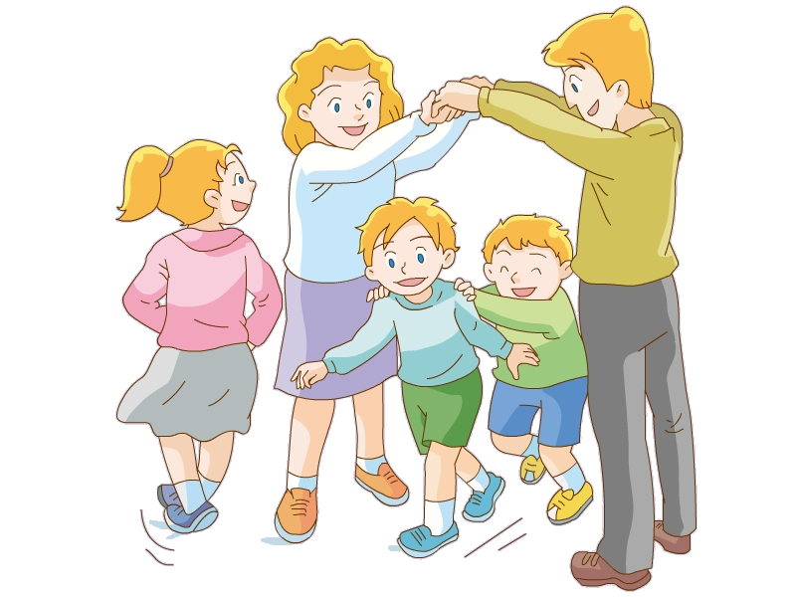
—________
A. Yes, we are. B. No, we aren’t.
三、仿照例句，写一写。
He is tidying his room.
He isn’t tidying his room.
1. She is doing her homework. 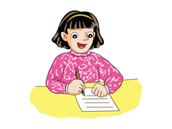
___________________________________________________________________
2. He is reading a letter. 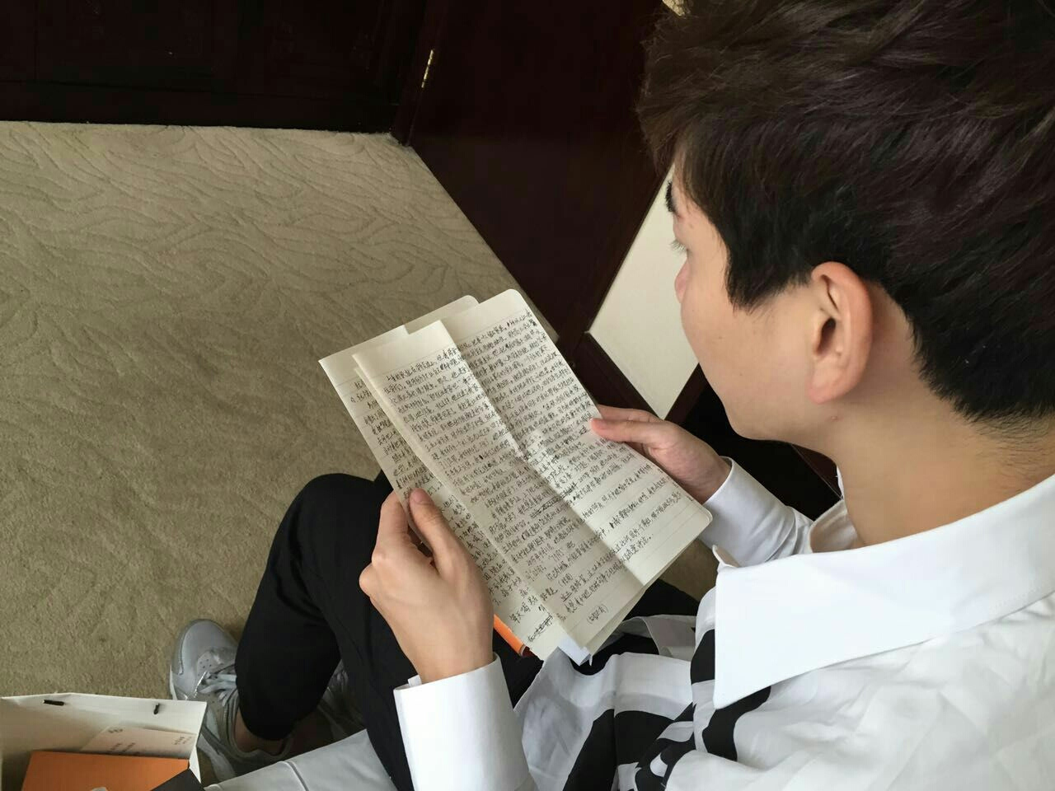
___________________________________________________________________
四、读一读，根据提示补全对话。
1. —What’s she doing? 
—She’s ____________________.
2. —What’s he doing? 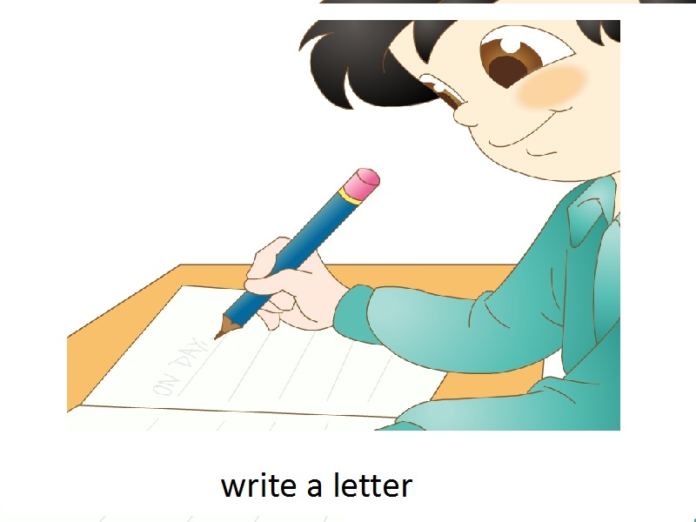
—He’s ____________________.
3. —What’s the boy doing? 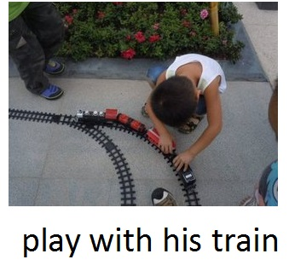
—He’s ____________________._
4. —What’s are you doing? 
—I’m ____________________.
5. —What are they doing? 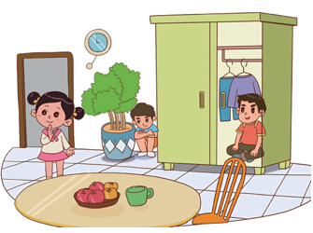
—They’re ____________________.
五、读一读，选一选。
My life is colorful (多姿多彩的). It’s like a rainbow, like a flower, like a picture. When (当......时候) I am skiing, my life (生活) is the colour white. When I am swimming, my life is the colour blue. When I’m reading a book, my life is orange. I like the many colours that books share (分享) with me.
( ) (1) My life is like a ________.
A. book B. orange C. rainbow
( ) (2) When I’m skiing, my life is ________.
A. white B. blue C. orange
( ) (3) When I’m my life is orange ________.
A. skiing B. swimming C. reading
( ) (4) I liking the many colours that ________ share with me.
A. flowers B. books C. pictures

参考答案
听力部分
听力材料
一、
1. It’s summer.
2. It’s autumn.
3. It’s cold.
4. It’s windy.
二、
1. Are they flying a kite?
2. Is he sleeping?
3. Are they tidying their room?
4. Are they dancing?
5. Is he playing with his train?
6. Is she playing five-stones?
听力答案
一、
1-4ABAB
二、
1-6××√×√×
笔试部分
一、
(1)-(6)DECFBA
二、
1-5AABBB
三、
1. She isn’t doing her homework.
2. He isn’t reading a letter.
四、
1. She is reading a newspaper.
2. He is writing a letter.
3. He is playing with his train.
4. We are listening to music.
5. They’re playing hide-and-seek.
五、
(1)-(4)CACB

