沪教版一年级下册英语期中测试卷期A
听力部分
一、听录音，选出你所听到的同类单词。
( ) 1. A. hen B. paper C. ground D. draw
( ) 2. A. come B. there C. hear D. bear
( ) 3. A. room B. close C. in D. sweet
( ) 4. A. walk B. here C. bicycle D. fish
( ) 5. A. stop B. tree C. sea C. brown
( ) 6. A. run B. jump C. chick D. climb
( ) 7. A. red B. orange C. brown D. white
( ) 8. A. under B. apple C. run D. cat
( ) 9. A. tiger B. farm C. egg D. zoo
( ) 10 A. bag B. bed C. door D. table
二、听录音，选出正确的图片。
( ) 1. A. 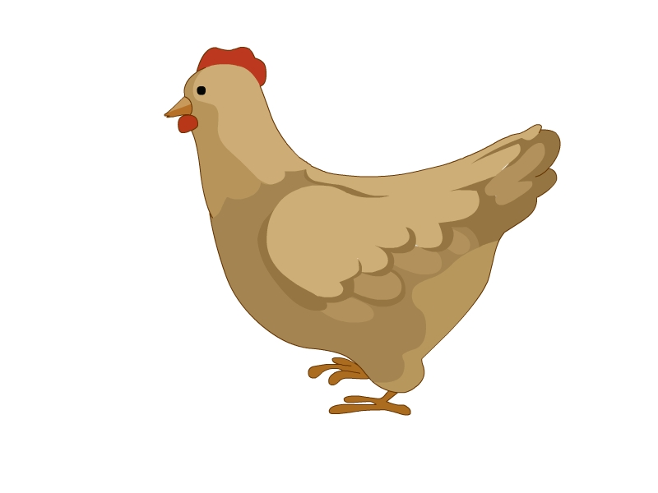 B. 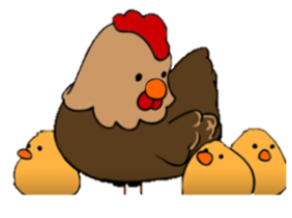
( ) 2. A. 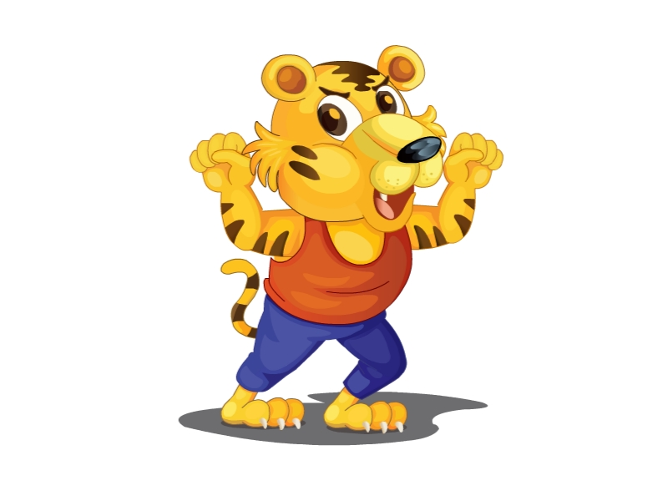 B. 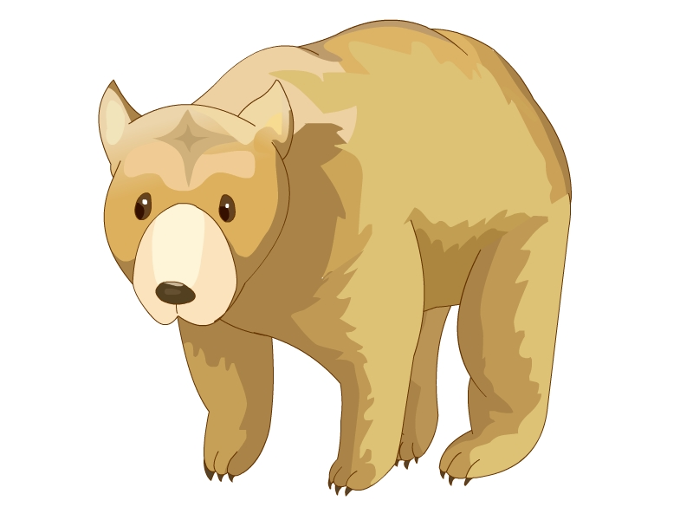
( ) 3. A. 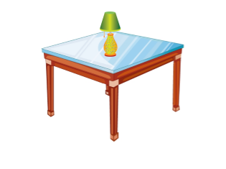 B. 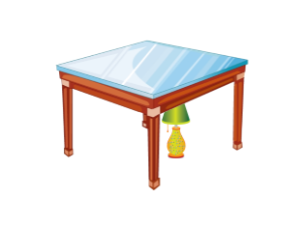
( ) 4. A. 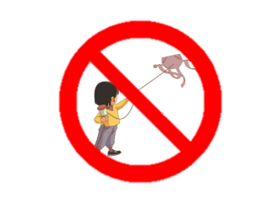 B. 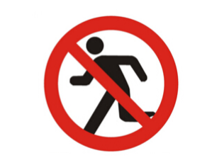
( ) 5. A. 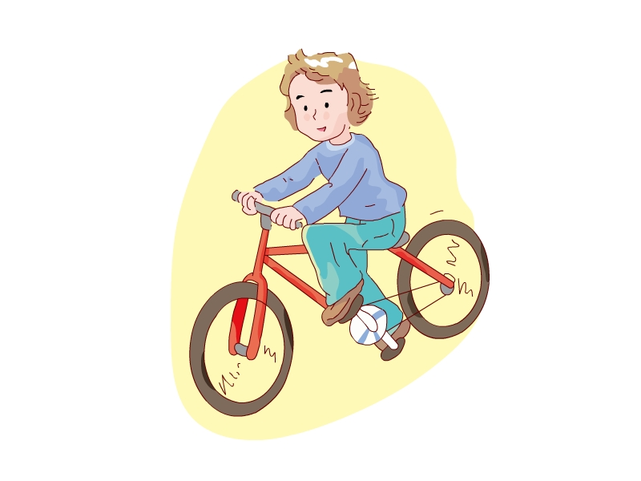 B. 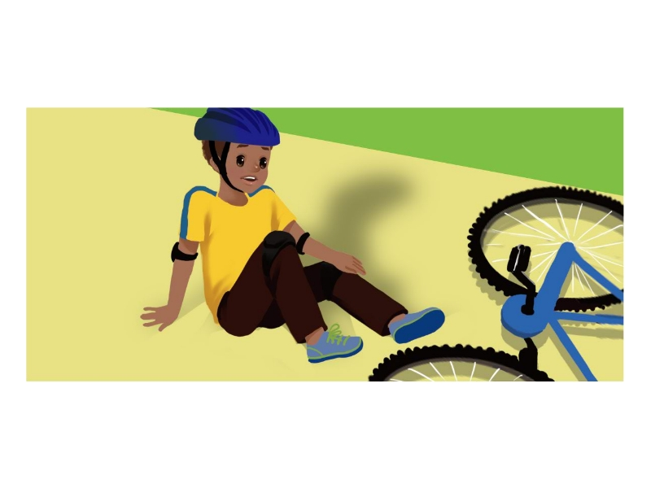
( ) 6. A. 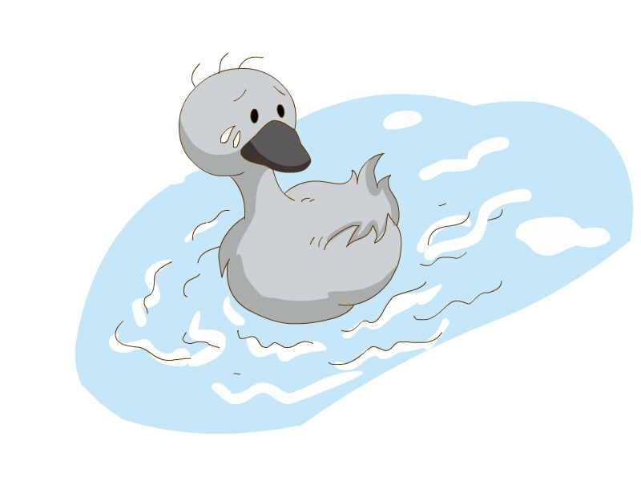 B. 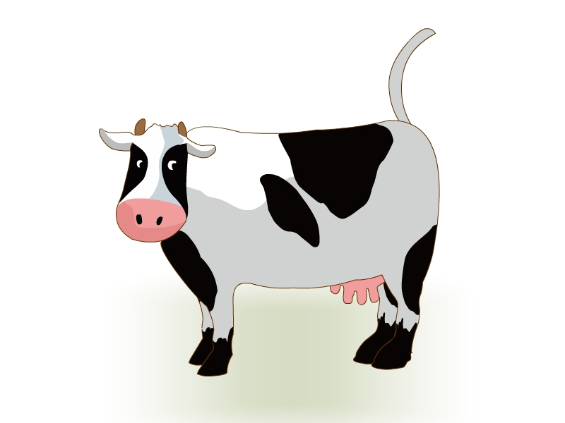
( ) 7. A. 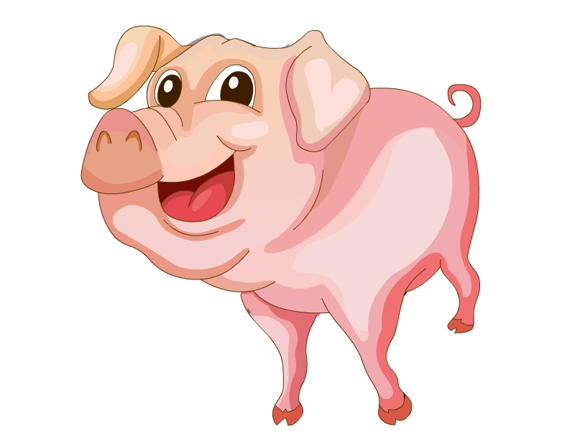 B. 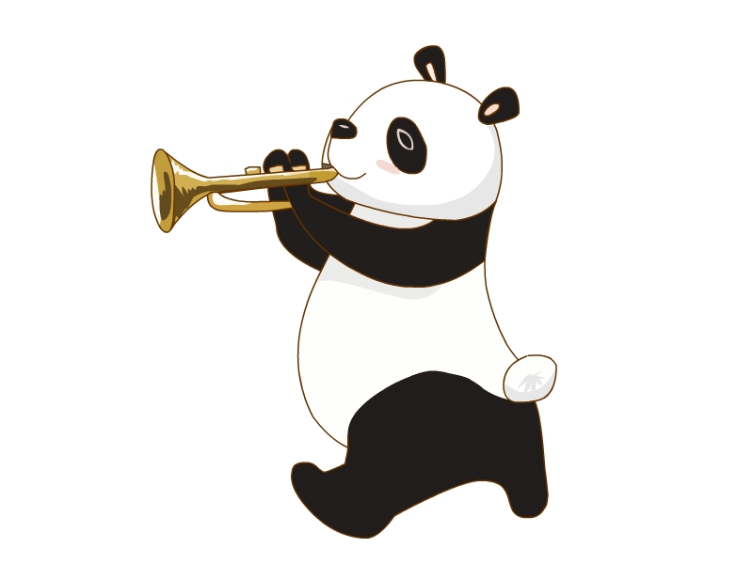
( ) 8. A. 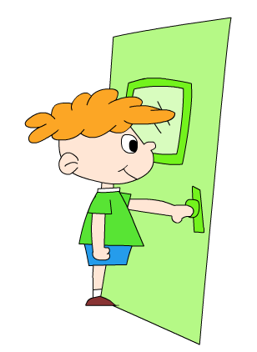 B. 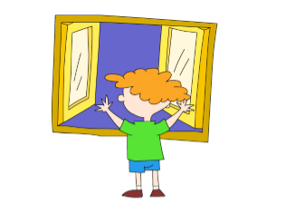
( ) 9. A. 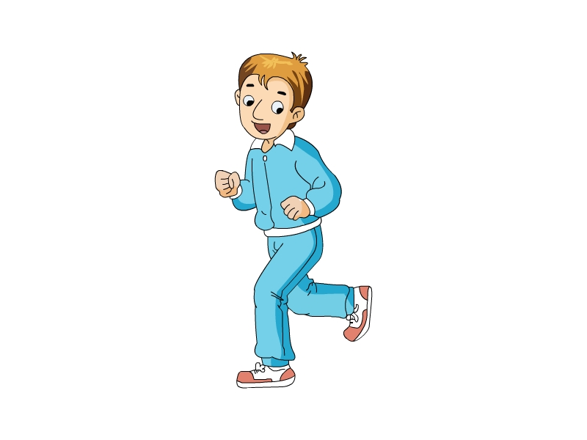 B. 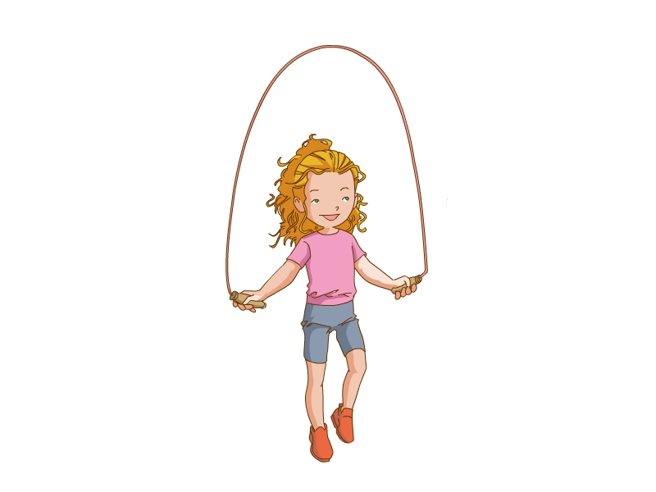
( ) 10. A.  B. 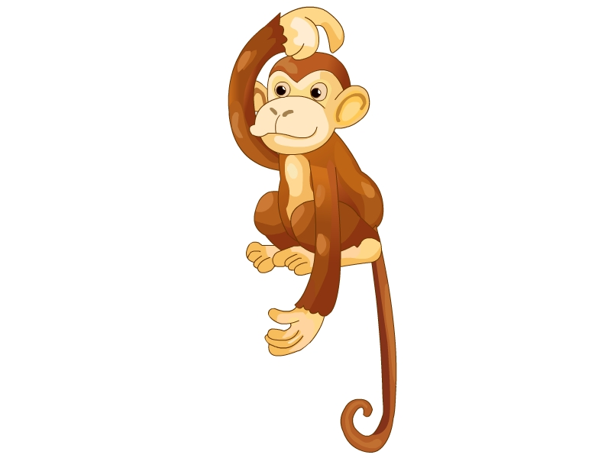
三、选出听到的词组或句子。
( ) 1. A. draw a pencil B. draw a panda
C. draw on the paper
( ) 2. A. look at the umbrella B. look at the rubber
C. look at the umbrella
( ) 3. A. hear a chick B. hear a pig
C. hear a dog
( ) 4. A. on the bed B. under the bed
C. under the table
( ) 5. A. open the window B. close the window
C. close the door
( ) 6. A. Spotty can ride here B. Spotty can’t ride here
C. Spotty can run here
( ) 7. A. I see a little and white dog. B. I see a red and brown dog.
C. I see a white and brown dog
( ) 8. A. Walk like a cat on the floor. B. Fly like a kite in the sky.
C. Walk like a cow on the grass
( ) 9. A. There is a cow on the farm. B. There are two cows on the farm.
C. There is a cow in the zoo.
( ) 10. A. Don’t climb the tree. B. Don’t climb the chair.
C. Don’t climb the window.
四、听录音，选出正确的应答句。
( ) 1. A. I see a pig. B. I hear a pig.
( ) 2. A. She is a rabbit. B. She is a monkey.
( ) 3. A. There is a bed. B. There is a monkey.
( ) 4. A. It can jump. B. It can fly.
( ) 5. A. Close the window, please. B. Open the window, please.
( ) 6. A. I’m sorry. B. Thank you.
( ) 7. A. It goes ‘baa, baa’. B. It goes ‘quack, quack’.
( ) 8. A. I can run. B. It can run.
( ) 9. A. OK. B. Yes.
( ) 10. A. It’s on the table. B. Yes, it’s on the table.
笔试部分
一、看图，写出正确的单词。
1. 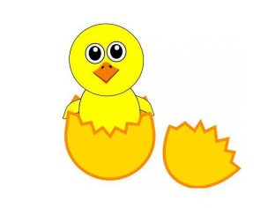 ichck ________ 2. itgre ________
3. 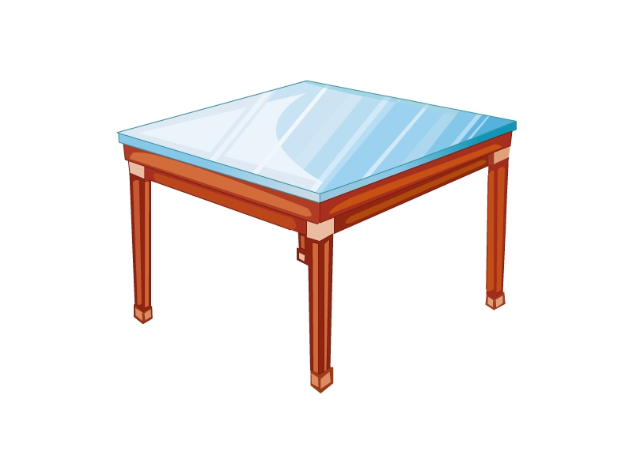 ablte ________ 4. 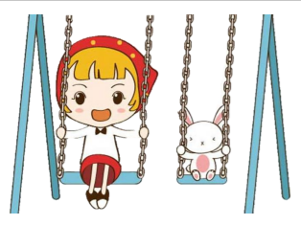 inwsg ________
5.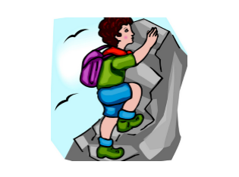 imcbl ________ 6.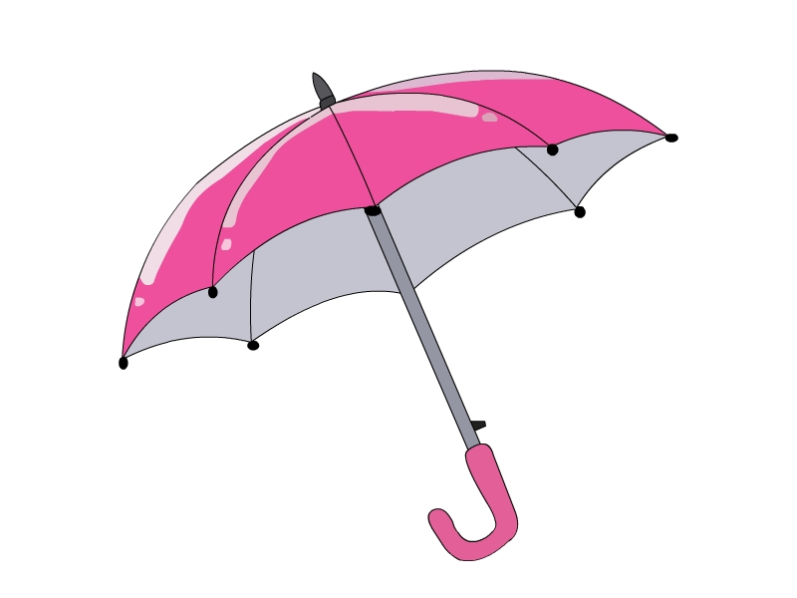mureball ________
7.  oesn ________ 8. 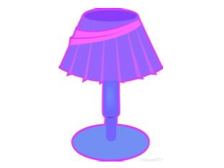 lpam ________
9.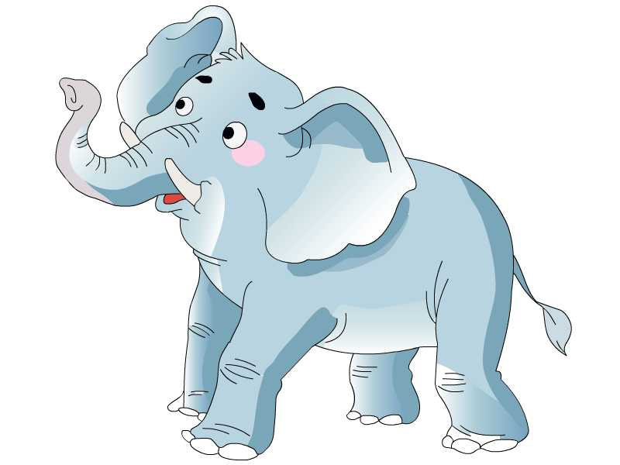hpelenat ________ 10.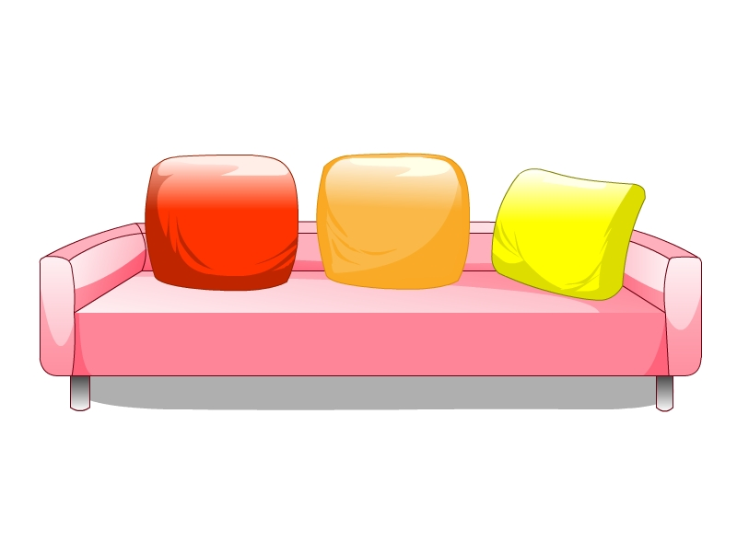ofas ________

二、选择填空。
( ) 1. —What ________ you hear?
—I hear a cow.
A. do B. in C. is
( ) 2. Come ________, Spotty.
A. hear B. here C. there
( ) 3. Look ________ the quilt.
A. to B. on C. at
( ) 4. There ________ two bags on the floor.
A. is B. are C. am
( ) 5. I ________ run in the park.
A. can B. can’t C. don’t
( ) 6. Walk ________ a cat.
A. can B. don’t C. like
( ) 7. Don’t ________ the tree.
A. jump B. walk C. climb
( ) 8. Spotty, don’t ________ there.
A. stop B. go C. to
( ) 9. Spotty can ________ a bicycle.
A. ride B. swing C. run
( ) 10. There is a ________ on the table.
A. lamp B. lamps C. Lamp
三、用所给单词写一句话。
1. elephant, the, a, has, long, nose (.)
_____________________________________________________________________
2. is, there, a, room, in, sofa, the (.)
_____________________________________________________________________
3. climb, don’t, the, tree, here (.)
_____________________________________________________________________
4. can, who, like, run, dog, a (?)
_____________________________________________________________________
5. a, hen, draw, the, ground, on (.)
_____________________________________________________________________
6. hear, a, dog, I (.)
_____________________________________________________________________
7. the, don’t, walk, grass, on (.)
_____________________________________________________________________
8. are, two, cats, sofa, there, under, the (.)
_____________________________________________________________________
9. pig, fat, big, and, is, the (.)
_____________________________________________________________________
10. see, do, you, what (?)
_____________________________________________________________________
四、根据所给图片完成句子。
can legs friends white in
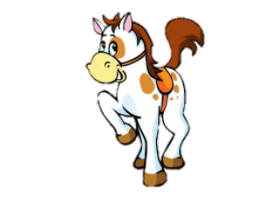
I have a (1) ________.
It has four long (2) ________.
It (3) ________ run fast.
It’s big and (4) ________.
It’s (5) ________ the zoo.
Who’s he?
He’s a horse.

参考答案
听力部分
听力材料
一、
1. cow 2. tiger 3. bed 4. ride 5. white 6. hen 7. apple 8. on
9. horse 10. pencil
二、
1. The hen has three chicks.
2. Look at the tiger. It’s yellow and brown.
3. There is a lamp under the table.
4. Don’t fly a kite here.
5. Sam can ride a bicycle.
6. There is a duck on the river.
7. I see a big panda.
8. Open the door.
9. I can run fast.
10. Swim like a fish.
三、
1. draw on the paper
2. look at the lamp
3. hear a chick
4. under the bed
5. open the window
6. Spotty can run here.
7. I see a red and brown dog.
8. Walk like a cow on the grass.
9. There is a cow on the farm.
10. Don’t climb the chair.
四、
1. Oink, oink. What do you hear?
2. She has two long ears. Who’s she?
3. What’s in the room?
4. What can a monkey do?
5. It’s very hot.
6. Don’t skip on the grass.
7. Listen to the duck.
8. What can you do?
9. Draw a cow on the paper.
10. Where is the lamp?
听力答案
一、
1-10 ADAAD CBAAA
二、
1-10 BABAA ABAAA
三、
1-10 CAABA CBCAB
四、
1-10 BAAAB ABAAA
笔试部分
一、
1. chick 2. tiger 3. table 4. swing 5. climb 6. umbrella 7. nose
8. lamp 9. elephant 10. sofa
二、
1-10 ABCBA CCBAA
三、
1. The elephant has a long nose.
2. There is a sofa in the room.
3. Don’t climb the tree here.
4. Who can run like a dog?
5. Draw a hen on the ground.
6. I hear a dog.
7. Don’t walk on the grass.
8. There are two cats under the sofa.
9. The pig is fat and big.
10. What do you see?
四、
(1)-(5) friend; legs; can; white; in

