沪教版一年级下册英语期中测试卷期B
听力部分
一、听录音，给图片编号。
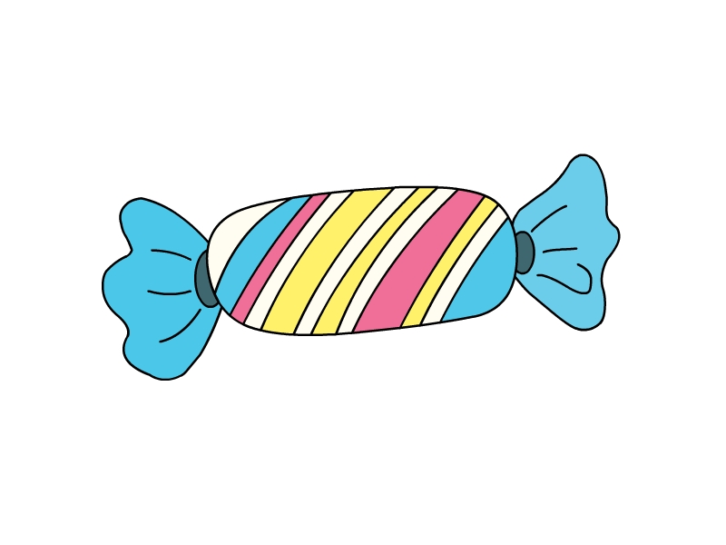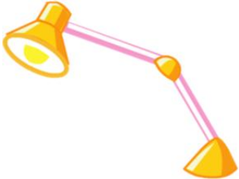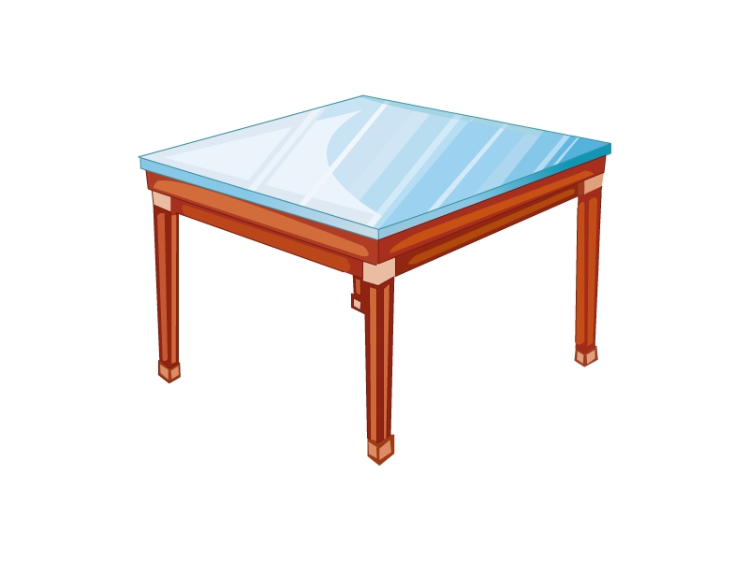
( ) ( ) ( )
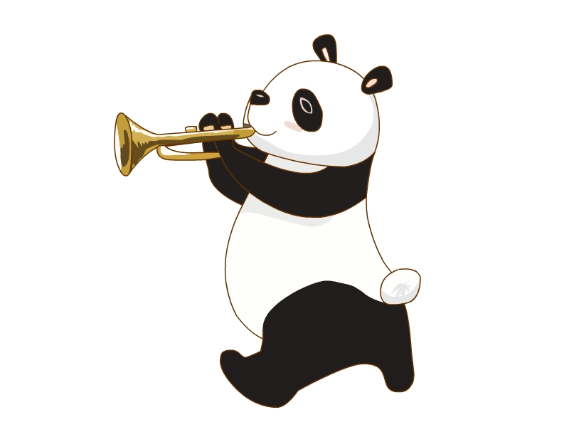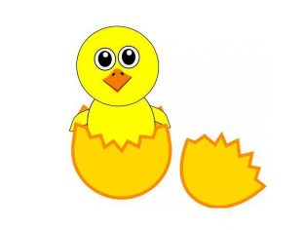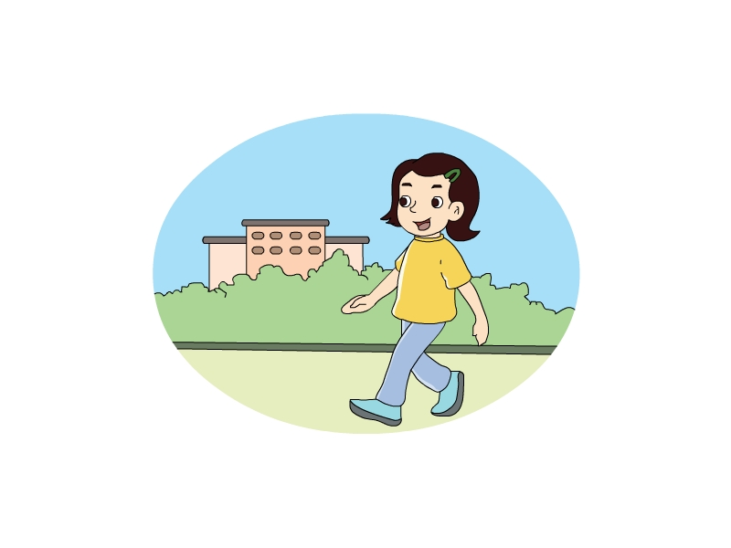
( ) ( ) ( )
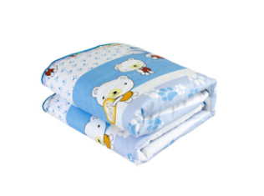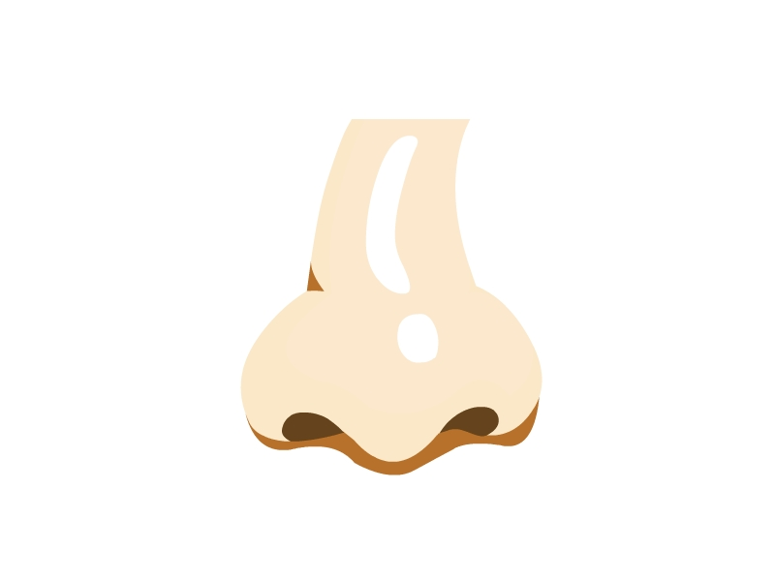
( ) ( )
二、听录音，选出你听到的单词或词组。
( ) 1. A. ground B. brown C. ride
( ) 2. A. stop B. Spotty C. skip
( ) 3. A. paper B. pencil C. please
( ) 4. A. there B. hear C. bear
( ) 5. A. four big eggs B. four long legs C. four red eggs
( ) 6. A. come here B. go back C. go there
( ) 7. A. on the table B. under the table C. under the sofa
( ) 8. A. run like a dog B. jump like dog C. run like a horse
( ) 9. A. in the sea B. in the zoo C. in the park
( ) 10. A. clean the window B. close the window C. clean the door
三、听录音，判断听到的内容与图片是否一致，一致的用“√”表示，不一致的用“×”表示。
( ) 1. 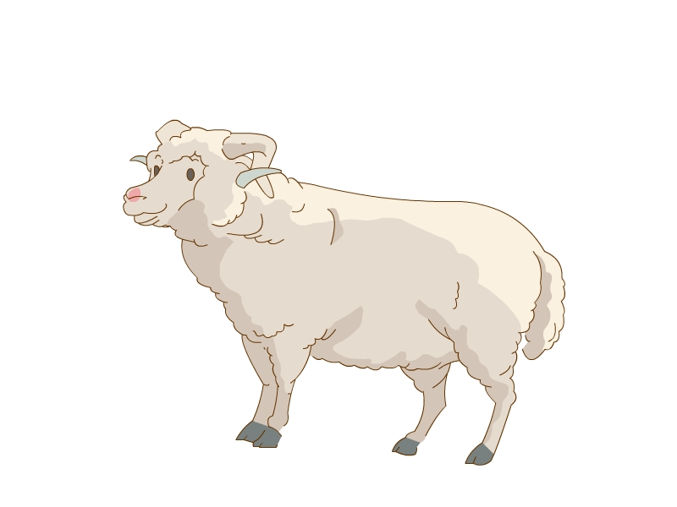 ( ) 2. 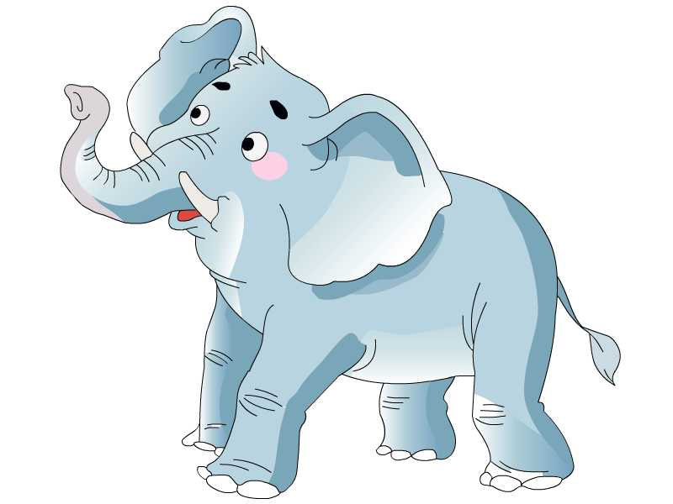
( ) 3. 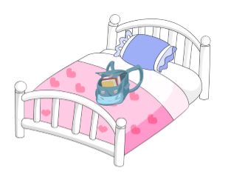 ( ) 4. 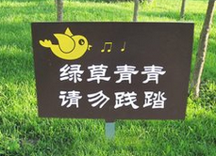
( ) 5. 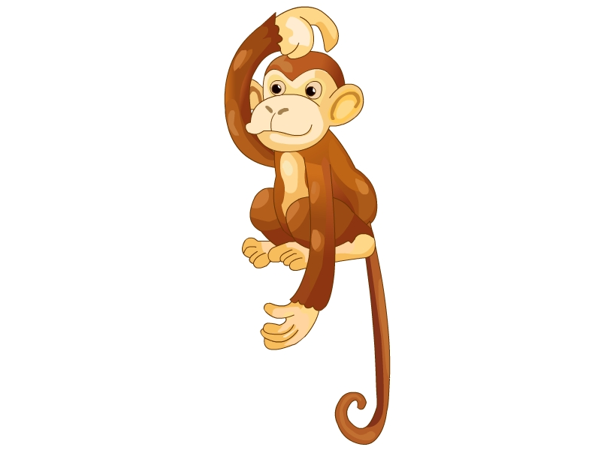 ( ) 6. 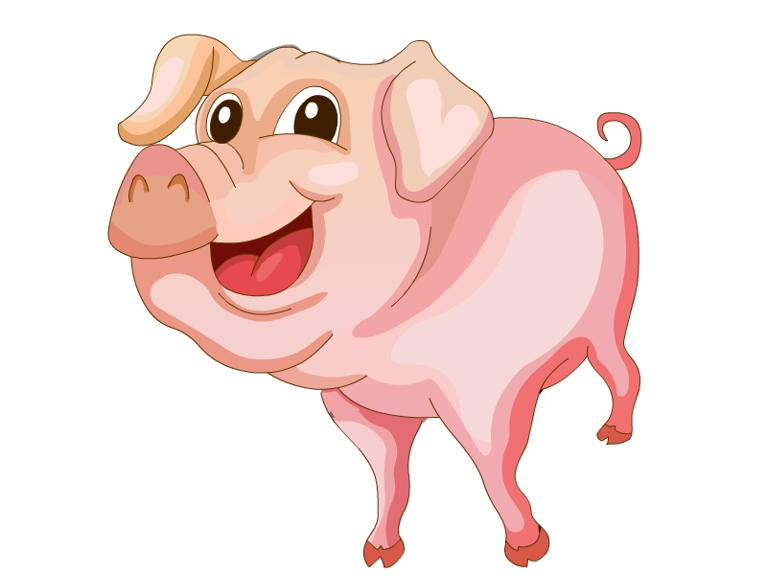
( ) 7. 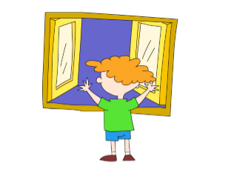 ( ) 8. 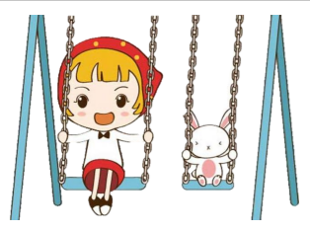
( ) 9. 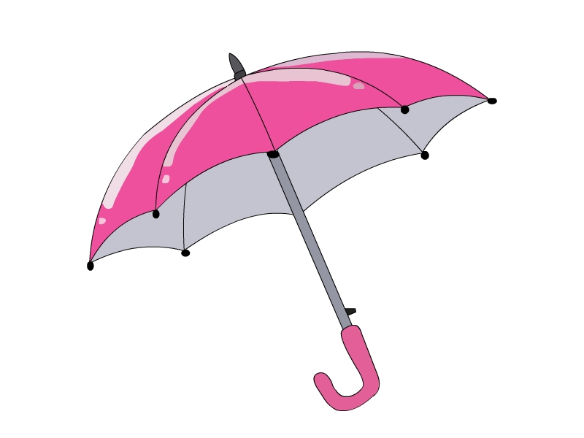 ( ) 10. 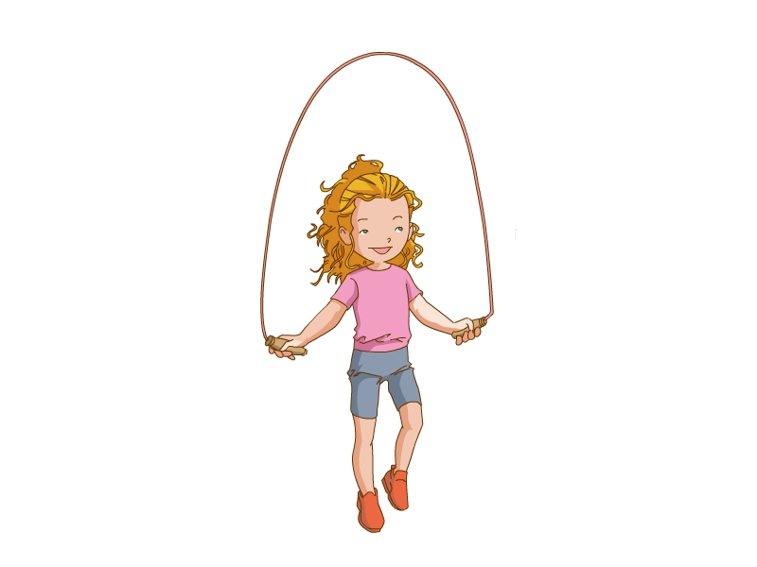
四、听录音，选出相应的应答句。
( ) 1. A. I see a sheep. B. I hear a sheep.
( ) 2. A. OK. B. Thank you.
( ) 3. A. I can ship. B. Spotty can skip.
( ) 4. A. This is a bed. B. There is a bed.
( ) 5. A. It goes ‘oink, oink’. B. It goes ‘quack, quack’.
( ) 6. A. Open the door, please. B. Close the door, please.
五、听录音，填空完成短文。
ears dog jump room run under fly sing eyes bed
I’ve got a friend. It’s in my ________. It’s ________ the ________. It has two small ________ and two big ________. It can ________ and ________. It can’t ________ and ________. Who is my friend? It’s a toy ________.
笔试部分
一、根据图片填上所缺的字母。
1. 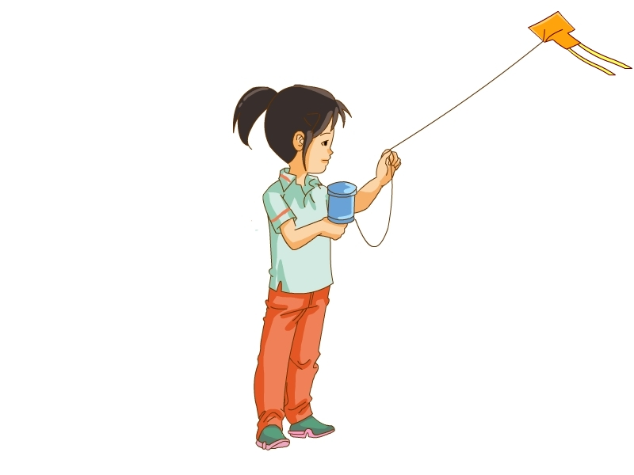 f__ __ 2. __mbrell__
3. t__b__ 4. q__ __lt
5. n__se 6. 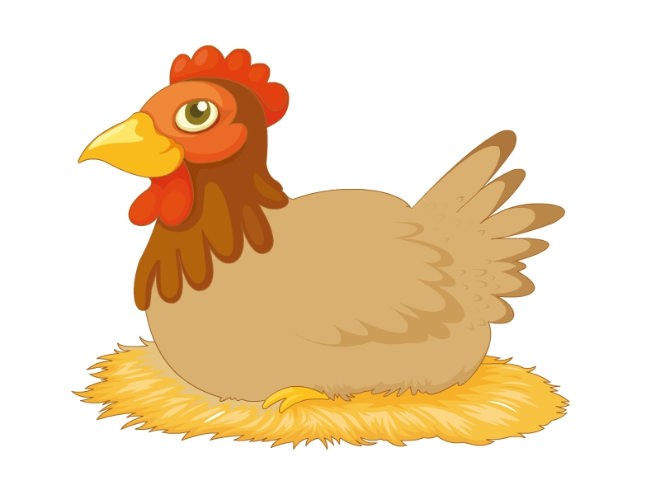 h__ __
7. 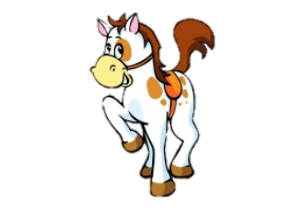 h__ __se 8. 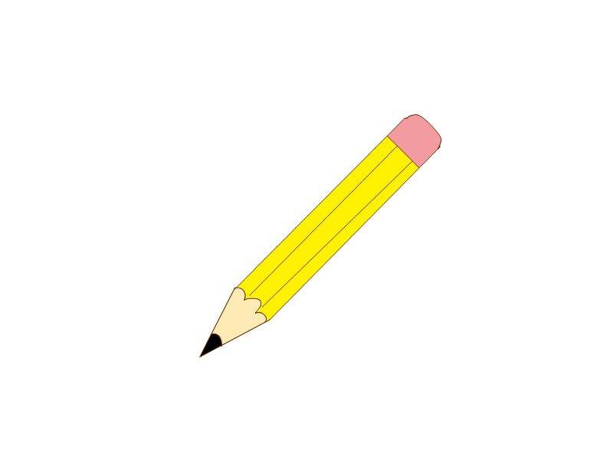 p__ne__l
9. 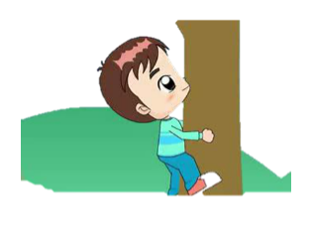 cl__m__ 10. 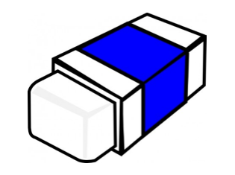 r__bb__r
二、写单词。
1. 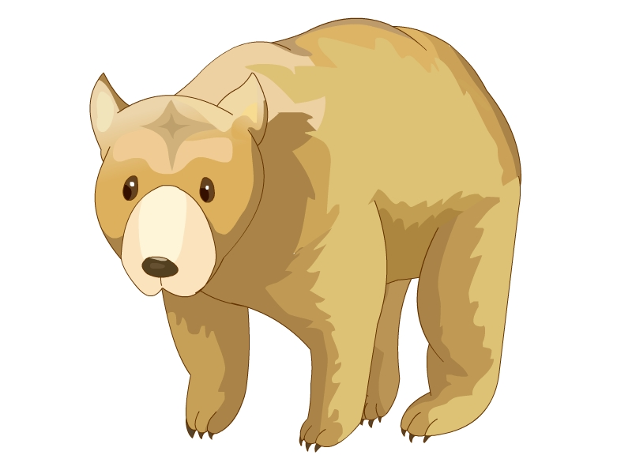 ________ 2. ________
3. 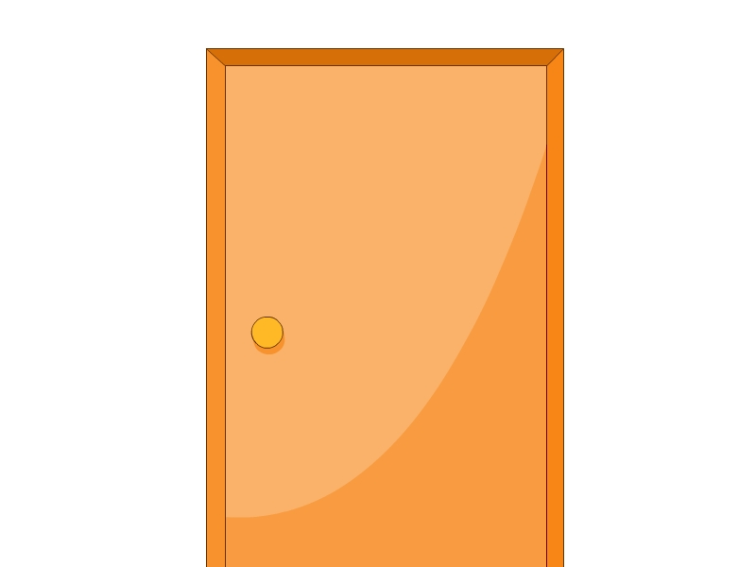 ________ 4. 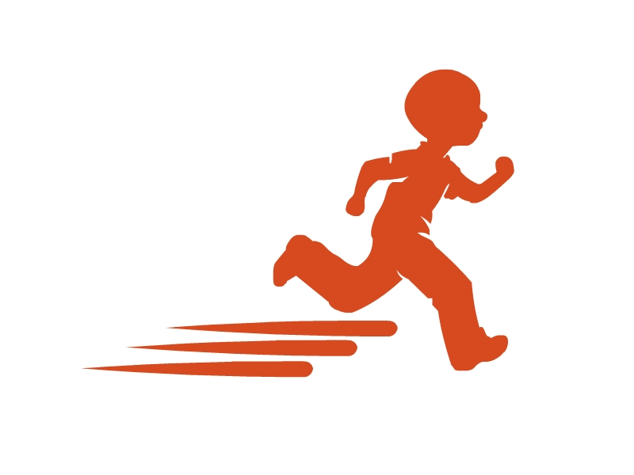 ________
5. ________ 6. 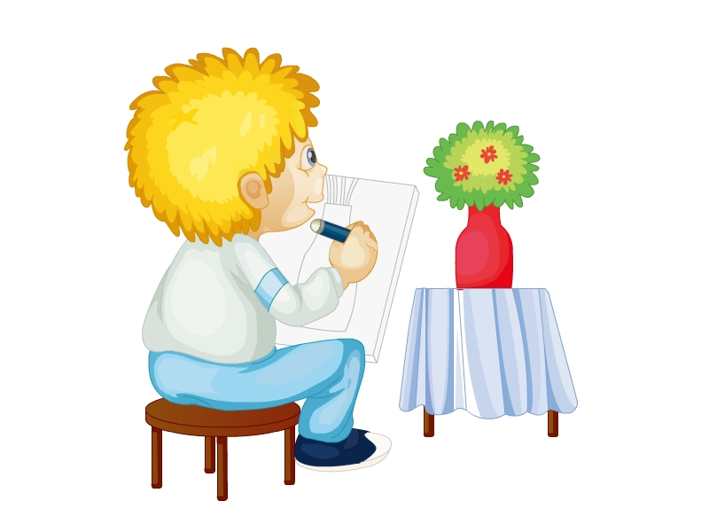 ________
7. 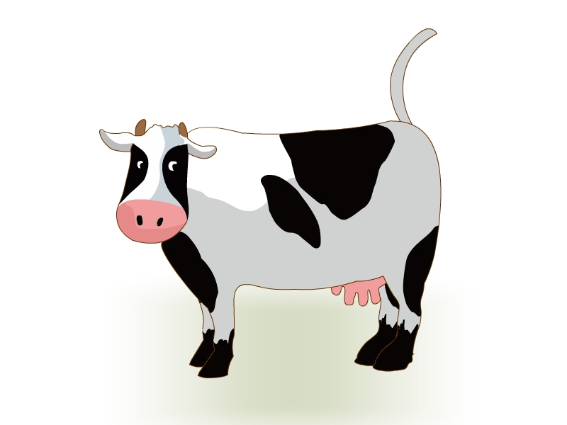 ________ 8. 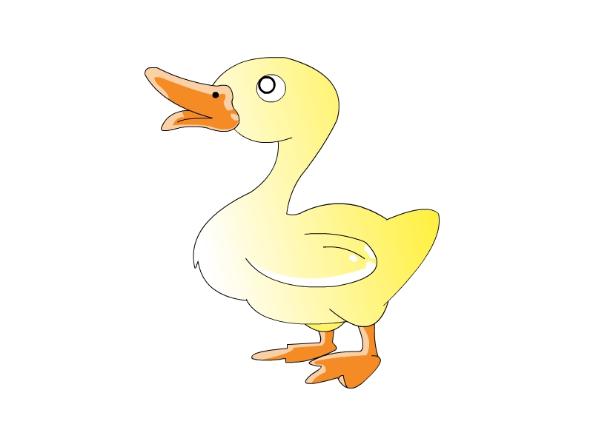 ________
9. 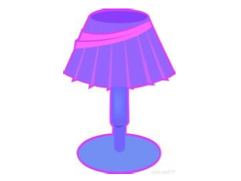 ________ 10. ________
三、选择填空。
( ) 1. —What do you see?
—I ________ a duck.
A. see B. like
( ) 2. —Who is your friend?
—It’s ________.
A. a panda B. in the zoo
( ) 3. —What’s this?
—________ is a lamp.
A. There B. It
( ) 4. —What can May do?
—________ can skip.
A. May B. I
( ) 5. —What’s in your room?
—There ________ two bags.
A. is B. are
( ) 6. —Don’t skip on the grass.
—________
A. Thank you. B. OK.
( ) 7. Look at the fish. It can ________.
A. swim B. fly
( ) 8. It’s hot today. ________ the window.
A. Close B. Open
( ) 9. I have a duck. It goes ________.
A. ‘quack, quack’ B. ‘cluck, cluck’
( ) 10. —Can you walk like a cat?
—Yes, I ________.
A. can’t B. can
四、选择正确的单词完成句子。
on hear at close is don’t can to please cat
(1) Look ________ the bear. It’s big and brown.
(2) ________ walk on the grass. 
(3) It’s cold. ________ the window, please. 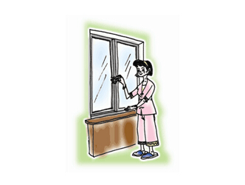
(4) Moo, moo. I ________ a cow.
(5) There ________ a sofa in my room. 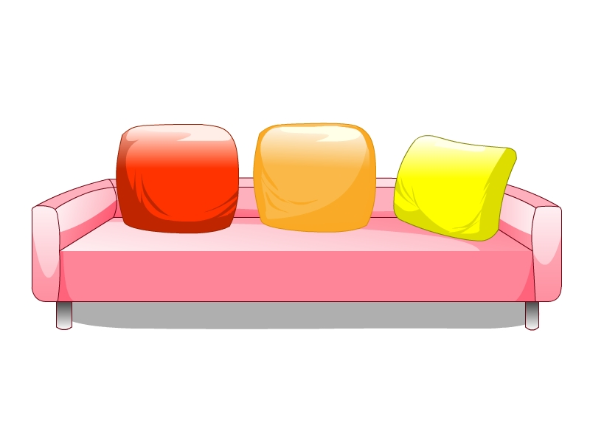
(6) Listen ________ the dog. 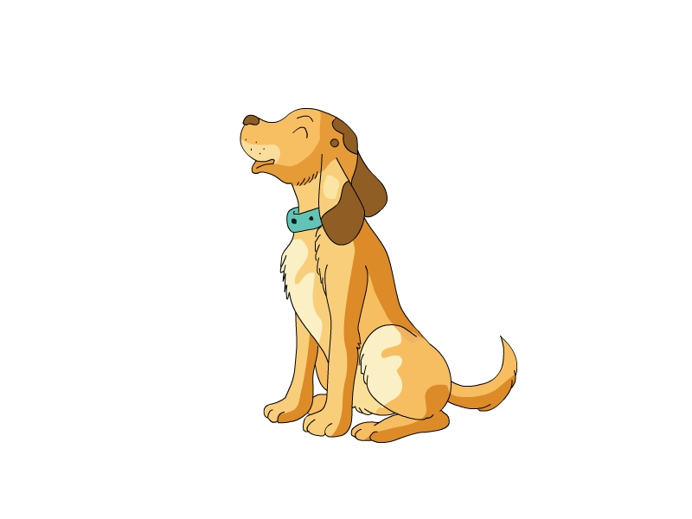
(7) Draw a chick on the paper, ________.
(8) A monkey ________ swing.
(9) The lamp is ________ the table. 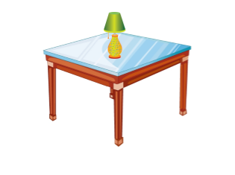
(10) There is a ________ under the table. 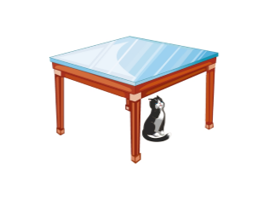
五、根据中文意思，选择正确的句子。
( ) 1. 在草地上走，你应该说：
A. Walk on the grass. B. Don’t walk on the grass.
( ) 2. 告诉同学你有一把伞，你应该说：
A. I have a quilt. B. I have an umbrella.
( ) 3. 告诉妈妈你会跳绳，该怎么说？
A. I can skip. B. I can swing.
( ) 4. 叫Spotty回来，你应该说：
A. Spotty! Come back. B. Spotty! Go there.
( ) 5. 天很热，妈妈要开门，该怎么说？
A. Mum, open the door. B. Open the door.
参考答案
听力部分
听力材料
一、
1. table 2. sweet 3. panda 4. lamp 5. chick 6. quilt 7. nose 8. walk
二、
1. ground 2. stop 3. please 4. bear 5. four big eggs 6. go back
7. under the table 8. run like a dog 9. in the park 10. clean the window
三、
1. Draw a sheep on the paper.
2. Look at the elephant. It’s big and fat.
3. There are two bags on the bed.
4. Don’t skip on the grass.
5. I’ve got a monkey. It’s thin and brown.
6. I have a pig. It goes ‘oink, oink’.
7. Close the door, please.
8. I can swing like a monkey.
9. This is an umbrella. It’s big.
10. —What can you do?
—I can jump, but I can’t skip.
四、
1. Baa, baa. What do you hear?
2. Don’t fly a kite.
3. Spotty, what can you do?
4. What is this?
5. There is a duck. How does it go?
6. It’s cold today.
五、
I’ve got a friend. It’s in my room. It’s under the bed. It has two small ears and two big eyes. It can run and jump. It can’t fly and sing. Who is my friend? It’s a toy dog.
听力答案
一、
2-4-1-3-5-8-6-7
二、
1-10 AACCA BBACA
三、
1-10 √√××√ √×√√×
四、
1-6 BAAABB
五、
room; under; bed; ears; eyes; run; jump; fly; sing; dog
笔试部分
一、
1. ly 2. u; a 3. a; le 4. ui 5. o 6. en 7. or 8. e; ci 9. i; b 10. u; e
二、
1. bear 2. pencil 3. door 4. run 5. nose 6. draw 7. cow 8. duck
9. lamp 10. skip
三、
1-10 AABAB BABAB
四、
(1)-(10) at; Don’t; Close; hear; is; to; please; can; on; cat
五、
1-5 ABAAB

