期中测试卷B
一、判断每组单词画线部分的读音是(√)否(×)相同。
1. idea eat ( ) 2. why your ( )
3. picnic kite ( ) 4. Monday tomorrow ( )
5. take dance ( ) 6. week see ( )
7. help Wednesday ( ) 8. tall small ( )
9. house mouse ( ) 10. London open ( )
二、翻译下列短语。
1. River Thames __________ 2. Big Ben __________
3. London Eye __________ 4. On Saturday __________
5. Little Six __________ 6. twenty-nine __________
7. a bit shy __________ 8. Tower Bridge __________
9. a good idea __________ 10. have a birthday party __________
三、找出所给词的同类词。
( ) 1. peach A. yesterday B. orange C. station
( ) 2. Tuesday A. Saturday B. countryside C. different
( ) 3. helpful A. quiet B. newspaper C. always
( ) 4. twenty A. pink B. tomorrow C. hundred
( ) 5. farmer A. policeman B. long C. river
( ) 6. grandparent A. banana B. father C. clock
( ) 7. sleep A. apple B. take C. pen
( ) 8. Chinese A. Science B. Hong Kong C. England
( ) 9. tiger A. pick B. park C. lion
( ) 10. Big Ben A. London Eye B. supermarket C. zoo
四、单项选择。
( ) 1. Look at the London Eye. It’s a big ________.
A. eye B. clock C. wheel
( ) 2. Xiaoyong is free on Sunday. He wants to visit ________ grandpa.
A. he B. him C. his
( ) 3. This little girl can’t do her Maths. I’m going to ________ her.
A. help B. take C. pick
( ) 4. Daming is a good boy. He isn’t ________ in class.
A. wide B. naughty C. high
( ) 5.—Hello! What day is today?
—It’s ________.
A. Wednesday B. Chinese C. Hong Kong
( ) 6.—What’s sixty plus thirty?
—It’s ________.
A. seventy B. eighty C. ninety
( ) 7. Look at this fruit farm. Let’s ________ there!
A. feed the ducks B. pick pears C. go swimming
( ) 8. Lingling likes this film very much. She’ll go to ________ it tomorrow.
A. see B. watch C. look
( ) 9. Amy is a good girl. She’s quiet good ________ English.
A. in B. with C. at
( ) 10.—How many ________ are there in the pocket?
—There are fifteen.
A. peach B. peaches C. two peaches
五、完成句子。
1. My parents were very __________ (年轻的) then. Now they are old.
2. I’m very good at English. I’m going to __________ (帮助) Fangfang.
3. Amy’s very __________ (友善的). She’s a good girl.
4. Tomorrow is __________ (星期一), we’ll go to the zoo.
5. —Hello! Amy, will you phone me this weekend?
—No, I __________ (不会).
6. What’s sixty plus __________ (30)? It’s ninety.
7. The river is very wide. And it’s __________ (很长).
8. What are you going to do? I’m going to __________ (去游泳).
9. This weekend, we’ll __________ (摘水果).
10. There are fourteen __________ (桃子) on these trees!
六、连词成句。
1. shy, but, she’s, a bit, (.)
___________________________________________________________________
2. cats, I, see, lots of, will, (.)
___________________________________________________________________
3. we, pears, will, pick, (?)
___________________________________________________________________
4. vegetables, are, the, where, (?)
___________________________________________________________________
5. forty, what’s, plus, sixty, (?)
___________________________________________________________________
七、连线。
(1) On Saturday, we’re going to have a picnic. A. 
(2) The cat was on the first floor. B. 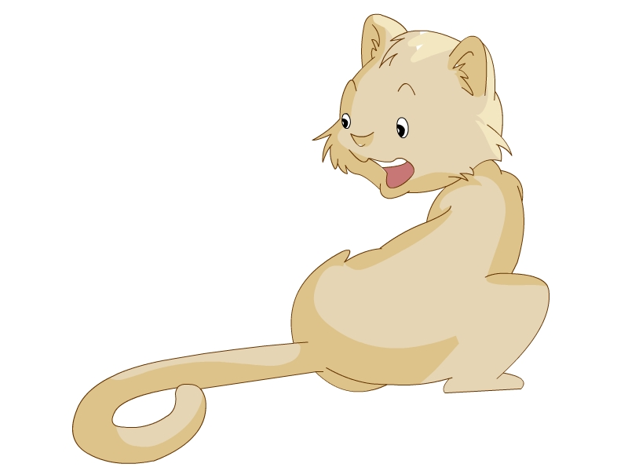
(3) The River Thames is wide and long. C. 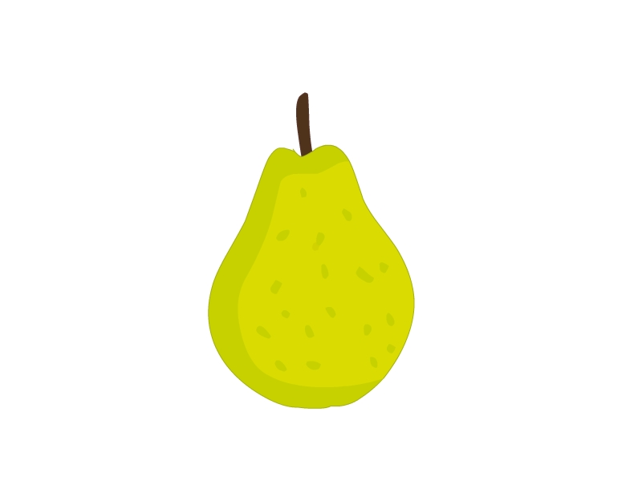
(4) This weekend, we’ll see lions and tigers. D. 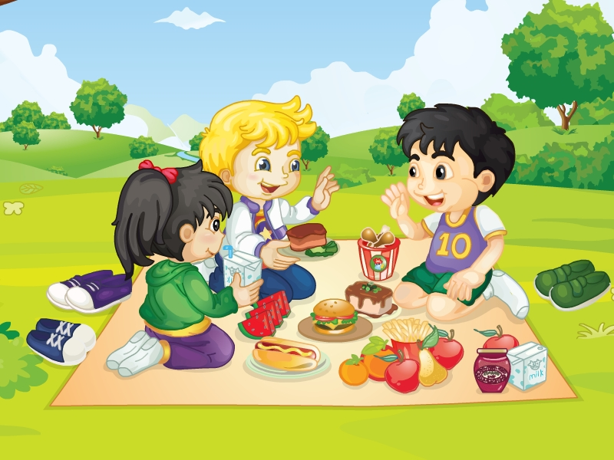
(5) There are sixteen pears on the tree. E. 
八、仿写句子。
(1) Xiaoyong is very clever. But he’s a bit shy.
Meimei is very __________. But she’s __________.
(2) A: What will you do this weekend?
B: Maybe I’ll go to the zoo.
A: What will you __________?
B: Maybe I’ll __________.
(3) A: What’s thirty plus twenty?
B: It’s fifty.
A: What’s __________?
B: It’s __________.
(4) A: Will we pick oranges?
B: No, we won’t.
A: Will we __________?
B: No, __________.
(5) A: How many boys are there?
B: There are twenty boys.
A: How many __________?
B: There are __________.
九、排序。
( ) What will you see?
( ) Great! And you will love London.
( ) Hi, Fangfang. I’ll visit Beijing in the Summer Holiday. Where will you visit?
( ) I will see Tower Bridge. It can open.
( ) I will visit London.
十、连线。
(1) What will you do tomorrow? A. No, we won’t.
(2) How many children are there in your class? B. It’s twenty-one.
(3) What will we pick? C. I’ll read books.
(4) Will you pick oranges? D. We’ll pick oranges.
(5) What’s ten plus eleven? E. There are thirty children.
十一、选词填空。
A
new old wide long tall big
Amy is from London. Here is a photo of London. This is River Thames. It’s (1) __________ and (2) __________. This is the Big Ben. It is a very (3) __________ clock. It’s very (4) __________. And this is a (5) __________ wheel. It’s (6) __________ and round. Amy likes London very much!
B
Writer policeman film star (影星) football (球星)
Daming, Amy, Sam and Lingling are talking about their future. Daming likes football, maybe he’ll be a (1) __________. Amy likes film very much, she’ll be a (2) __________. Sam wants to help people, he’ll be a (3) __________. Lingling likes reading books, she’ll be a (4) __________.
十二、阅读理解。
A. 阅读小短文，选择正确的选项。
It’s Parents’ Day today. Lucy’s dad and mum are going to speak to her teacher.
Now Lucy’s parents are talking to Ms. Smart. Ms. Smart says, “Lucy is a good and clever girl. She works hard. She isn’t lazy. She is good at English.”
Lucy’s father and mother are happy with Lucy’s work.
( ) (1) Today is ________.
A. Teacher’s Day B. Children’s Day C. Parents’ Day
( ) (2) What’s Lucy like? She’s ________.
A. a good and clever girl B. a naughty and clever girl
C. a quiet and clever girl
( ) (3) Is Lucy lazy? ________
A. Yes, she is. B. No, she isn’t. C. I don’t know
( ) (4) Lucy is good at ________.
A. Chinese B. PE C. English
( ) (5) Who is happy with Lucy’s work? ________.
A. Daming B. Lucy’s parents C. my teacher
B. 阅读短文，判断对(√)错(×)。
Dear Sam,
In the holiday, I’m going to go to the countryside. I’ll visit my grandpa. I’ll see pigs and giraffes. They are fruit trees in the countryside. I’ll pick apples, bananas and pears with my grandpa. I like fruit. Peaches are my favourite fruit. I’ll be happy.
From,
Daming
(1) Daming will go to the zoo. ( )
(2) Daming is going to visit his grandpa. ( )
(3) There are cows and pigs in the countryside. ( )
(4) Daming will pick pears. ( )
(5) The letter is from Sam. ( )

参考答案
一、
1-5 ××××× 6-10 √√√√×
二、
1. 泰晤士河 2. 大本钟 3. 伦敦眼 4. 在周六 5. 小六
6. 29 7. 一点害羞 8. 搭桥 9. 好主意 10. 生日聚会
三、
1-5 BAACA 6-10 BBACA
四、
1-5 CCABA 6-10 CBACB
五、
1. young 2. help 3. nice 4. Monday 5. won’t
6. thirty 7. very long 8. go swimming 9. pick fruit 10. peaches
六、
1. But she is a bit shy.
2. I’ll see lots of cats.
3. Will we pick pears?
4. Where are the vegetables?
5. What’s forty plus sixty?
七、
(1)-(5) DBAEC
八、
略
九、
35142
十、
(1)-(5) CEDAB
十一、
A
(1) long (2) wide (3) old (4) tall (5) big (6) new
B
(1) footballer (2) film star (3) policeman (4) writer
十二、
A
(1)-(5) CABCB
B
(1)-(5) ×√×√×

