人教PEP小学三年级下册期中测试卷
听力部分
一、Listen and choose.听录音，选出你听到的单词。
( ) 1. A. fat B. cat ( ) 2. A. dad B. bad
( ) 3. A. hen B. ten ( ) 4. A. big B. pig
( ) 5. A. red B. bed ( ) 6. A. fish B. milk
二、Listen and tick.听录音，选出与录音内容相符合的图。
( ) 1. A. 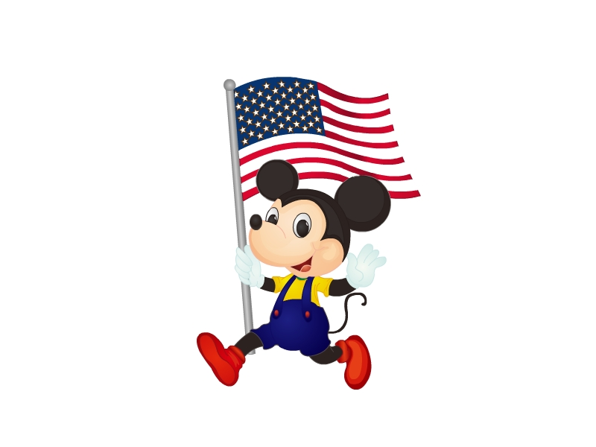 B. 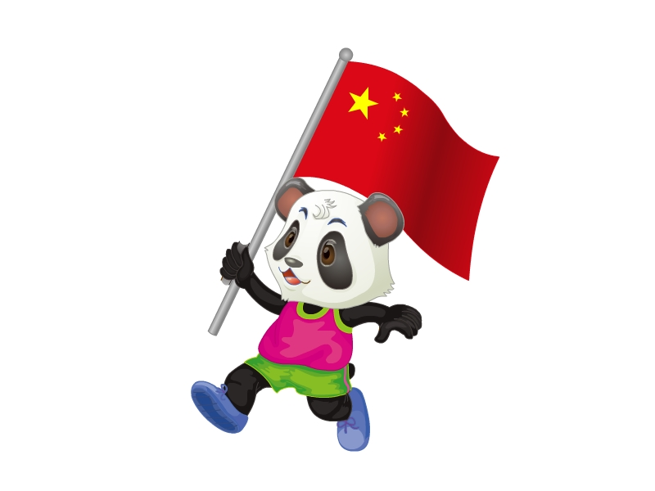
( ) 2. A. 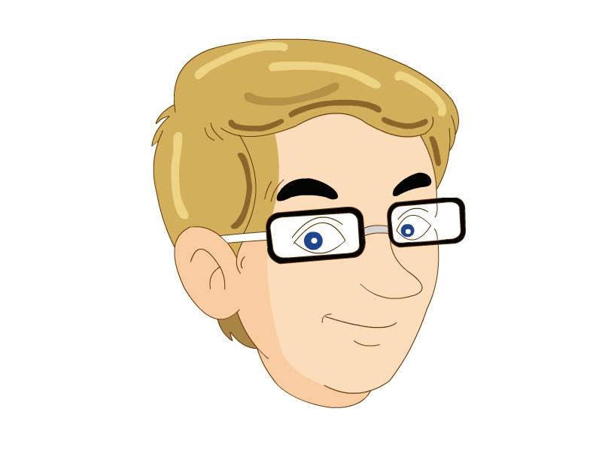 B. 
( ) 3. A. 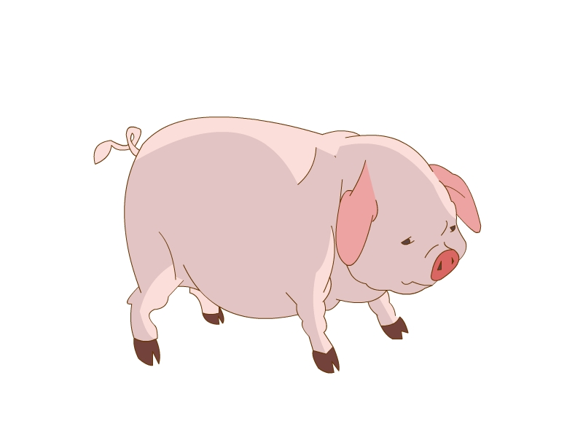 B. 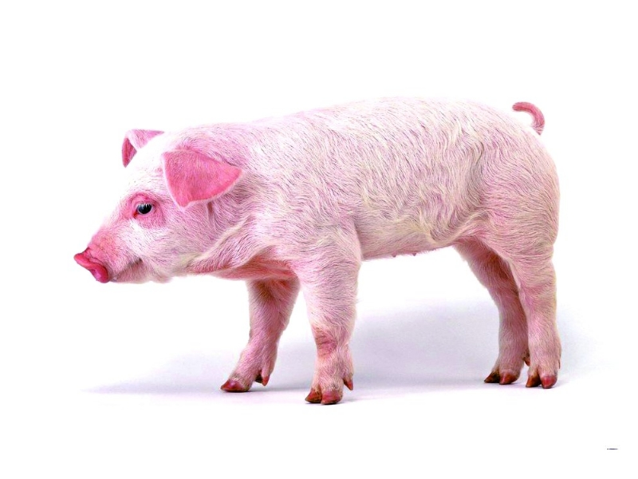
( ) 4. A. 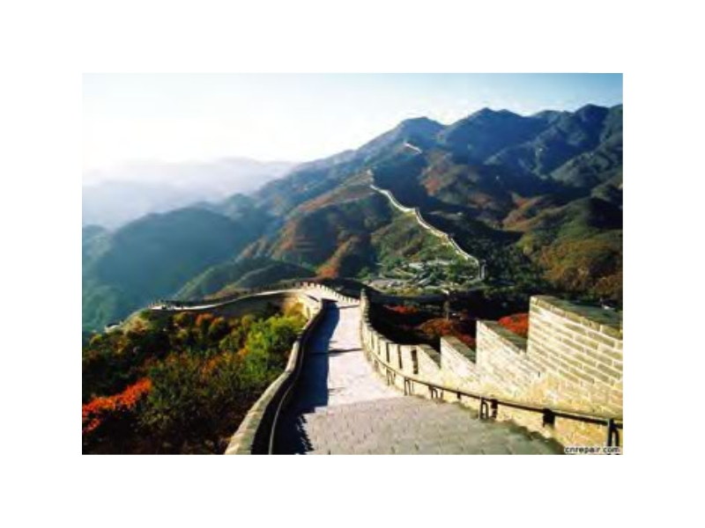 B. 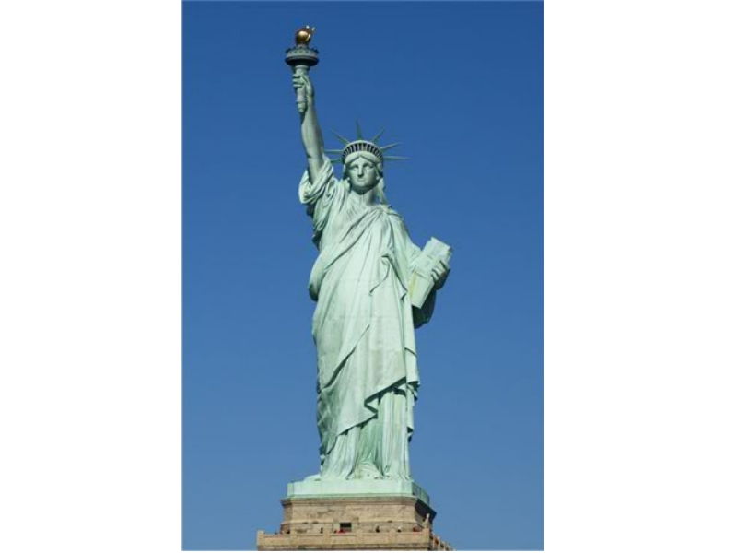
三、Listen, tick(√)or cross(×).Zhang Peng 到Amy的家里做客，看到了她的全家福，请你仔细听他们的对话，然后判断下列句子的正误。
( ) 1. My father is short.
( ) 2. My mother is thin.
( ) 3. My brother is tall.
( ) 4. My cat is fat.
四、Listen and match.班上新来了几位同学，听一听他们是从哪里来的，将人名与国家对应的标志物连线。
(1) Ben A. 
(2) Mike B. 
(3) Ming Ming C. 
(4) John D. 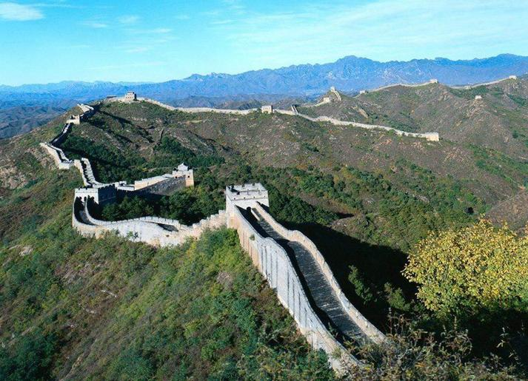
笔试部分
一、Read and match.下面是John的family，请你看一看，并连线。
(1) A. mother
(2) 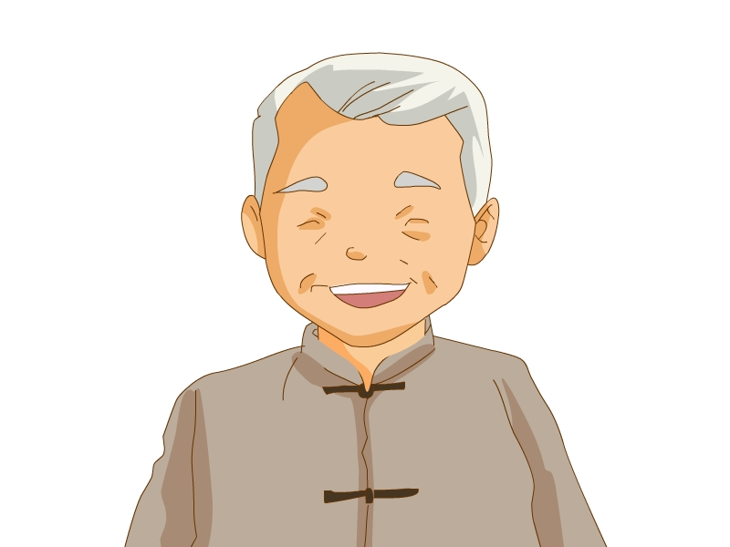 B. sister
(3) 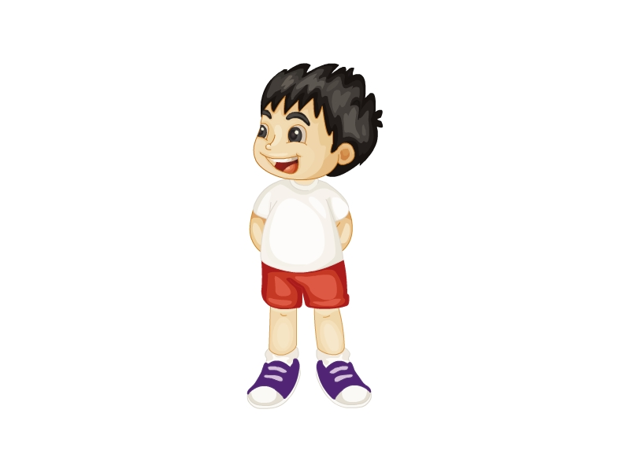 C. brother
(4) 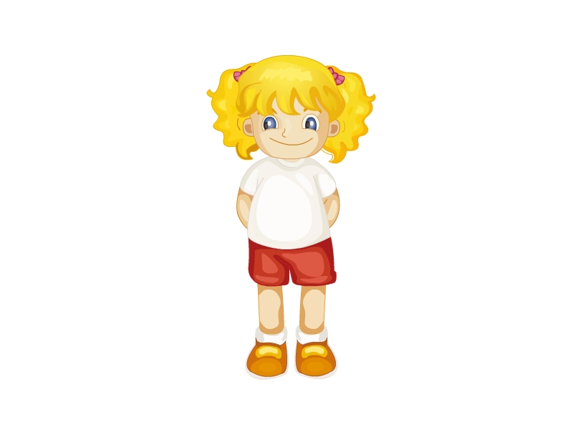 D. grandmother
(5) 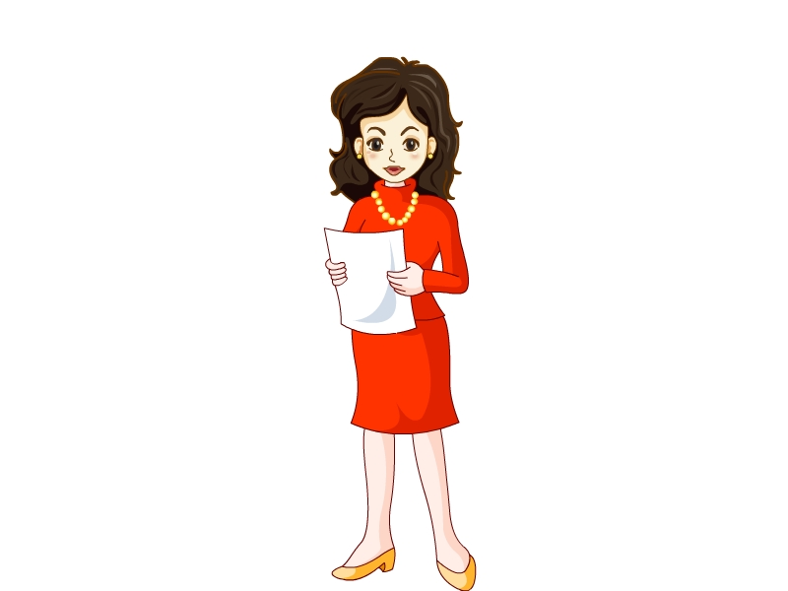 E. father
(6)  F. grandfather
二、Read and match.读一读，将下面的图与句子连线。
(1) Hello. I’m Line Ling. I’m from China. A.
(2) This is my grandfather. B. 
(3) This is Miss White. She’s my teacher. C.
(4) My name’s Arthur. I’m from Australia. D. 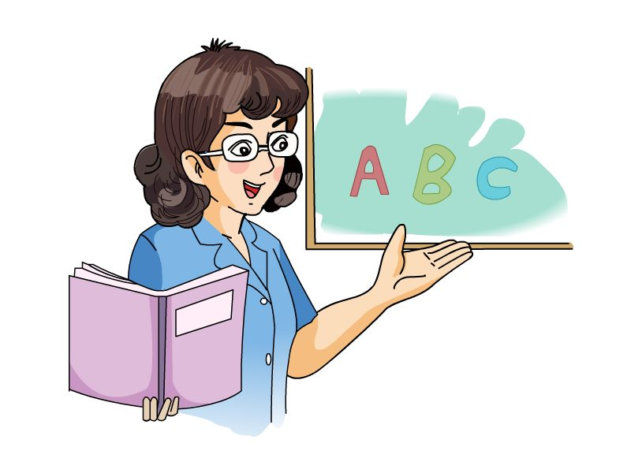
三、Read and write.请读下面的图，将单词缺少的字母填上。
1. p_n 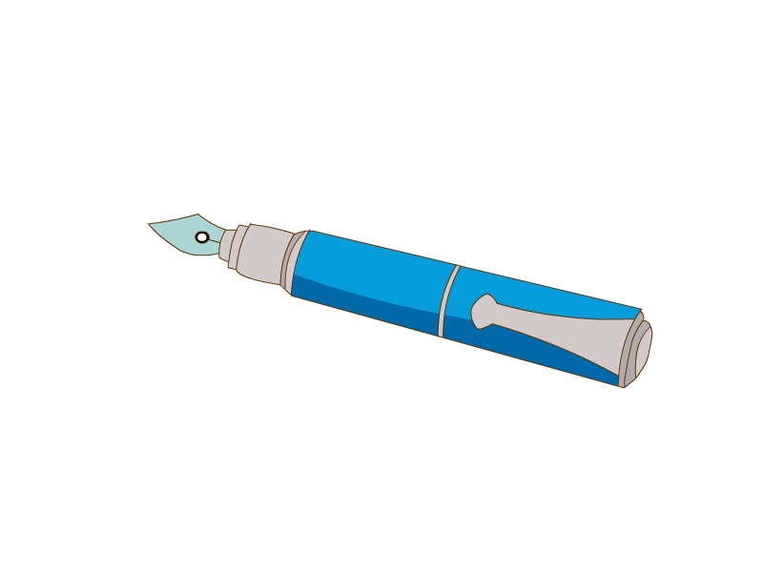 2. le_ 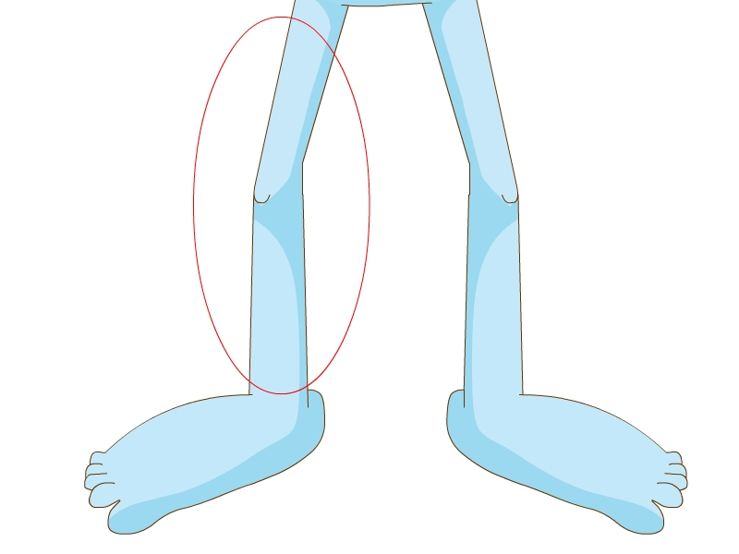
3. _at 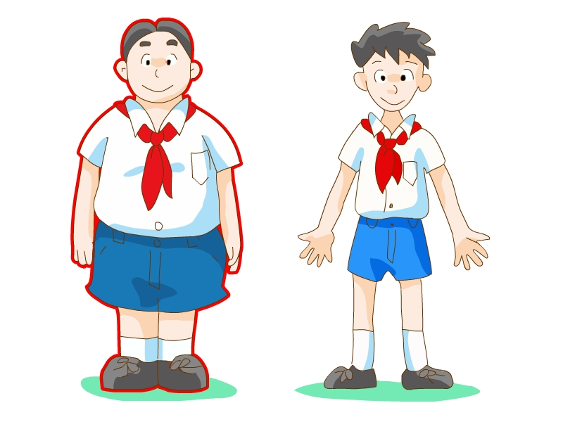 4. p_g
5. _ix 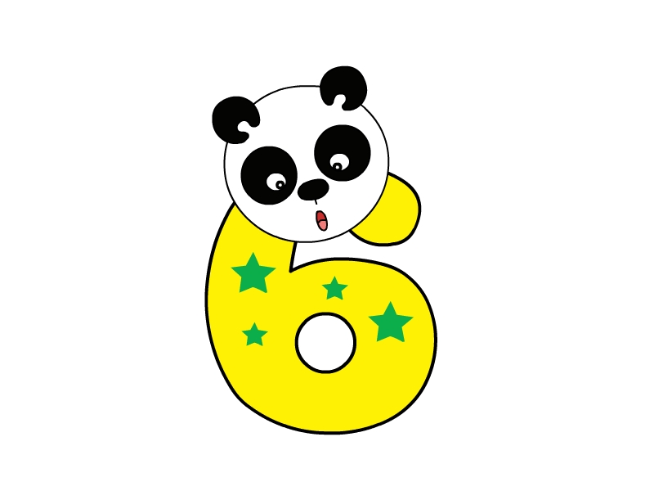 6. b_g 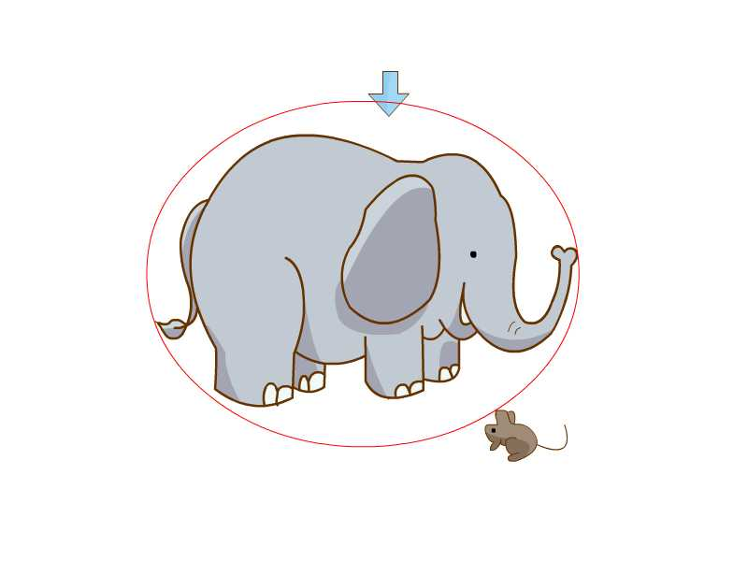
四、Read and tick.连线。
(1) woman A. 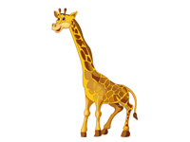
(2) girl B.
(3) boy C.
(4) giraffe D. 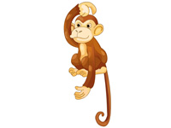
(5) monkey E.
五、Read and match.同学们正在公园里看动物，请读一读他们说的话，然后将这些句子与相应的动物连线。
(1) It has a long neck. It’s tall. A.
(2) It has a long tail and big eyes. It’s thin. B. 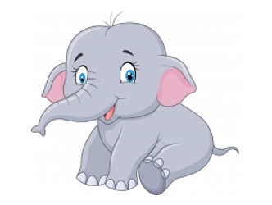
(3) It has a big body and a long nose. C. 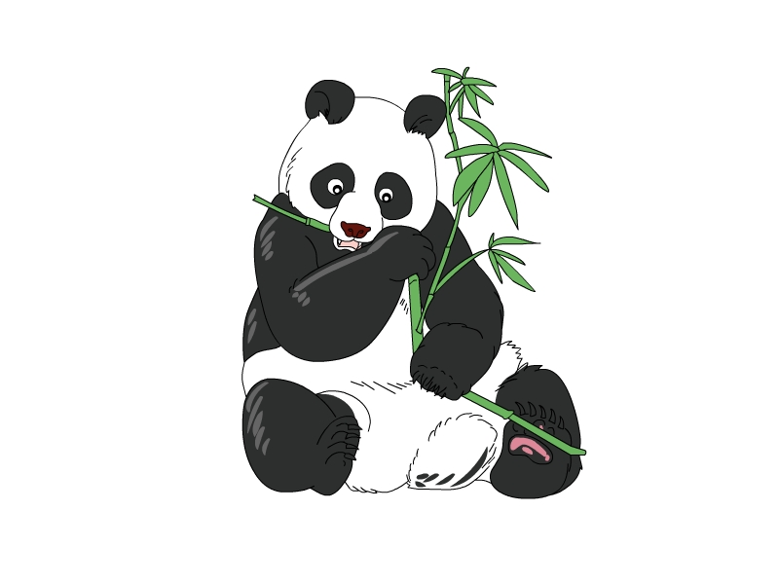
(4) It’s big. It has a short tail. D.
It’s black and white.
六、Read and choose.读下面的图，然后从所给的选项中选出问题的正确答案。
( ) 1. Where are you from?
A. I’m from Canada. B. I’m from the USA.
( ) 2. Who’s that boy?
A. He’s my friend, John. B. She’s my friend, Amy.
( ) 3. Is she your mother?
A. Yes, he is. B. No, she isn’t. She’s my teacher.
( ) 4. Who’s that woman?
A. She’s my little sister. B. She’s my mother.
七、Read and circle.请你读一读下面的情景，然后从所给的选项中选出正确的答案。
( ) 1. 开学了，班里来了一位新同学，你想知道她是从哪里来的，该如何问？
A. What’s your name? B. Where are you from?
( ) 2. 你到同学家里玩，看到有一个中年男子正在她家的花园里修剪草坪，你想知道那个男人是不是她爸爸，该如何问？
A. Is he your father? B. Who’s that man?
( ) 3. 你的朋友Wu Yifan 到你家里来玩，你要把他介绍给爸爸，你会怎样说？
A. Dad, who’s that boy? B. Dad, this is my friend, Wu Yifan.
( ) 4. 你在动物园里看到了一只大象，你觉得它好大啊，你会怎么说？
A. Look at the elephant. It’s so big.
B. Look at the elephant. It has a long nose.

参考答案
听力部分
听力材料
一、
1. cat 2. dad 3. ten 4. big 5. red 6. milk
二、
Where are you from? I’m from China.
Who’s that man? He’s my father.
Look at the pig. It’s so fat.
Hello, I’m May. I’m from the USA.
三、
Zhang Peng: Is this your family photo?
Amy: Yes, it is.
Zhang Peng: Who’s that man? Is he your father?
Amy: Yes, he is.
Zhang Peng: Oh, your father is tall.
Zhang Peng: Look at the woman. She’s thin. Is she your mother?
Amy: Yes, she is.
Zhang Peng: Who’s that boy?
Amy: He’s my brother. He’s short.
Zhang Peng: Look at your cat. It’s so fat.
Amy: Yes, it is.
四、
Miss White: Hi, boys and girls! We have some new friends today.
Ben: Hello, I’m Ben. I’m from the UK.
John: Hi! I’m John. I’m from the USA.
Ming Ming: Hello! I’m Ming Ming. I’m from China.
Mike: Hi! I’m Mike. I’m from Canada.
听力答案
一、
1-6 BABAAB
二、
1-4 BAAB
三、
1-4 ×√×√
四、
(1)-(4) ACDB
笔试部分
一、
(1)-(6) EFCBAD
二、
(1)-(4) CADB
三、
1. pen 2. leg 3. fat 4. pig 5. six 6. big
四、
(1)-(5) ECBAD
五、
(1)-(4) DABC
六、
1-4 AABB
七、
1-4 BABA

