期中测试卷
听力部分
一、听录音，为下列图片排序。
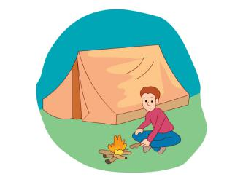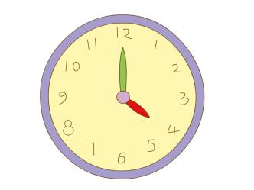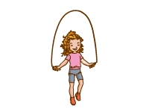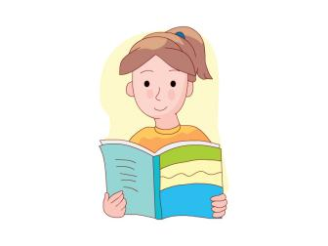
( ) ( ) ( ) ( ) ( )
二、听录音，判断下列译文是否正确，用“√”或“×”表示。
( ) 1. 汤姆在美术教室里。
( ) 2. 我们的教室在一楼。
( ) 3. 你会写电子邮件吗？
( ) 4. 我想去上学。
( ) 5. 学校真无聊。
三、听录音，选出你所听到的句子。
( ) 1. A. It is fun. B. This is fun.
( ) 2. A. I listen to beautiful songs. B. I am listening to beautiful songs.
( ) 3. A. We do activities. B. We can observe things.
( ) 4. A. I have English and music. B. I have bread and milk.
( ) 5. A. It’s in the lake. B. It’s on the plate.
四、听录音，根据问句选答句。
( ) 1. A. Mr Lee. B. Green.
( ) 2. A. Yes, I do. B. No, I can’t.
( ) 3. A. I can play chess. B. Yes, I can play chess.
( ) 4. A. He is in the computer room. B. It is on the second floor.
( ) 5. A. We are going to play sports. B. They are going to sing songs.
笔试部分
一、根据图片把下列字母排列成正确的单词。
1. 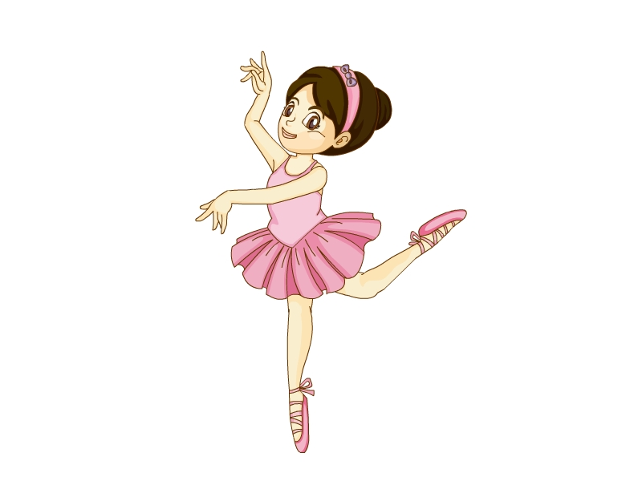 d, n, c, a, e ________
2. 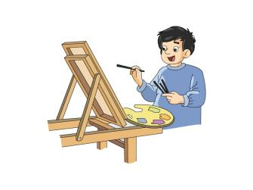 w, d, a, r ________
3. 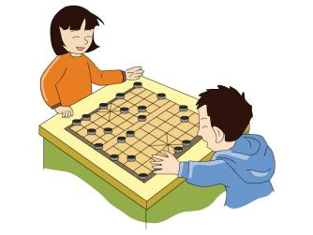 s, s, c, e, h ________
4. 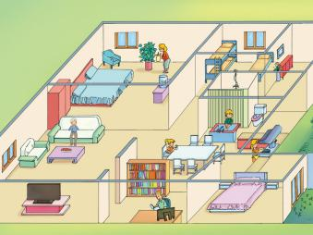 m, o, h, e ________
5.  b, l, l, o, o, a, t, f ________
二、判断下列每组单词划线部分读音是否相同,用“√”或“×”表示。
( ) 1. A. room B. classroom
( ) 2. A. hope B. hot
( ) 3. A. name B. late
( ) 4. A. where B. here
( ) 5. A. my B. family
( ) 6. A. we B. he
( ) 7. A. class B. cane
( ) 8. A. now B. know
( ) 9. A. go B. to
( ) 10. A. play B. day
三、为下列图片选择合适的句子。
( ) (1) 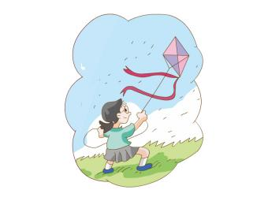 A. I don’t like snakes.
( ) (2) B. Can you fly kites with me?
( ) (3) 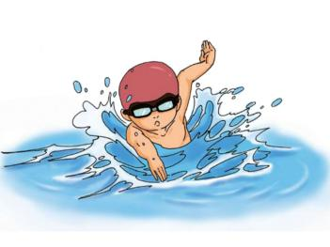 C. I can write an email.
( ) (4) 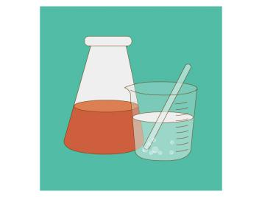 D. We’re going to swim on Friday.
( ) (5)  E. My favorite subject is science.
四、连词成句。
1. I, room, in, teachers’, am, your, (.)
____________________________________________________________________
2. out, he, the, of, runs, door, (.)
____________________________________________________________________
3. red, he, at, water, looks, some, (.)
____________________________________________________________________
4. is, my, not, school, boring, (.)
____________________________________________________________________
5. sees, he, himself, the, in, book, (.)
____________________________________________________________________
五、将下列句子译成中文。
1. He doesn’t like maths.
____________________________________________________________________
2. My brother is in the music room.
____________________________________________________________________
3. He can draw pictures with his feet.
____________________________________________________________________
4. The baby is washing her feet.
____________________________________________________________________
5. Sam helps Tim with his maths.
____________________________________________________________________
十、读一读，将下列句子补充完整。
My name is ________. I’m ________ years old. My favorite subject is ________. My favorite day is ________. My best friend is ________. I’m in grade ________. I'm going to ________ on Saturday. My classroom is on the ________ floor. We have ________ toilets at school. I ________ my school.
参考答案
听力部分
听力材料
一、
1. at a camp 2. jump rope 3. hold a flea market 4. read a book 5. four o’clock
二、
1. Tom is in the computer room.
2. Our classroom is on the first floor.
3. Can you write an email?
4. I want to go to the park.
5. School is boring.
三、
1. It is fun.
2. I am listening to beautiful songs.
3. We do activities.
4. I have bread and milk.
5. It’s in the lake.
四、
1. Who is your science teacher?
2. Can you dance?
3. What can you do?
4. Where is the computer room?
5. What are they going to do?
听力答案
一、
1-5 31524
二、
1-5 ×√√×√
三、
1-5 ABABA
四、
1-5 ABABB
笔试部分
一、
1. dance 2. draw 3. chess 4. home 5. football
二、
1-5 ××√××
6-10 √×××√
三、
(1)-(5) BADEC
四、
1. I am in your teachers’ room.
2. He runs out of the door.
3. He looks at some red water.
4. My school is not boring.
5. He sees himself in the book
五、
1. 他不喜欢数学。
2. 我的弟弟在音乐教室里。
3. 他能用脚作画。
4. 这个婴儿正在洗脚。
5. 萨姆帮助蒂姆学数学。
六、
略

