人教PEP小学三年级下册期中测试卷
听力部分
一、听录音，选出与你所听到的单词相符的图片。
( ) 1. A. 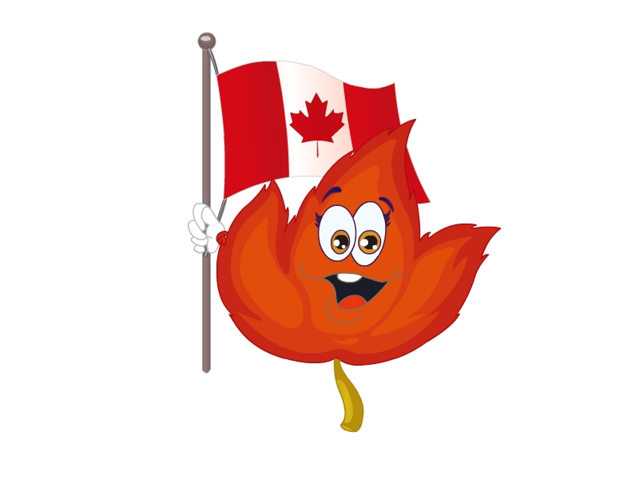 B. 
( ) 2. A.  B. 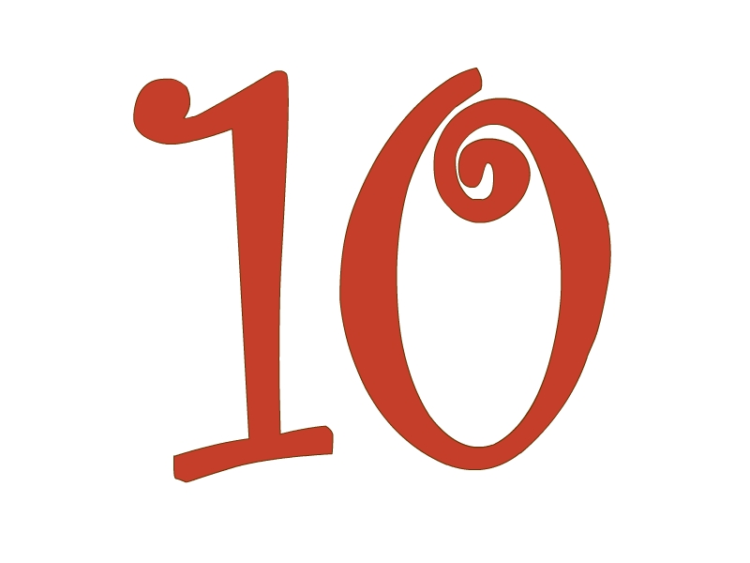
( ) 3. A. 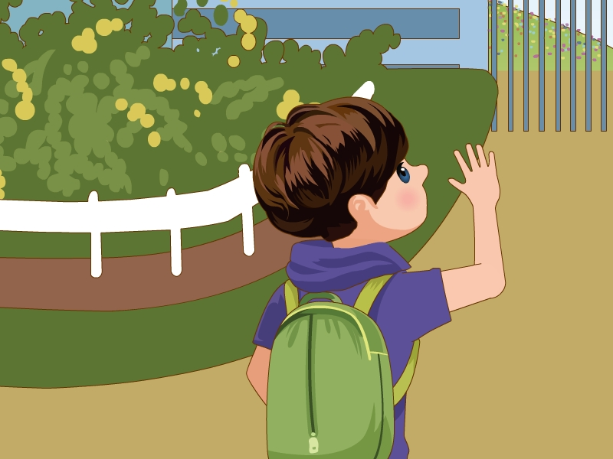 B. 
( ) 4. A. 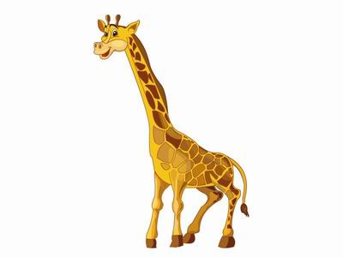 B. 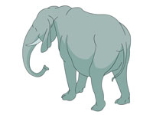
( ) 5. A. 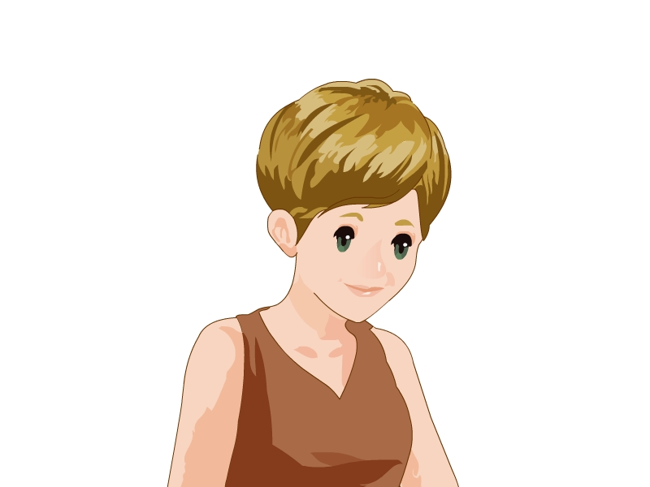 B. 
二、听录音，选出你所听到的内容。
( ) 1. I have a ________.
A. brother B. sister
( ) 2. Look at the ________.
A. elephant B. giraffe
( ) 3. That woman is my ________.
A. mother B. teacher
( ) 4. Wow! The giraffe is so ________.
A. thin B. tall
( ) 5. My pen is ________.
A. short B. long
三、听录音,给下列图片按A-E排序。
(1) 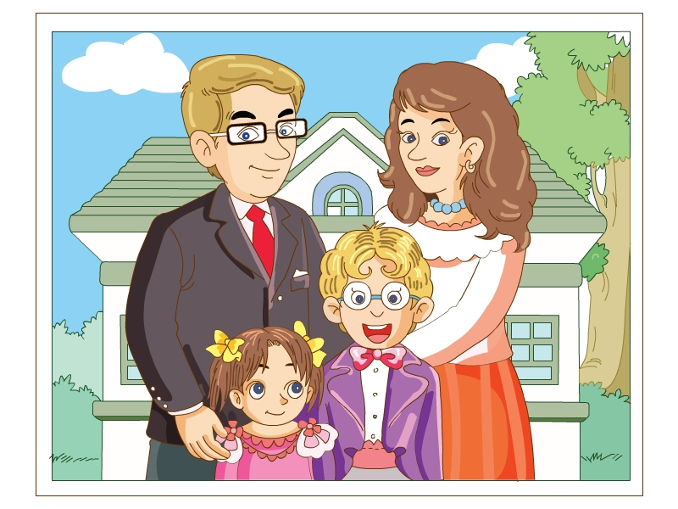 (2) 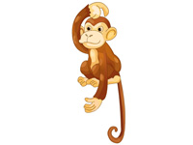 (3)
( ) ( ) ( )
(4)  (5) 
( ) ( )
笔试部分
一、看图，选单词。
A. father B. teacher C. giraffe D. girl
E. grandma F. China G. Canada H. boy
(1) 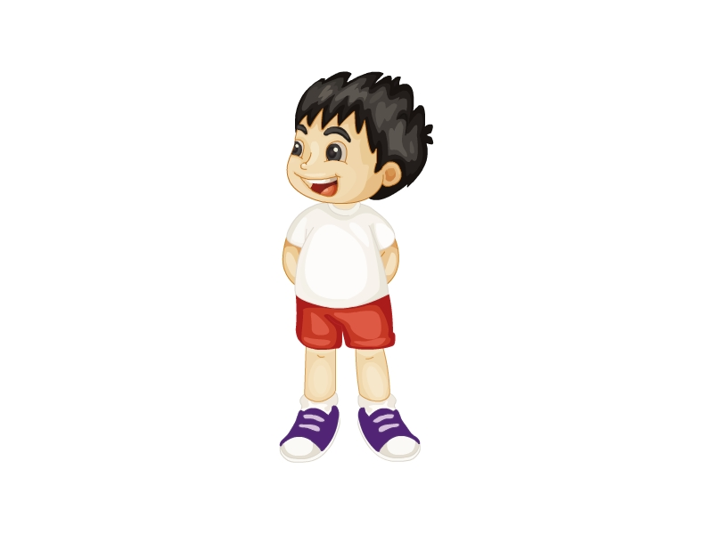 (2) (3)
( ) ( ) ( )
(4) 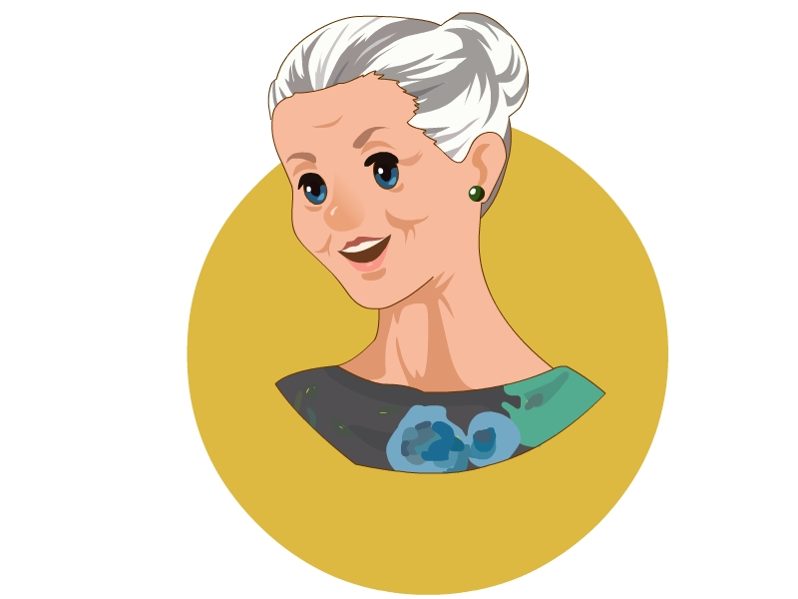 (5) (6) 
( ) ( ) ( )
(7) (8)
( ) ( )
二、选一选。
( ) 1. ---Where are you from?
---________
A. How are you? B. I’m from the UK. C. Thank you.
( ) 2. Don’t ________ the animals.
A. give B. has C. feed
( ) 3. ---Is he your father?
---________
A. Yes, I am. B. No, he isn’t. C. No, she is.
( ) 4. ---Do you like apples?
---________
A. No, I am not. B. Yes, I do. C. Yes, I am.
( ) 5. ---We have two new ________ today.
---Welcome!
A. friend B. a friend C. friends
三、为下列句子选择正确的答语。
(1) Look at the elephant. A. Yes, she is.
(2) Who’s that man? B. Wow! It’s so big.
(3) Nice to meet you. C. He’s my father.
(4) Is she your mother? D. Nice to meet you, too.
(5) Who’s that girl? E. She’s my sister.
四、判断下列句子与所给图片是(√)否(×)相符。
1. Look at the girl. She is thin. 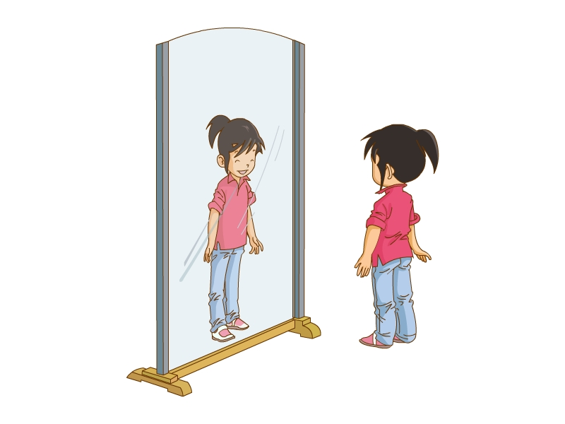 ( )
2. It has big eyes. 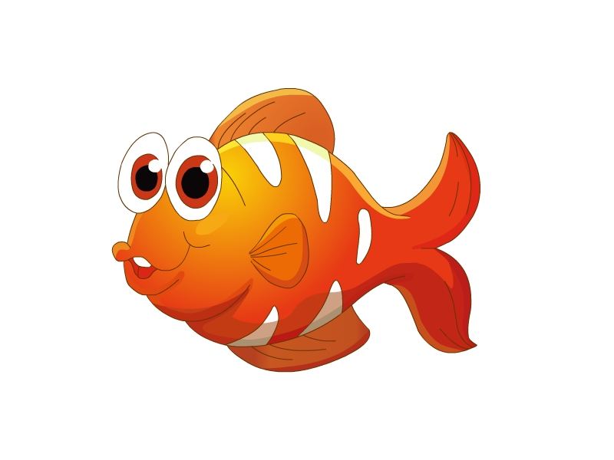 ( )

3. It is an elephant. It is tall. ( )

4. This is Xiaoming. He is fat. 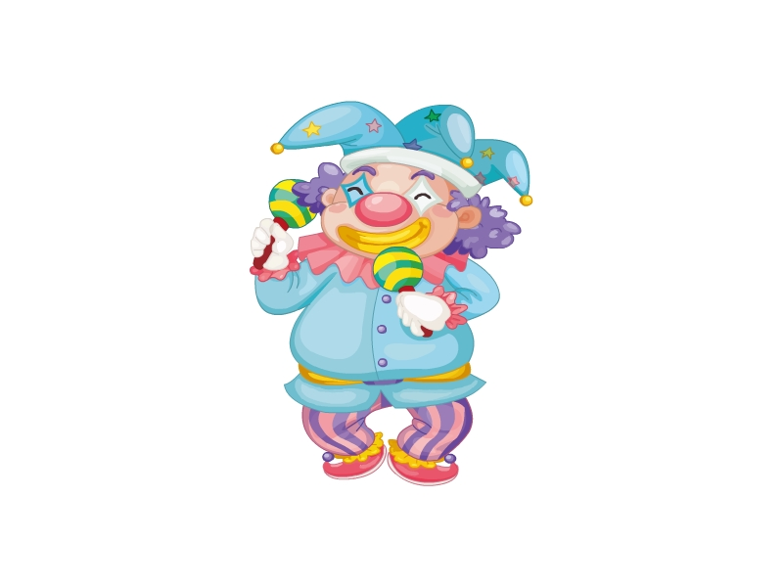 ( )

5. It has long ears. 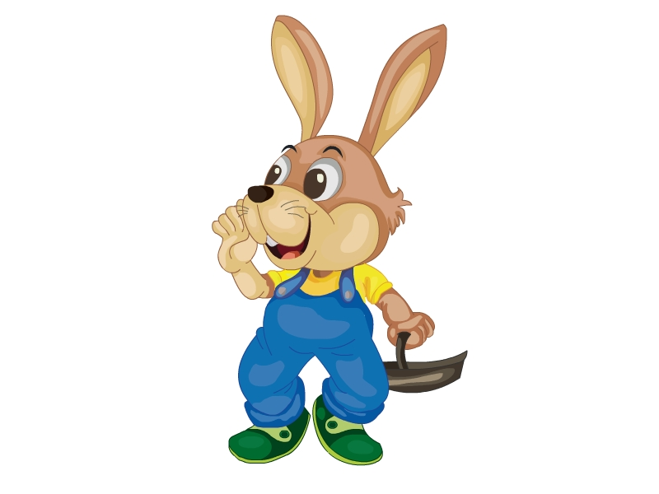 ( )
五、Zhang Peng和Jim正在谈论Jim的家庭照片，选择合适的选项补全对话。
A. Who’s that boy? B. He’s my father.
C. She’s my mother. D. She’s my sister.
Zhang Peng: Who’s that man?
Jim: (1) ________
Zhang Peng: (2) ________
Jim: He’s my brother.
Zhang Peng: Who’s that woman?
Jim: (3) ________
Zhang Peng: Who’s that girl?
Jim: (4) ________

参考答案
听力部分
听力材料
一、
1. Canada 2. ten 3. student 4. giraffe 5. dad
二、
1. I have a sister.
2. Look at the elephant.
3. That woman is my teacher.
4. Wow! The giraffe is so tall.
5. My pen is short.
三、
A. My mother is a teacher.
B. This is my family.
C. That girl is my sister.
D. The monkey has a long tail.
E. That boy is my brother.
听力答案
一、
1-5 ABAAB
二、
1-5 BABBA
三、
(1)-(5) BDAEC
笔试部分
一、
(1)-(5) HVAEC (6)-(8) FGD
二、
1-5 BCBBC
三、
(1)-(5) BCDAE
四、
1. √ 2. √ 3. × 4. √ 5. √
五、
(1)-(4) BACD

