译林小学英语三年级下册期中试卷
学校 班级 姓名 学号___________________
--------------------------------------密-----------------------------------------------封--------------------------------------------线------------------------------------------------
(时限：50分钟) 2018.4
听力部分（40分）
一、听录音，选出你所听到的内容，听两遍。 (10分)
( ) 1. A.on B. no C. in
( ) 2. A.run B.robot C.rubber
( ) 3. A.book B. box C. ball
( ) 4. A.here B.there C.three
( ) 5. A. black B.blackboard C. birthday
( ) 6. A. three B. tree C.there
( ) 7.A.Mr Green B.Miss Green C. Mrs Green
( ) 8. A. stand up B. sit down C. listen to
( ) 9. A. my crayon B. your crayon C. her crayon
( )10. A. Is this a skirt? B. Is that a skirt? C. Is it a skirt?
二、听录音，给下列图片排序，听两遍。（8分）
1. 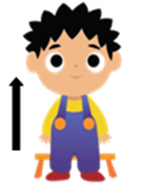 2. 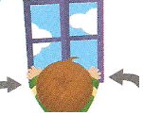 3.  4. 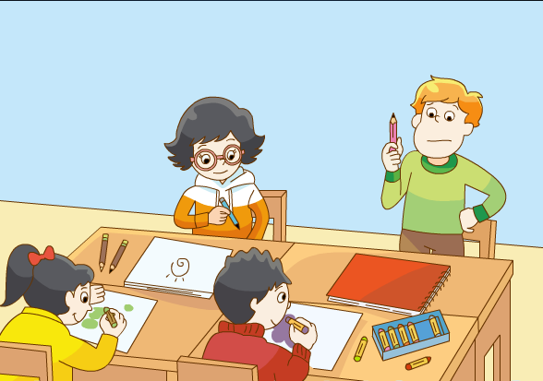
( ) ( ) ( ) ( )
5. 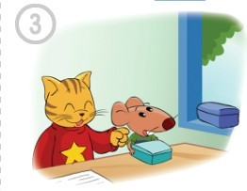 6. 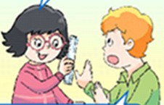 7. 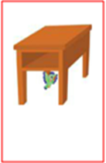 8. 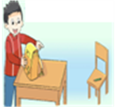
( ) ( ) ( ) ( )
三、听录音，判断所听内容与下列句子是否一致，用√或×表示, 听两遍。（6分）
( ) 1. Where is my robot ?
( ) 2. Would you like a sweet ?
( ) 3. That isn’t my dog.
( ) 4. Is that her schoolbag?
( ) 5. It’s just beside the door.
( ) 6. Don’t listen to the parrot.
四、根据所听句子，选择其对应的中文选项,听两遍,。（5分）
( ) 1. A. 这是什么？ B. 那是什么？
( ) 2. A. 不要在课上说话。 B. 不要在图书馆里说话。
( ) 3. A. 这不是我的新机器人。 B. 这是我的新机器人。
( ) 4. A. 这是你的T恤衫吗？ B. 那是我的T恤衫吗？
( )5. A. 这是一支蜡笔吗？ B. 那是一支蜡笔。
五、根据所听内容选择合适的应答句,听两遍。（6分）
( ) 1. | A.It’s a hot dog. | B. It’s on the box | C. It’s nice.
( ) 2. | A. No, thank you. | B. Yes, it is. | C. I’m sorry.
( ) 3. | A.It’s brown. | B. It’s a rubber. | C. It’s on the tree.
( ) 4. | A.He’s behind the door. | B. It’s in the tree. | C. She’s in the library.
( ) 5. | A. How beautiful! | B. Yes,please. | C. Yes,it is.
( ) 6. | A.Yes,it is. | B.Yes,please. | C. Thank you.
六、听录音，写单词，将句子补充完整,听三遍。 (5分)
1.A: _________ is my _______?
B: It’s ______ the ________.
2. Don’t drink my .
3. My ______ is not here. It’s on the ________.
4. A: ________ that your ________?
B:No, it ______.
笔试部分（60分）
一、判断下列划线部分读音是否相同，相同的写“T”，不同的写“F”。（6分）
( ) 1. doll blue ( ) 2. parrot grandpa ( ) 3. big robot
( ) 4. dog stand ( ) 5. green red ( ) 6. run father
二、选出与其他两项不同类的单词。（5分）
( ) 1. A. black B. red C. rubber
( ) 2. A.stand B. up C.down
( ) 3. A. beautiful B. nice C.here
( ) 4. A.run B.drink C. crayon
( ) 5. A. schoolbag B. lunch box C. pencil case
三、英汉互译。（10分）
1. 打开你们的书 your 6. beside my schoolbag
2. 那支漂亮铅笔 nice 7. come in
3. 在课桌下面 ____ the 8.fly away
4. 吃一个鸡蛋 egg 9. in the library
5.不要说话！ ________ _________! 10.over there
三、单项选择。（15分）
( ) 1. —Is this _______schoolbag? —Yes.
A. I B. you C. your
( ) 2. ___________ . Your cap is behind the door.
A . Look at B. look C. Look
( ) 3. —________ is your crayon? —It’s over there.
- Where’s B. Where C. What
( ) 4. – Is this your father? - ___________.
A. Yes, I am. B. Yes, it is. C. Yes, he is.
( ) 5. — What’s this? —It’s _______ English book.
A. a B. an C. /
( ) 6. — ______ Helen? — ______ behind the door.
A. Where's; She's B. Where's; He’s C. Where; She

( ) 7.-What is ______ over there? –It’s a rubber,
A . the B. that C. this
( ) 8. —______ that your cake? — No, ______.
A. Is; it is. B. Is;it isn’t. C. Are; they aren’t.
( ) 9.It’s very cold(冷的). Please don’t _______ the window.
A. open B. close C. look at
( ) 10. Yang Ling. Her skirt is very nice.
- Look B. look at C. Look at
( ) 11. 当你想告诉对方这不是对方的书时，你可以说：
- That isn’t your book. B. This isn’t my book. C. This isn’t your book.
( ) 12. 爸爸叫你不要关窗，他会对你说：
A. Close the window. B. Don’t close the window. C. OK.
( ) 13. 刘涛在图书馆里大喊大叫，我们应该这样提醒他：
A. Don’t drink. B. Don’t run. C. Don’t shout.
( ) 14. 你询问王兵远处的T恤衫是否是他的，可以说：
A. Is that your T-shirt? B. Is this your T-shirt? C. That is your T-shirt.
( ) 15. 你想把东西给对方，你可以说：
A. Here you are. B. Thank you. C. Hello.
四、情景匹配。（8分）
( ) 1. Don’t run. A. No, thank you.
( ) 2. Is that an ice cream? B. It’s on the floor.
( ) 3. Stand up,Liu Tao. C. How beautiful!
( ) 4. Look at my new skirt. D. Yes, it is.
( ) 5. Would you like a sweet? E. I’m sorry.
( ) 6. Where’s your CD? F. No, it isn’t. It’s under the table.
( ) 7. What’s this? G. Yes, Miss Li.
( ) 8.Is the dog on the table? H. It’s a lunch box.
五、连词成句，书写时注意首字母大写和标点符号。（5分）
1. jacket, where, my, is (?)
2. that, pencil case, your, is (?)
3. in , don’t , drink , class ( . )

4. at, the, blackboard, look ( .)

5.is, your, it, in, schoolbag ( ?)

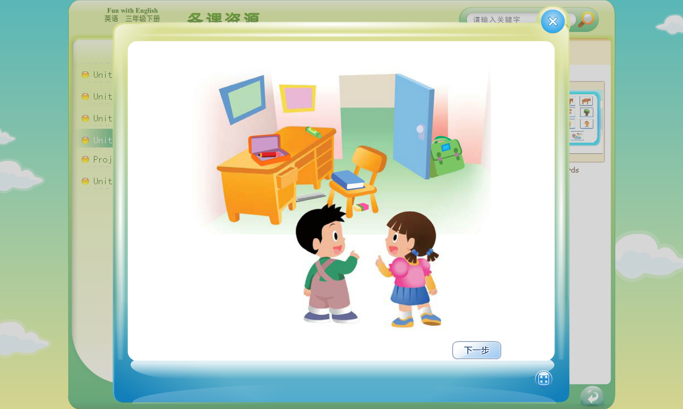
六、根据图片完成成对话, 注意大小写。（5分）
1. A: my schoolbag?
B: Is it the ?
A: , it is. Thank you.
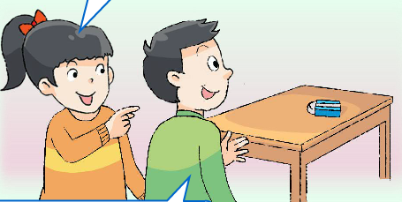
2. A: Wang Bing,What’s ________?
B: It’s a ________
A: Is________ your rubber?
B: _____,it is.
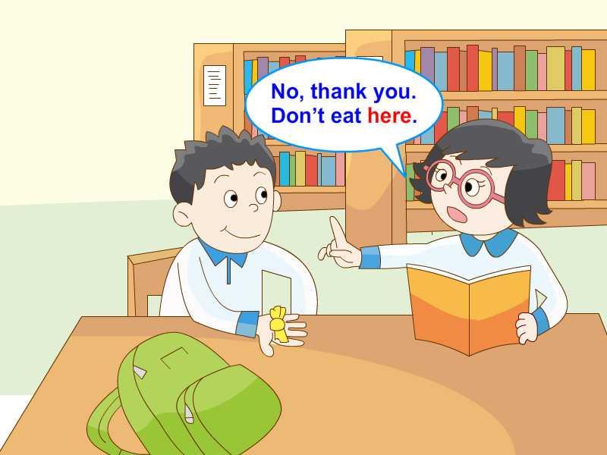
3. A: Would you like a sweet,Yang Ling ?
B: No,thank you . __________ here.
A: I’m sorry.

七、阅读理解，判断正误。正确的用“√”表示，错误的用“×”表示。（6分）
A:Good morning, Liu Tao.
B: Good morning,Mike.
A: What’s this?
B:It’s a black robot.
A:Is this your robot?
B:No,it isn’t. My robot is red. I think it’s Wang Bing’s.
A: Where’s Wang Bing?
B:He’s in the playground（操场）。
A: Let’s go and ask(问)。
B:Sure.
( ) 1. The robot is blue.
( ) 2. It’s Mike’s robot.
( ) 3. Wang Bing is in the classroom.
( ) 4. It is in the morning..
( ) 5. Liu Tao’s robot is red.
( ) 6. A is Mike.

译林小学英语三年级下册期中试卷听力部分
一、听录音，选出你所听到的内容，听两遍。 (10分)
1. A.on
2. C.rubber
3. A.book
4. C.three
5. B.blackboard
6. B. tree
7.A.Mr Green
8. C. listen to
9. B.your crayon
10. C. Is it a skirt?
二、听录音，给下列图片排序，听两遍。（8分）
- The bird is under the desk.
- Stand up,please.
- A:where’s your lunch box?
B: It’s over there.
- Please close the window.
- This isn’t my pencil.
- Don’t shout.
- A:Is this your ruler?
B:No,it isn’t.
8.This is my schoolbag. That is my pencil.
三、听录音，判断所听内容与下列句子是否一致，用√或×表示, 听两遍。（6分）
1. Where is your robot ?
2. Would you like a cake ?
3. That isn’t my dog.
4. Is that your schoolbag?
5. It’s just beside the door.
6. Don’t listen to Bobby.
四、根据所听句子，选择其对应的中文选项,听两遍,。（5分）
1. What’s that?
2. Don’t talk in the library,
3. This isn’t my new robot.
4. Is this your T-shirt?
5. That’s a crayon.
五、根据所听内容选择合适的应答句,听两遍。（6分）
1. | What’s that?
2. | Don’t run in class.
3. | What colour is the rubber?
4. | Where is Mike?
5. | Is this your pencil?
6. | Would you like a pie?
六、听录音，写单词，将句子补充完整,听三遍。 (5分)
1.A: __Where_______ is my _bird______?
B: It’s _under_____ the ___desk_____.
2. Don’t drink my milk .
3. My _ruler_____ is not here. It’s on the __chair______.
4. A: ___Is_____ that your ___book_____?
B:No, it __isn’t____.

