盐城市盐都区小学三年级英语学科
学校_________________ 班级_____________ 学号______________ 姓名_______________

…………………………………………………………………密封线内不得答题………………………………………………………………

期中学业水平调研试卷
同学们，半个学期一眨眼就过了，想知道你英语学得怎么样吗？那就认真完成这张试卷吧，记得要仔细审题哦，祝你考出好成绩，加油！
听力部分（40分）
一 、听录音，选出你所听到的单词、短语或句型。(5%)
( )1. A. brown B. blue C. black
( )2. A. father B. mother C. brother
( )3. A. white B. write C. orange
( )4. A. egg B. dog C. hot dog
( )5. A. What about…? B. Would you like…? C. What colour….?
二、判断你所听到的对话内容是否与图片相符，相符画√，不相符画×。（8%）
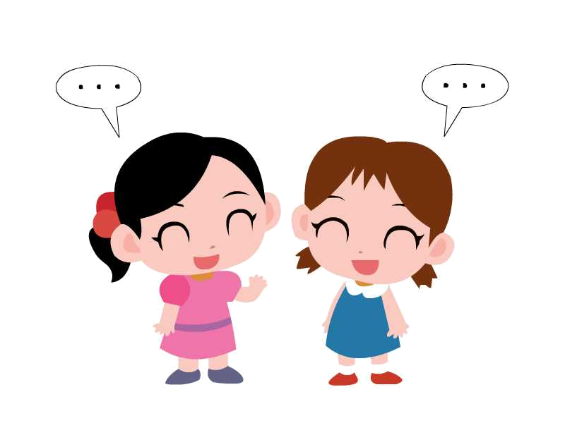

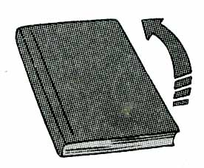
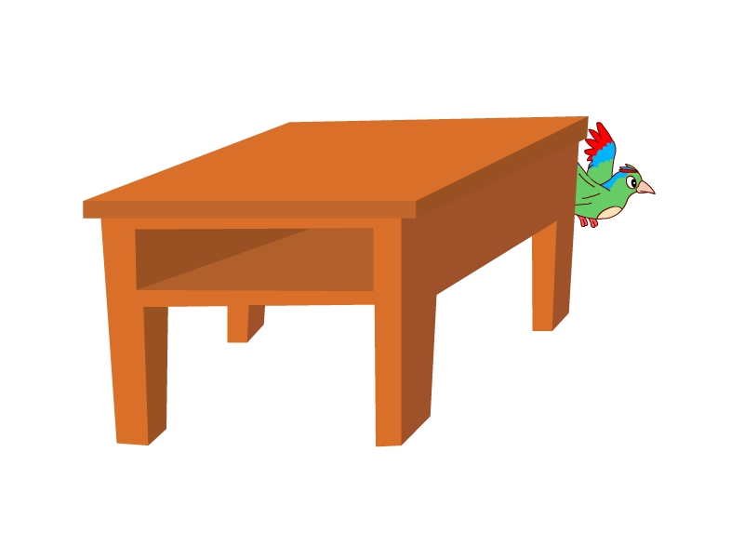

( ) ( ) ( ) ( )
三、听录音，选择合适的应答句。(10%)
( ) 1.A Yes, it is. B. Yes, please.
( ) 2.A.It’s over there. B. It’s a schoolbag.
( ) 3.A.It’s blue. B. It’s a jacket.
( ) 4.A. Thank you. B. No. it isn’t.
( ) 5.A .No, thank you. B. I’m sorry, Mr Green.
四、听录音，判断下列句子与所听内容是否相符，用√或×表示。(8%)
( )1.Look at the window.
( )2.Don’t eat my hot dog.
( )3.That is a rubber.
( )4.Don’t drink here.
五、听录音完成句子。（9%)
1、Is it _______ the ________?No.It’s on my_________.
2、Please_________ the _________ OK.
3、This_________ is for you. Thank you.
4、_________is it? It’s _________ the _________.
笔试部分（60分）
一、选出与其他两项不同类的单词。(5%)
( ) 1. A. blue B.doll C. black
( ) 2. A. under B. chair C. behind
( ) 3. A. come B. listen C. here
( ) 4. A.it B.this C. that
( ) 5. A. am B.an C.is
- 英汉互译（10%）
关门 Don’t eat here.
在椅子下 stand up
在门后面 a beautiful bird
我的红铅笔 on the blackboard
打开你的书 in the library
二、单项选择。(16%)
（ ）1._______that your crayon? Yes, ________ .
A. Is, it is. B. Is isn’t. C. Are, they are.
（ ）2.This rubber is for you. _______ .
A. Yes. B. OK. C. Thank you.
（ ）3.Is that_______parrot? No,________ isn’t
A. you, it B your, he C. your, it
（ ）4. ______is this?
A. What B What’s C. what
（ ）5.Where ’s my schoolbag? ________.
- That’s my schoolbag. B It’s my schoolbag.. C. It’s over there.
（ ）6.Don’t my sweets.--- .
A. eat；No B. drink；OK C. eat；I’m sorry
（ ）7.--Look at the blackboard. --_______________.
A. I’m sorry B. Yes, Mr Green C. It’s nice
（ ）8.It’s too cold(冷). _______ the window, please.
A. Don’t open B. Open C. Talk
（ ）9.— Don’t listen _______Sam, Bobby.—OK.
A. / B. for C. to
（ ）10.---_______________ --- It’s on the chair.
A. Is this a chair? B. Where’s the book? C. What’s this?
（ ）11.当你想告诉别人这不是你的书时，你应该说：
A. I’m sorry. B This is your book. C. This isn’t my book.
（ ）12.当你想询问别人那是否是他的钢笔时，你会说：
A. That is your pen. B. Is that your pencil? C. Is that your pen?
（ ）13.当你想询问你的橡皮在哪里时，你应该说：
A. What’s that? B where’s my rubber? C.Where’s my ruler？.
（ ）14.当你要给别人某件东西时，你会说：
A. This is for you.. B. Thank you.. C. Is this for you?
（ ）15.当你想告诉别人东西在远处时，你应该说：
- Where’s my car? B It’s over there.. C. That is your book.
（ ）16.你想告诉别人鸟在树上，你可以说：
A. It’s on the tree. B. It’s in the tree. C. It’s under the tree.
四、句子匹配（8%）
（ ）1、Don’t shout in the library. A. OK, Miss Li.
（ ）2、What’s this? B. Good evening, Mr Green.
（ ）3、Is this your book? C. I’m sorry.
（ ）4、Would you like a pie? D. How nice!
（ ）5、Open the window, LiuTao. E. It’s a rubber.
（ ）6、Good evening, Mr Black. F. Yes,it is.
（ ）7、Look at my new rubber. G. She’s in the library.
（ ）8、Where’s your mother? H. Yes, please.
五、排序。（6% ）
A．Thank you. B. Hello, Mary. Is this my pencil?
C. No, it isn’t. It’s mypencil. D. Hello, Liu Tao. E. Where’s my pencil?
F. Look! It’s under the desk. Here you are.
( ) ( ) ( ) ( ) ( ) ( )
六、连词成句，注意大小写和标点符号。(10%)
1、at the blackboard look Sam (, .)

- talk the don’t in library(.)

3、like Would sweet a you Mike (,?

4、 in tree it’s now the (.)

5、your Is robot this (?)

七、阅读对话，判断下列句子是(T)否(F)与对话内容相符。 (5%)
My name is David. I’m ten. I have a brother and a sister. Tom is my brother. He’s five. Who's Ann? She’s my sister. She is twelve. We have many toys（玩具）. Look, this panda is nice. It’s black and white. That’s a monkey. It’s brown. It’s great. This tiger is new. It’s yellow. Look at these cars. They are nice, but（但）they are old. Do you like these toys?
( )1. David is five.
( )2. Ann is Tom’s sister.
( )3. They have many toys.
( )4. The monkey is black and white.
( )5. The cars are new.

同学们，是不是已经做好了啊？那你可以开始检查啦，要细心哦，祝你成功！

