四年级下册期中测试
一、根据汉意把下列单词补充完整
n ____ ____gh ____ ____（淘气的） l____ ____ ____ ____ ____ （小的）
ab ____ ____ t（关于） m ____ ____ ____ （很多的）
p ____ ____ n ____ ____（野餐） b ____ ____ ____ ____ ____ ____ （因为）
w ____ ____ ____ ____ er（天气） l ____ ____ ____ ____ n（学习）
t ____ ____ ____（比） s ____ ____ ____ ____ ____（强壮的）
二、英汉互译
这些朋友____________________ a bit nice____________________
一本关于伦敦的书____________________ the River Thames____________________
在星期六____________________ have a picnic____________________[来源:Z§xx§k.Com]
做家务____________________ do one’s homework___________________
长城____________________ Mount Qomolangma__________________
三、按要求做
their（同音词）____________________ much（近义词）____________________
cold（对应词）____________________ won’（完全形式）____________________
that（对应词）____________________ children（单数）____________________
holiday（复数）____________________ swim（现在分词）____________________
Queen（所有格）____________________ London（国家）____________________
四、从下面每组四个词中选出一个不同类的单词，将其序号写在题前括号中
（ ） 1. Wednesday B. Thursday C. yesterday D. Tuesday
（ ） 2. A. cloudy B. sunny C. windy D. Sunday
（ ） 3. A. today B. Monday C. tomorrow D. yesterday
（ ） 4. A. The Great Wall B. Big Ben C. Tower Bridge D. Hyde Park[来源:学_科_网Z_X_X_K]
（ ） 5. A. London B. America C. Beijing D. Shanghai
（ ） 6. A. naughty B. cute C. play D. clever
（ ） 7. A. cold B. I C. he D. she
（ ） 8. A. China B. New York C. America D. England
五、将下列单词与正确图片连线
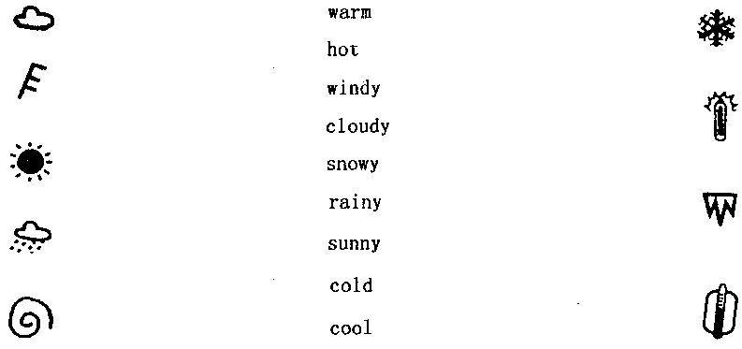
六、单项选择
（ ） 1. ____________is long and wide.
A. Big Ben B. The River Thames C. Hyde Park
（ ）2. Will the robot do everything?
A. Yes, it will. B. No, it will. C. No, it won’t.
（ ）3. I’m from ____________. I’m a ____________.
A. China, Chinese B. English, England C. Chinese, China
（ ） 4. What’s that, Dad?
A. Is it mine? B. It’s white. C. It’s a robot.
（ ）5. Will it be fine tomorrow?
A. Yes, it will. B. Yes, it will be. C. Yes, tomorrow will.
七、根据图示回答问题
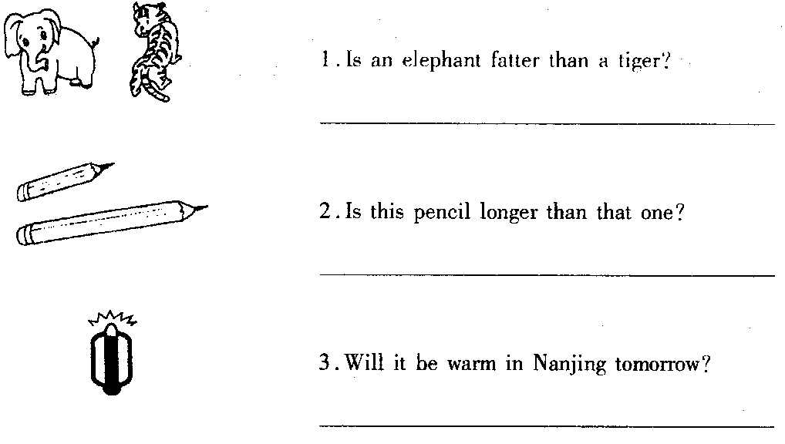
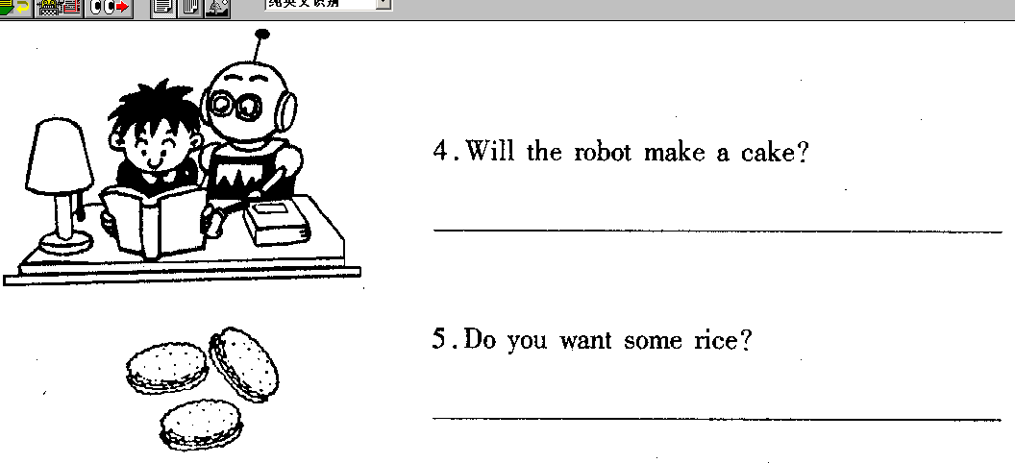
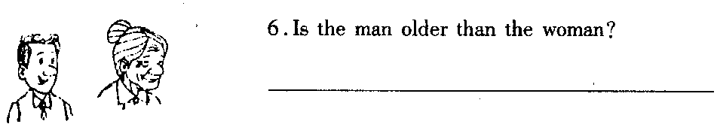
八、下面是从中央电视台天气预报节目中节选的部分。仔细观察图，完成句子
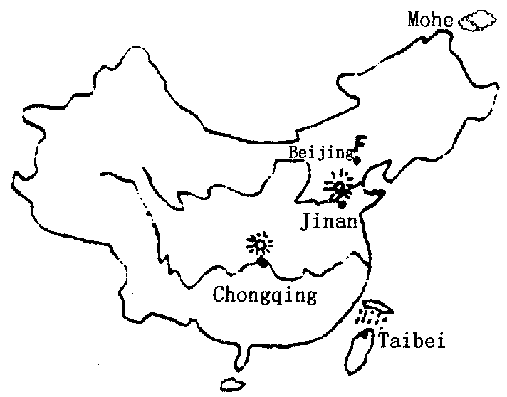
1. It will ________in Mohe tomorrow. It will be very old.
2. It will be very ________in Jinan and Chongqing.
3. —Will it be sunny in Taibei?
—No, it will
4. —What will the weather be in Beijing’?
—It will________.
九、连词成句
1. clever, she, pupil, a, is
__________________________________________________________________________
2. brother, my, cool, is, big[来源:学科网]
__________________________________________________________________________
3. England, the, London, of, is, capital
__________________________________________________________________________
4. very, Big, old, Ben, is
__________________________________________________________________________
5. take, will, tomorrow, ball, your, you
__________________________________________________________________________
6. you, what, week, do, next, will
__________________________________________________________________________
7. Darning, younger, I, than, am
__________________________________________________________________________
十、阅读理解
This is Lingling. She’s a clever girl. She likes watching TV. She’s 11 years old. Her father is a driver. He’s very cool. Her mother is a teacher. She is thin and tall. Lingling is shorter than her mother. On Saturday Lingling’s parents will take her to have a picnic.
仔细阅读小短文，判断下列各题是否正确，正确打“√”，否打“×”。[来源:学科网]
（ ）1. Lingling likes swimming.
（ ）2. Lingling’s father is very tall.[来源:学.科.网]
（ ）3. Lingling’s mother is taller than Lingling.
（ ）4. On Sunday they’ll have a picnic.
参考答案：
一、略
二、略
三、there, many, hot, will not, this, child, holidays, swimming, Queen’s, England
四、C D B A B C A B
五、略
六、B C A C A
七、1 .Yes, it is. 2. Yes, it is. 3. No, it won’t. 4. No, it won’t.
5. No, thank you. 6. No, he isn’t.
八、1. be cloudy 2.sunny 3.rain 4.be
九、略
十、××√×

