四年级下册期中测试
一、看图写单词
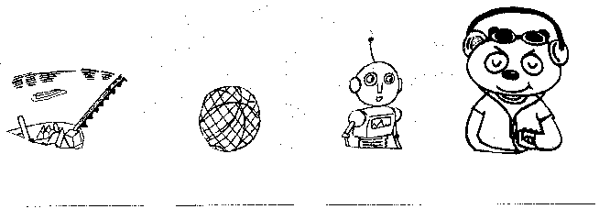
二、看图写短语
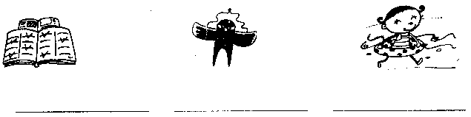
三、词类转换
nice（比较级）___________ teacher（对应词）___________
big（对应词）___________ lady（复数）___________
next（近义词）___________ my（复数）___________
up（对应词）___________ feet（单数）___________
thin（比较级）___________ old（对应词）___________
四、将下列单词放在同类的括号内
A. sister B. Big Ben C. Monday D. listen E. tall
F. pear G. bigger H. windy I. bird J. red
1. （ ） River Thames Hyde Park Tower Bridge
2. （ ） longer shorter fatter
3. （ ） high thin small
4. （ ） father mother brother
5. （ ） lion elephant tiger
6. （ ） Sunday Tuesday Friday
7. （ ） read write send
8. （ ） yellow blue green
9. （ ） hot cold sunny
10. （ ） apple orange banana
五、看图写出句子中所缺的单词
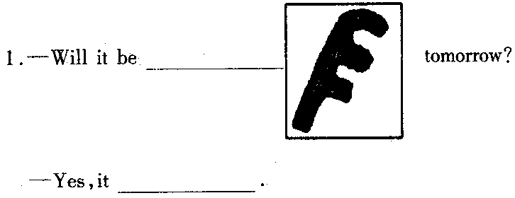
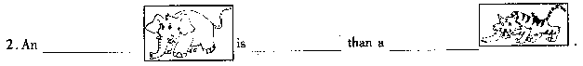
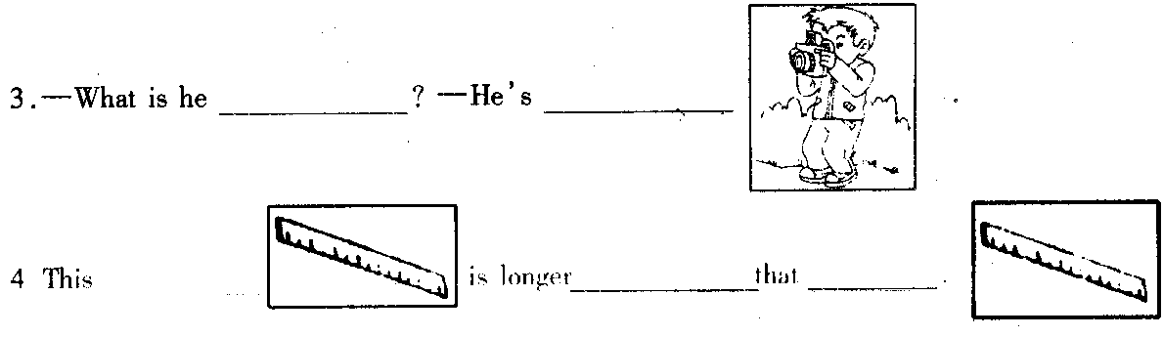
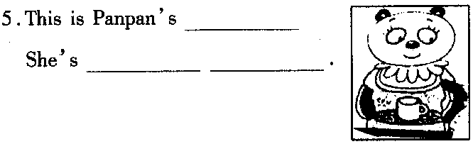
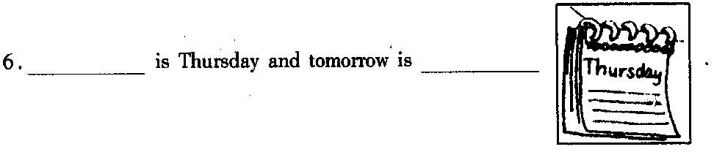
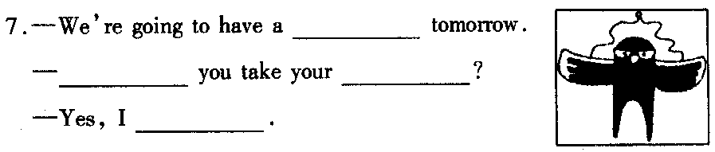
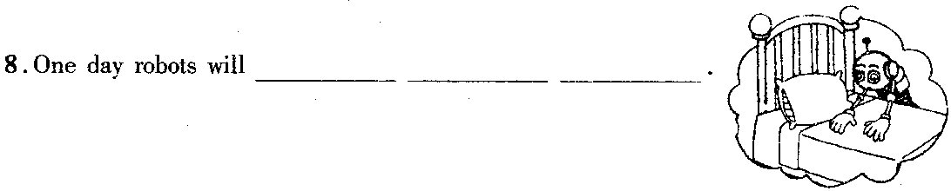
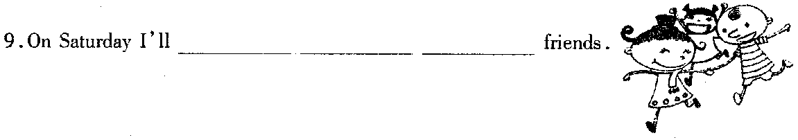
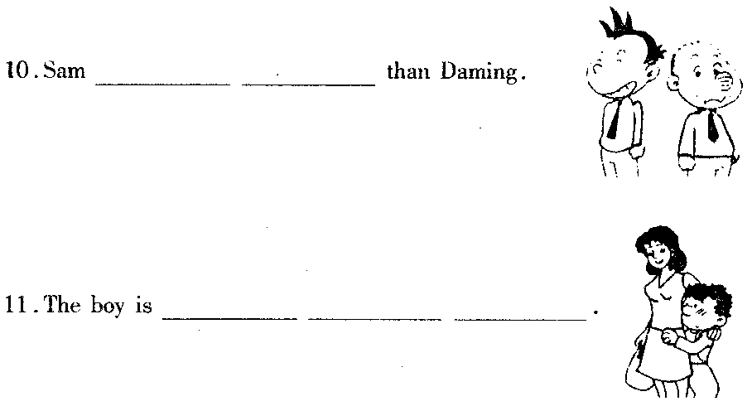
六、从II栏中找出I栏的答句
I栏 B栏
（ ）1. What are you doing? A. It will be sunny in Guangzhou.
（ ）2. Is this ruler longer than that one? B. I’m writing a letter.
（ ）3.Will it be cold in Guangzhou? C. Yes, he is.
（ ）4. Is Sam stronger than Lingling? D. Yes, I can.
（ ）5. Where will be sunny tomorrow? E. I’m from England.
（ ）6.Why don’t we go and play in the park? F. No, it won’t.
（ ）7.Where are you from? G. That’s a good idea.[来源:学科网ZXXK]
（ ）8. Can you make a cake? H. No, it isn’t.
七、将下列单词与正确地名连线，并写出地名的汉语意思
1. long and wide Buckingham Palace（ ）
2. old and tall Big Ben（ ）
3. big and beautiful the River Thames（ ）
4. famous and beautiful Hyde Park（ ）[来源:学科网ZXXK]
5. beautiful Tower Bridge（ ）
八、请你按西方国家的习惯按顺序写出星期的缩略形式
______________ ______________ ______________ ______________
______________ ______________ ______________ ______________
九、阅读短文，判断正（R）误（W）
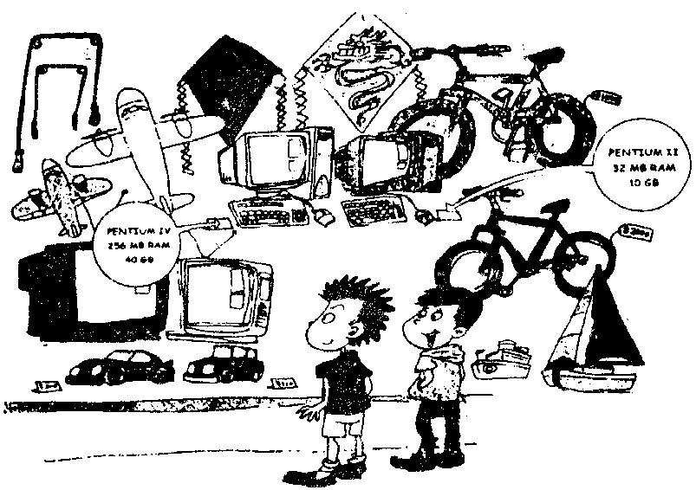
A: Look, there are many beautiful things in the shop.
B: Yes, I like them. Let’s buy the white computer（计算机）.
A: That’s a good idea. It’s more powerful （功能强大的） than the blue one.
B: But it’s more expensive（昂贵的）. We haven’t enough（足够的）money.
Why don’t we buy a toy car’? It’s lovely.
A. You are right. Let’s buy a toy car.
B: That’s a great idea. We can go and play it in the park.
（ ）1. There aren’t many beautiful things in the shop.
（ ）2. The white computer is more powerful and expensive than that blue one.
（ ）3.They buy a computer.
（ ）4. They can go and play the computer in the park.
十、读短文回答问题
Hello! My name is Panpan. I’m 9 years old. I have a big family. My mother is a teacher. She’s very nice. My father is a doctor. He’s very cool. My brother is a student. He’s very clever. My little sister is only three. She’s very cute.
1. How many people are there in Panpan’s family?
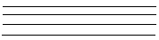
2. Panpan is very, very old. Yes?[来源:Zxxk.Com]
3. Panpan’s father is a teacher, isn’t he?
4. Is Panpan’s sister a pupil?
参考答案：
一、river, ball, robot, cool
二、do one’s homework, fly a kite, go swimming
三、nicer, pupil, small, ladies, near, our, down, foot, thinner, young
四、1-5 B G E A I 6-10 C D J H F
五、1. windy, win
2. elephant, fatter/bigger, tiger[来源:学科网]
3. doing, taking a picture
4. ruler, than, ruler/one
5 .mother, very nice
6. Today, Friday
7. picnic, Will, kite, win
8. do the housework
9. play with my
10. is shorter
11. a bit shy[来源:学+科+网Z+X+X+K]
六、B H F C A G E D
七、略
八、略
九、W R W W
十、1. There are five 2. No, he isn’t 3. No, he isn’t 4. No, she isn’t

