四年级下学期牛津英语期中测试卷
听力部分
一、Listen and choose.听录音，选出听到的内容。
( ) 1. A. taste B. touch C. teach
( ) 2. A. English club B. Music club C. Maths club
( ) 3. A. favourite food B. favourite fruit C. favourite sport
( ) 4. A. thin branch B. thin tree C. thick tree
( ) 5. A. There isn’t a basketball behind the chair.
B. There’s a basketball on the chair.
C. There’s a basketball under the chair.
( ) 6. A. Are these sketchbooks Ben’s or Peter’s?
B. Are these storybooks Ben’s or Peter’s?
C. Are these picture books Ben’s or Peter’s?
二、Listen and number.听录音，给下列图片排序。
A. 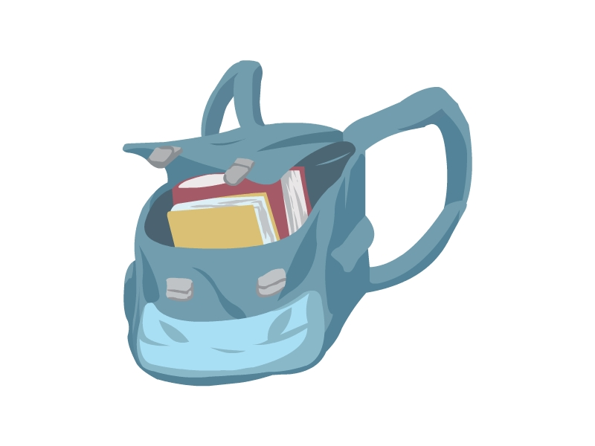 B. 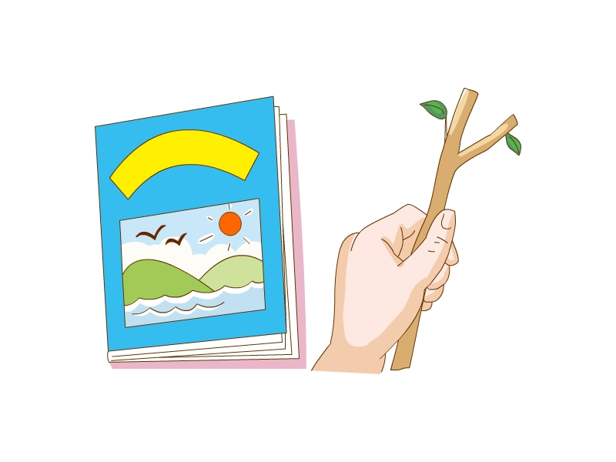 C. 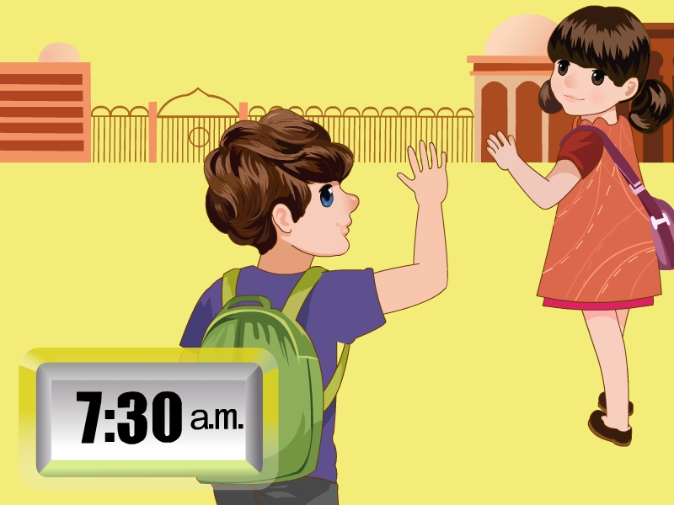
D. 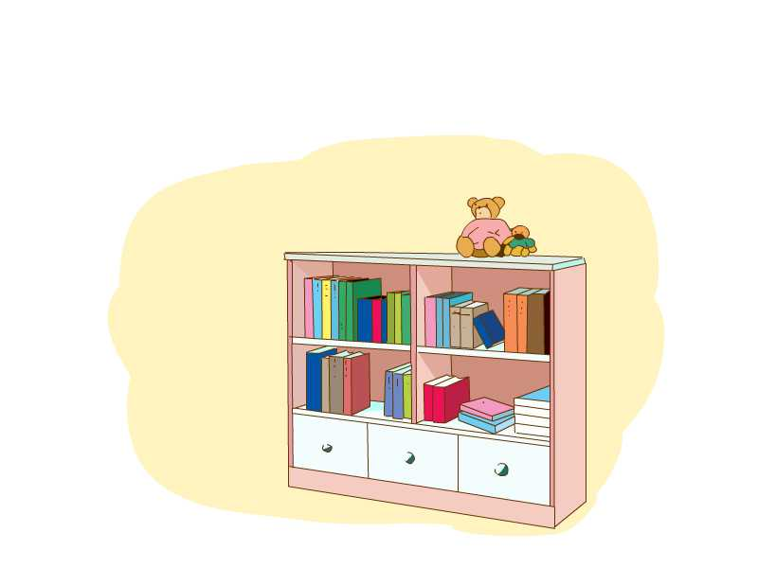 E. 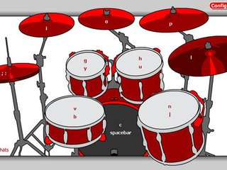
正确顺序为：__________________
三、Listen and choose.听录音，选出相应的问句或答句。
( ) 1. A. I can play the piano.
B. He can play the drum.
C. She can play the violin.
( ) 2. A. It’s big. B. It’s white. C. It’s smooth.
( ) 3. A. Sure, I’d love to. B. Sure. Here you are. C. I like playing football.
( ) 4. A. She doesn’t like playing the guitar.
B. She plays the guitar.
C. She likes playing the guitar.
( ) 5. A. Whose soft balls are these?
B. Whose thin books are those?
C. Whose hard toys are these?
( ) 6. A. When does the sun rise?
B. When does the sun go down?
C. When is the moon high in the sky?
四、Listen and choose.听录音，选出正确的答案。
( ) 1. A. Yes, there is. B. No, there isn’t. C. No, it isn’t.
( ) 2. A. Danny’s. B. Tom’s. C. Peter’s.
( ) 3. A. Some lemon juice. B. Some apple juice. C. Some orange juice.
( ) 4. A. Grapes. B. Strawberries. C. Pineapples.
五、Listen and write.听录音，填入所缺单词完成短文。
Today is (1) ________. I stay at home with my family. I often play the (2) ________ in the living room. My father sometimes plays (3) ________ with his friends in the garden. My mother usually (4) ________ the house. But today she is ill (生病的). So my father is doing the housework. Where is my sister? Look! She’s drinking a glass of (5) ________ juice in the kitchen.
笔试部分
一、Read and choose.读一读，选出与所给单词划线部分发音不同的单词。
( ) 1. dress: A. music B. sky C. grass D. student
( ) 2. thin: A. thick B. Chinese C. in D. it
( ) 3. where: A. how B. whale C. white D. when
二、Look and write.根据图意，写出合适的单词完成句子，每线一词。
1. The sun goes down in the evening. The tree’s s________ grows long. 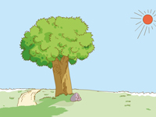
2. —Touch the desk. How does it feel? 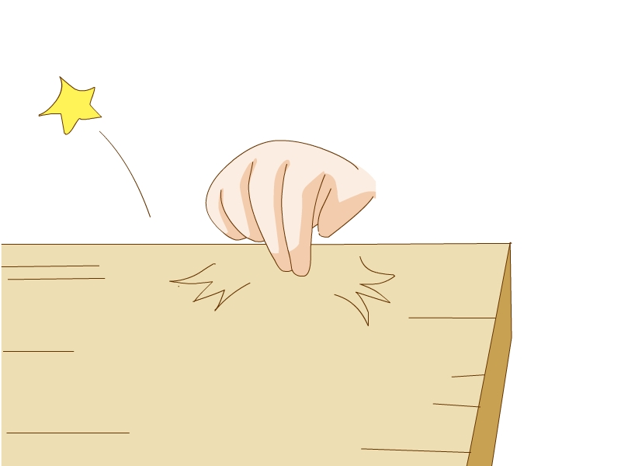
—It’s h________.
3. —Are there two g________ of juice? 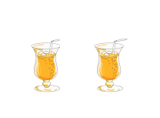
—Yes, they’re nice.
4. Swimming is her favourite s________. It’s fun. 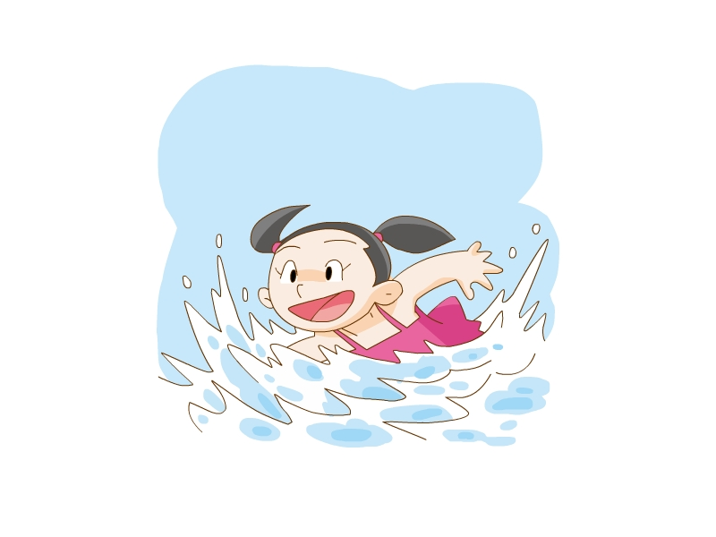
5. The boy likes p________ in the art room. 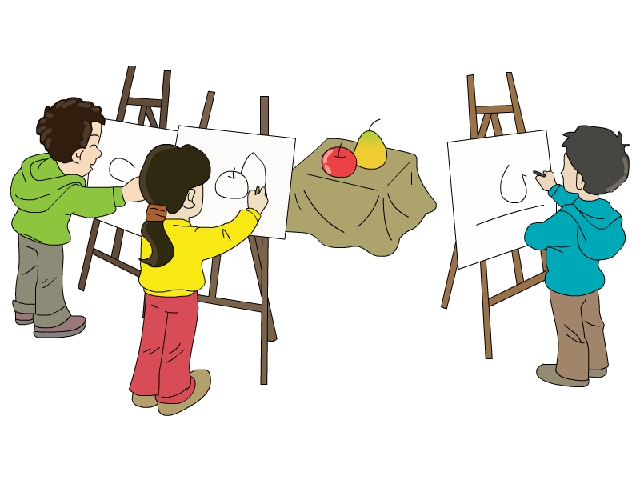
三、Read and choose.选择填空。
( ) 1. Hello, I’m Jack. I can taste with my ________.
A. nose B. ear C. tongue
( ) 2. I like sleeping ________ noon.
A. on B. at C. in
( ) 3. —________ toy bear is this?
—It’s my little sister’s.
A. Who’s B. Who C. Whose
( ) 4. I like ________ hot ________.
A. drinking, drinks B. drinking, drink C. drink, drinks
( ) 5. John usually ________ football in the playground. But today he is ________ a book at home.
A. play, reading B. plays, reading C. playing, reads
( ) 6. The moon is high in the sky. It is ________.
A. in the morning B. at night C. in the afternoon
( ) 7. We can look and see ________ our eyes.
A. use B. on C. with
( ) 8. How ________ these lemons taste?
A. are B. do C. does
( ) 9. Mark ________ a black piano. He likes ________ the piano very much.
A. has; playing B. have, is playing C. has, play
( ) 10. We can ________ the shadow, but we can’t ________ it.
A. smell, hear B. see, smell C. taste, touch
四、Think and write.按要求改写下列句子。
1. There is a science club in our school. (改为否定句)
_____________________________________________________________________
2. These are Ben’s new triangles. (对划线部分提问)
_____________________________________________________________________
3. The moon rises in the evening. (对划线部分提问)
_____________________________________________________________________
4. Alice likes cherry juice. Alice likes grape juice. (改为选择疑问句)
_____________________________________________________________________
5. drawing, art, room, Mary, likes, the, in, pictures, (.) (连词成句)
_____________________________________________________________________
6. Those are old Chinese books. (改成单数句)
_____________________________________________________________________
五、Read and write.读一读，填入合适的单词完成句子。
1. Look at the watermelons. They are big. They are ________ too.
2. —What do foxes like eating?
—They like eating ________.
3. —Are the ________ big or small?
—They’re big. Listen! “Boom-boom”. How nice!
4. There are many books in the library. Some are big. Some are small. Some are thin.
Some are ________.
5. —What ________ do you like best?
—I like English best.
六、Read and choose.读一读，选择合适的句子，完成对话。
A. Mum, I don’t want to join the English club.
B. Basketball is my favourite sport.
C. Please let him join the basketball club.
D. You can join the English club.
E. Does Danny like playing basketball?
Danny: Oh, there are some new clubs in our school. I can join the basketball club. (1) ________ Look at the posters, Mum. Can I join the basketball club?
Mum: Let me see. No, no, no, Danny! Do you like reading English?
Danny: Yes, I do.
Mum: OK. (2) ________
(Being a child is not easy.)
Mum: Hello, Miss Fang.
Miss Fang: Hello. Which club does Danny want to join? (3) ________
Mum: No, he doesn’t. He likes reading English. He can join the English club.
Danny: (4) ________ I like playing basketball. Let me join the basketball club. Please, Mum: Please!
Miss Fang: Danny is a good basketball player. (5) ________
Mum: Um, OK, Danny.
Danny: Hurrah! Great! Thank you, Mum. Thank you, Miss Fang.
(Being a mother is not easy.)
七、Read and answer.阅读短文，回答下列问题。
One morning, Judy sees an egg on her way to school. She takes it to her classmates. The children put the egg into a big box. Five days later (五天以后), the egg opens. A lovely baby bird comes out. The children call the bird Titi. Titi is warm and soft. It’s cute. Every day they give it rice and water. But Titi likes worms (虫). It doesn’t like rice at all.
(1) Who sees the egg?
_____________________________________________________________________
(2) Where do the children put the egg?
_____________________________________________________________________
(3) How does Titi feel?
_____________________________________________________________________
(4) What does Titi like eating?
_____________________________________________________________________
(5) Does Judy like animals?
_____________________________________________________________________
八、Writing. 书面表达。
将题目补充完整，然后写一写。要求语句通顺，语法正确，3种句型以上。
My favourite ________ (subject/sport)
_____________________________________________________________________
__________________________________________________________________________________________________________________________________________

参考答案
听力部分
听力材料
一、
1. Touch the pineapple, please. How does it feel?
2. There’s a poster in our school. It’s about the music club.
3. —What’s your father’s favourite sport?
—Football.
4. Look at the thin branch. It’s long.
5. There isn’t a basketball behind the chair.
6. Are those storybooks Ben’s or Peter’s?
二、
1. I have a thin book. It’s interesting.
2. —I can see a big drum. Is it Tom’s?
—No. It’s Danny’s.
3. —Peter, put your toy bear in the bag.
—All right.
4. —Whose books are those? They’re so thick.
—Oh, they’re Miss Fang’s.
5. We walk to school every day.
三、
1. What can Lily play?
2. What colour is Peter’s triangle?
3. Would you like to join the football club?
4. What does Linda like doing?
5. They are Joe’s soft balls.
6. The moon is high in the sky at night.
四、
1. A: Look at the poster, Ben. There’s a new table tennis club in our school. Do you like playing table tennis?
B: Yes, I do. It’s my favourite sport.
A: Me too. Let’s join the club together.
B: Great!
Q: Is there a tennis club in Ben’s school?
2. A: Is this your guitar, Danny?
B: No. My guitar is red. This guitar is brown. It’s Peter’s.
Q: Whose guitar is brown?
3. A: Dad, I’m thirsty.
B: Some lemon juice, Eddie?
A: No, thanks. Dad, give me some orange juice.
B: OK. Here you are.
Q: What does Eddie want?
4. A: Look, Jill. What are they?
B: They’re grapes.
A: Taste them. Are they sweet?
B: No, they are sour. I don’t like them.
A: What do you like?
B: I like strawberries.
Q: What fruit does Jill like?
五、
Today is Sunday. I stay at home with my family. I often play the piano in the living room. My father sometimes plays basketball with his friends in the garden. My mother usually cleans the house. But today she is ill. So my father is doing the housework. Where is my sister? Look! She’s drinking a glass of watermelon juice in the kitchen.
听力答案
一、
1-5 BBCAAB
二、
BEADC
三、
1-6 CBACAC
四、
1-4 BCCB
五、
(1) Sunday (2) piano (3) basketball (4) clean (5) watermelon
笔试部分
一、
1. A 2. B 3. A
二、
1. shadow 2. hard 3. glasses 4. sport 5. painting
三、
1-5 CBCAB 6-10 BCBAB
四、
1. There isn’t a science club in our school.
2. Whose new triangles are these?
3. When does the moon rise?
4. Does Alice like cherry juice or grape juice?
5. Mary likes drawing pictures in the art room.
6. That is an old Chinese book.
五、
1. sweet 2. grapes 3. drums 4. thick 5. subject
六、
(1)-(5) BDEAC
七、
(1) Judy sees the egg·
(2) They put it into a big box.
(3) It’s warm and soft./Warm and soft.
(4) It likes eating worms./ Worms.
(5) Yes, she does.
八、
略。

