小学英语译林五下 期中 测试卷

第一部分 听力部分

一、听录音，选出你所听到的单词。
( ) 1. A. farmer B. fairy C. fine
( ) 2. A. science B. cinema C. film
( ) 3. A. bedtime B. timetable C. mushroom
( ) 4. A. stop B. supermarket C. bookshop
( ) 5. A. snack B. check C. duck
( ) 6. A. Maths B. with C. brush
( ) 7. A. orange B. elephant C. giraffe
( ) 8. A. water B. sweet C. weekend
( ) 9. A. should B. would C. doctor
( ) 10. A. wait B. point C. dentist
二、听录音，给下列图片排序。
A. 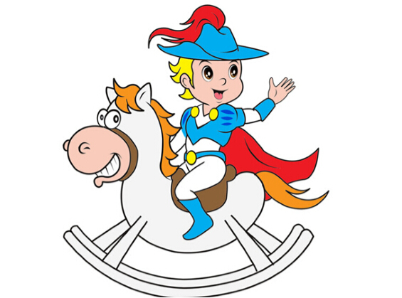 B. 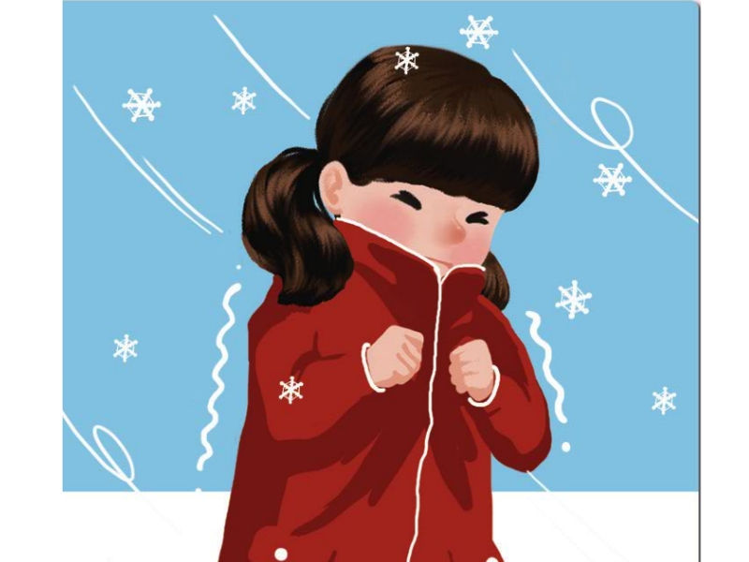 C. 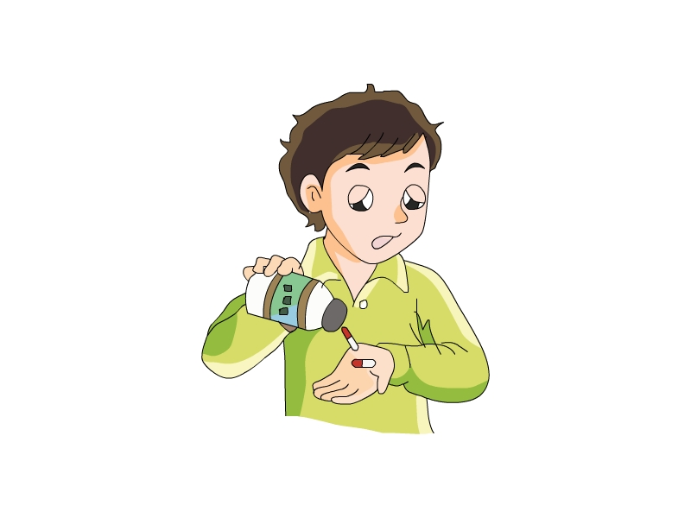
( ) ( ) ( )
D. 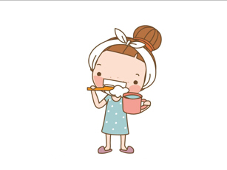 E. 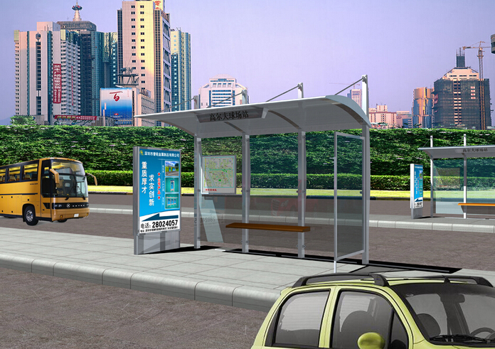 F. 
( ) ( ) ( )
三、听录音，判断下列句子与所听内容是否一致，一致的打“√”，不一致的打“×”。
( ) 1. He’s happy to help them.
( ) 2. Go along the road and then turn left.
( ) 3. Is it far from the library?
( ) 4. You can go by ship.
( ) 5. What's wrong with Miss White?
( ) 6. My mouth hurts.
四、听录音，选择合适的答句。
( ) 1. A. It’s on Guangming Street.
B. She’s on Moon Street.
C. He’s on Sun Street.
( ) 2. A. No, it doesn’t. B. Yes, it is. C. Yes, he is.
( ) 3. A. I am a doctor.
B. You should eat more vegetables.
C. You are right.
( ) 4. A. He’s my uncle.
B. He likes playing football.
C. He’s a policeman.
( ) 5. A. She’s ill. B. He’s tired. C. They have a cold.
( ) 6. A. Yes, I do. B. Yes, I am. C. Me, too.
( ) 7. A. Yes, they are. B. Thanks. C. No, there aren’t.
( ) 8. A. On foot. B. By plane. C. On bike.

第二部分 笔试部分

一、判断下列每组单词画线部分读音是否相同，相同的写“√”，不相同的写“×”。
( ) 1. traffic driver ( ) 2. ship show
( ) 3. plane water ( ) 4. drink draw
( ) 5. fit pick ( ) 6. train metro
二、根据句意及首字母或中文提示完成句子。
1. E________ me, is this Xiangyang Street?
2. —Are there any horses in the z________?
—No, there aren’t any horses. But there are some elephants,
3. You can g________ on the bus at the bus s________.
4. My mother buys some new ________ (衣服) for me.
5. Are there any funny ________ (电影) this week?
三、选择合适的短语完成句子，每个短语只填一次，注意字母的大小写形式。
get off go to the party get there before supper
have a good time come back have to it’s time to

1. —Do you do your homework _________?
—No, I do it after supper.
2. We all ________ at Ben 5 birthday party.
3. ________ get up, Linda.
4. The old man can’t find the park. He asks the policeman how to ________.
5. Who can’t________? Why?
6. I ________ go now.
7. You can take Bus No. 114 and ________ in front of Xinhua Bookshop.
8. —When does she _________?
—She comes back at five o’clock.
四、单项选择。
( ) 1. Gao Shan ________ his right ear.
A. point at B. points at C. points
( ) 2. —Why ________ Su Yang at school today?
—Because she _________ a headache.
A. aren’t; are B. isn’t; is C. isn’t; has
( ) 3. —What’s the matter?
—My teeth ________. I eat a lot of creams.
A. is B. wrong C. hurt
( ) 4. —Do they brush ________ teeth after dinner?
—Yes, they do.
A. they B. their C. them
( ) 5. I eat an apple every day. It’s good ________ me.
A. for B. too C. of
( ) 6. —What should my daughter do?
—She should ________ a lot of rest.
A. have B. has C. to have
( ) 7. —Can I ________ this nice dress?
—Of course.
A. try B. try in C. try on
( ) 8. ________, she goes to the supermarket. _________ she goes to the park.
A. First; Then B. Then; First C. First; Two
( ) 9. —Why can’t I go to work?
—Because you are too ________.
A. tall B. young C. thin
( ) 10. The train station is ________ from the bus stop.
A. next B. far C. near
五、连词成句。
1. you, your, do, like, classroom, new (?)
____________________________________________________________
2. City, Su Hai, near, Library, lives (.)
____________________________________________________________
3. a, Tom, bike, has, green (.)
_____________________________________________________________
4. is, bookshop, there, a, on, street, the (.)
____________________________________________________________
六、根据上下文补全对话。
A: Can I ________ a film this afternoon. Mum?
B: Of ________, you can.
A: How can I get to Red Apple Cinema?
B: It’s a ________ walk. You can ________ Bus No.8.
A: How many stops are there?
B: There are four.
A: Is it ________ Beijing Street?
B: Yes, it is.
A: ________ a lot, Mum.
B: Not at all.
七、阅读短文，判断正(√)误(×)。
There is a new park near my house. It’s a fine day today my family and I are in the park now. On my left, there is a cafe. On my right, there is a big lake. There are many flowers and trees near the lake. There’s a small hill behind the lake. Near the lake, there is a sign. It says, “Don’t swim in the lake!” There is a playground in the middle (中间) of the park. There are some small shops near the gate. The park is so beautiful. We like it very much.
( ) 1. The park near my house is new and beautiful.
( ) 2. The park is between the cafe and the lake.
( ) 3. People can swim in the lake.
( ) 4. The shops in the park are not small.
( ) 5. There is a playground behind the park.
八、书面表达。
用所给提示写一篇短文，不少于5句话。
提示: 小男孩Tom经常感冒，医生给了他一些建议。
参考词汇：has, should, shouldn’t
_____________________________________________________________________________________________________________________________________
_____________________________________________________________________________________________________________________________________________________________________________________________________
听力原文：
一、1. fairy 2. cinema 3. mushroom 4. supermarket
5. check 6. brush 7. giraffe 8. sweet 9. should
10. point
二、1. a fairy 2. brush the teeth 3. take some medicine
4. a prince 5. feel cold 6. a bus stop
三、1. He’s happy to ask them for help.
2. Go along the road and then turn left.
3. Is it next to the library?
4. You can go by ship.
5. What’s wrong with Mrs. White?
6. My mouth hurts.
四、1. Where is the supermarket?
2. Is it in front of the cinema?
3. What should I do?
4. What does he do?
5. What’s wrong with them?
6. Do you take any medicine?
7. Are there any parks in your city?
8. How does Millie usually go to school?

听力答案：
一、 1-5 BBCBB 6-10 CCBAB
二、 A. 4 B. 5 C. 3 D. 2 E. 6 F. 1
三、1. × 2. √ 3. × 4. √ 6. √
四、1-5 ABBCC 6-8 ACA
笔试答案：
一、1. D 2. S 3. D 4. S 5. S 6. S
二、1. Excuse 2. zoo 3. get; stop 4. clothes 5. films
三、1. before supper 2. have a good time 3. It’s time to 4. get there 5. go to the party 6. have to 7. get off 8. come back
四、1-5 BCCBA 6-10 ACABB
五、1. Do you like your new classroom?
2. Su Hai lives near City Library.
3. Tom has a green bike.
4. There is a bookshop on the street.
六、see; course; long; take; on; Thanks
七、1. √ 2. × 3. × 4. × 5. ×
八、One possible version:
Tom is a student. He is twelve years old. He often has a cold in winter. He often goes to see a doctor. The doctor says, “You should wear some warm clothes. You should often do exercise. You shouldn’t go to sleep late at night.”

