外研社一起小学英语五年级下册期中测试卷
一、找出不同类的单词。
( ) 1. A. winter B. summer C. spring D. cool
( ) 2. A. chicken B. juice C. potato D. vegetable
( ) 3. A. windy B. cloudy C. rain D. snowy
( ) 4. A. me B. he C. they D. you
( ) 5. A. hospital B. school C. shop D. farmer
二、单项选择。
( ) 1. Yao Ming ________ a basketball player before.
A. is B. was C. were
( ) 2. My mother works in a factory. She is ________.
A. a driver B. a worker C. a teacher
( ) 3. Lingling’s favourite ________ is fish and chips.
A. food B. drink C. fruit
( ) 4. I usually have ________ for my breakfast.
A. some books B. bread and milk C. a class
( ) 5. —Have you got any apples?
—________
A. Yes, please. B. Sorry, we haven’t any. C. No, thanks.
( ) 6. Sam likes sandwiches, ________ he doesn’t like hamburgers.
A. and B. but C. so
( ) 7. I sent you some pictures of Guilin. Did you see ________?
A. it B. they C. them
( ) 8. The first birthday of a child is ________ in China.
A. long B. special C. new
( ) 9. Many children in China ________ Harry Potter books, too.
A. has got B. have got C. there are
( ) 10. My favourite season is ________. I can see colourful leaves.
A. spring B. summer C. autumn
三、选择正确的单词。
1. __________ (Mine; My) bag is brown. __________ (Yours; Your) is black.
2. __________ (My; I) carry it with __________ (I; my) hand.
3. Please tell __________ (us; they) a story.
4. That’s __________ (our; we) classroom. __________ (They; We) love it.
5. Did you read __________ (they; them)?
6. Lingling is doing __________ (her; his) homework.
7. I want to buy __________ (your; you) a new gift.
四、根据汉语意思将句子补充完整。
1. He worked _____________________.（在办公室里）
2. _____________________（你有没有）the Harry Potter videos?
3. Please _____________________（还书）in two weeks.
4. She had _____________________（香肠和三明治）for lunch.
5. I _____________________（寄给）you _____________________（美国巧克力）.
五、根据图文提示，在横线上填入所缺的单词，完成句子。
1. A: What was your grandpa before?
B: __________ a doctor.
2. A: What did he play? 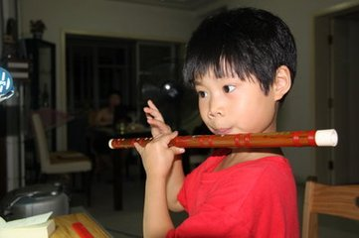
B: He __________ a __________.
3. A: Does he play the drums well? 
B: No, __________ __________.
4. A: What __________ she __________ there? 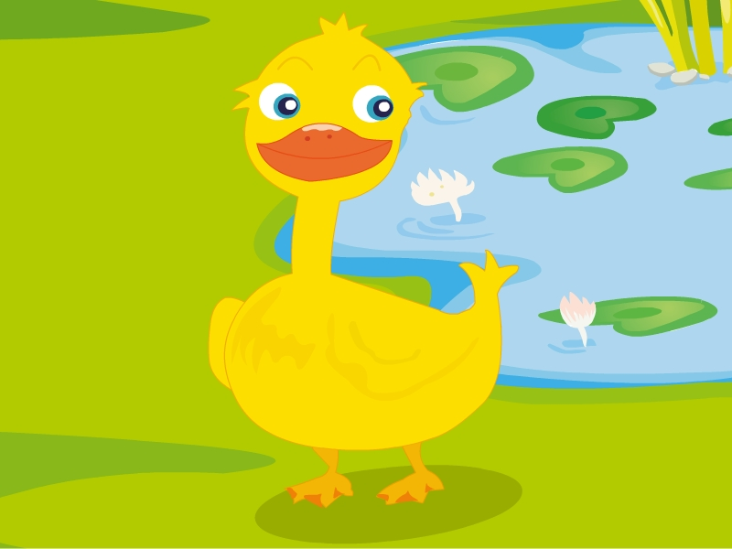
B: She’ll see some ducks.
5. A: Where did your father work? 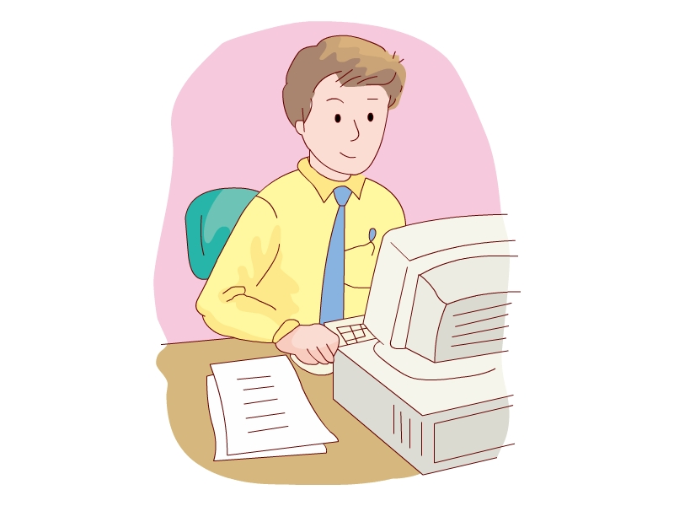
B: He __________ in __________ office.
六、补全对话。
A. She is from Los Angeles, America.
B. Who’s she?
C. Does she work hard?
D. Now, she can speak much Chinese.
E. She often helps her classmates learn English.
Linda: Mary, have a look at the photo.
Mary: (1) ________
Linda: She’s my good friend, Lucy.
Mary: Where is she from?
Linda: (2) ________ Now she’s learning Chinese in a school in Beijing.
Mary: She looks very pretty. What’s she like?
Linda: She’s very nice and friend. (3) ________
Mary: (4) ________
Linda: Yes. She often practices (练习) Chinese every day. (5) ________
Mary: I hope she can teach me some Chinese someday!
七、完形填空。
Mrs. Brown (1) ________ from Canada. She is a (2) ________. She (3) ________ in Japan. She (4) ________ English in a middle school. She goes to work from Monday to Friday. She works (5) ________. Mrs. Brown (6) ________ got one son and two (7) ________. The (8) ________ are in Canada. They stay (9) ________ their father. (10) ________ father works in a factory.
( ) (1) A. is B. from C. /
( ) (2) A. Canada B. canada C. Canadian
( ) (3) A. works B. work C. worked
( ) (4) A. teaches B. teach C. teachs
( ) (5) A. a lot B. hard C. good
( ) (6) A. have B. has C. is
( ) (7) A. daughters B. daughter C. sister
( ) (8) A. child B. children’s C. children
( ) (9) A. at B. with C. in
( ) (10) A. They B. Their C. Them
八、阅读理解。
Americans usually eat three meals a day. Breakfast usually comes before eight o’clock in the morning. They usually have eggs, some meat, bread, fruit juice and coffee. Lunch is between twelve and one o’clock. It is like a light meal and working people must take lunch with them or get it near workplace.
Children in school take sandwiches, fruit, and cookies with them or eat in school. Supper, the main meal, is between six and eight in the evening. People cook it carefully. They may have meat or chicken, turkey and duck. They may all have potatoes or rice, vegetables or salad. The drink is coffee, tea or milk. Then comes the dessert (甜食).
( ) (1) Americans have breakfast ________.
A. after eight o’clock. B. at eight o’clock
C. before eight o’clock in the morning
( ) (2) ________ is the most important meal in a day.
A. Breakfast B. Lunch C. Supper
( ) (3) What does “light” mean in Chinese? ________
A. 重的 B. 清淡的 C. 有用的
( ) (4) Americans usually have breakfast and supper at ________.
A. home B. office C. inn
( ) (5) When Americans have supper, ________ comes last.
A. drink B. meat C. dessert
九、阅读理解。
A small man goes to the cinema. He buys a ticket and goes in. But after two or three minutes he comes out. He buys a second ticket and goes in again. After a few minutes he comes out again and buys a third ticket. Two or three minutes after that, he comes out a third time and asks for another ticket. But the girl says to him, “Why are you buying all these? Are you meeting friends in the cinema all the time?” “No, I’m not doing that.” the small man says, “But a big woman always stops me at the door and tears (撕掉) my tickets up.”
( ) (1) The small man goes to the cinema to ________.
A. see a film B. watch TV C. meet his friends
( ) (2) The girl ________ the man a ticket.
A. buys B. sells C. tears
( ) (3) The small man buys the ticket for ________ times (次).
A. two B. three C. four
( ) (4) “No, I’m not doing that.” Means (意思是) ________.
A. “I’m not seeing a film.”
B. “I’m not meeting a friend.”
C. “I’m not buying a ticket.”
( ) (5) From the story we can guess (猜) ________.
A. the small man is the first time to go to a cinema.
B. the big woman doesn’t like him.
C. the man doesn’t like seeing films.
十、小练笔。
假如下面是你日常周末活动的安排。请你用英语写一个小短文，做一介绍。
Time | Activities (活动)
Saturday morning | do homework; listen to music
Saturday afternoon | have a piano lesson
Sunday morning | stay in bed; watch TV
Sunday afternoon | visit grandparents; read books; play football (sometimes)
_______________________________________________________________________________________________________________________________________________________________________________________________________________

参考答案
一、
1-5DBCAD
二、
1-5BBABB 6-10BCBBC
三、
1. My; Yours 2. I; my 3. us 4. our; We 5. them 6. her 7. you
四、
1. in an office 2. Have you got 3. give the books back
4. sausages and sandwiches 5. sent; American chocolate
五、
略
六、
(1)-(5)BAECD
七、
(1)-(5)ACAAB (6)-(10)BACBB
八、
(1)-(5)CCBAC
九、
(1)-(5)ABCBA
十、范文：
I have lots of things to do at weekends. On Saturday morning, I usually do my homework. It takes me about two hours. Then I often listen to some music on the Internet. In the afternoon, I have a piano lesson. I like it very much. On Sunday, I can do all the things I like. In the morning, I always stay in bed till half past nine. Then I watch some favourite TV programme on TV. In the afternoon, I sometimes visit my grandparents in the countryside. After getting home, I read books or play football with my friends.

