2017-2018学年度第二学期小学期中知识竞赛
学校__________________ 班级______________ 姓名______________ 座号____________
----------------------密--------------- 封---------------线---------------内.---------------请---------------不---------------要---------------答---------------题 ----------------------
五年级英语试卷 2018年5月
（满分：100分，检测时间：60分钟）
题号 | 一 | 二 | 三 | 四 | 五 | 六 | 七 | 八 | 九 | 十 | 十一 | 十二 | 总分
得分
听力部分（40分）
一、听句子，选出你所听到的单词。（5分）
（ ）1. A. draw B. draws C. drive
（ ）2. A. lot B. a lot C. lots of
（ ）3. A. contest B. best C. test
( ) 4. A. because B. beside C. beautiful
（ ）5. A. tall B .fall C. all
二、听录音，用阿拉伯数字给下列图片标序号。（5分）
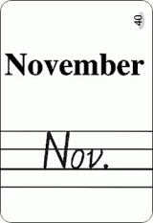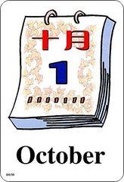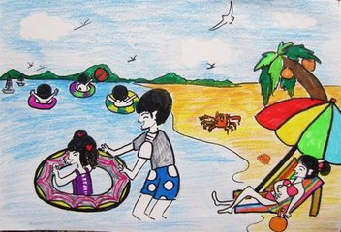
( ) ( ) ( ) ( ) ( )
三、听录音，选出你所听问句的答语。（10分）
( ) 1. A. Six o’clock. B. At 6:30 am. C. I get up late.
( ) 2. A. I like playing football after school. B. I’m running now.
C. I often play basketball .
( ) 3. A. It’s in August. B. It’s February 12th. C. There is a party.
( ) 4. A. I like spring best. B. She likes spring best.
C. I don’t like spring.
( ) 5. A. Yes, they go. B. No, I’m not. C. Yes, they do.
四、听对话，把句子补充完整，每空一词。（10分）
Amy： What do you usually do on the _____________, Chen Jie?
Chen Jie: I usually play__________ and take a ___________ class. Sometimes I
go on a ___________.
Amy: Do you go ______________?
Chen Jie: No, I ____________. I can’t __________ now. What do you do on Sunday?
Amy: I often _________ my room and __________ books. I sometimes go____________ with my mother.
五、听短文,判断句子正 “T”误“F”。（10分）
（ ）1. It is autumn in April in Sydney.
（ ）2. It is cool in the day and warm at night in Sydney in April.
（ ）3. Many people visit Sydney in autumn.
（ ）4.You can visit the Sydney Royal Easter Show in America.
（ ）5. This email is from Stella.
读写部分 （60分）
六、选择与话题词相关的单词。（10分）
（ ）1. Spain A. Beijing B. Lechang C. China
（ ）2. usually A. kind B.always C. class
（ ）3. vacation A. Monday B. July C. holiday
（ ）4. a few A. lots of B. some C. things
（ ）5. tell A. story B. letter C. card
七、读句子，选择合适的答案。（10分）
( ) 1. I’ll cook _______ my mother tomorrow, it’s Mother’s day.
- to B. for C.of
( ) 2. When is Tree Planting Day? It’s _______________.
- March 10th B. March 11th C. March 12th
( ) 3. We will have an English party __________ February.
- at B. in C. on
( ) 4. You ________ a robot _________ help you.
- need , to B. need, for C. are, to
( ) 5. I often go on a picnic _________ my family.
A. and B. with C. at
八、选择合适的疑问词填空。（10分）
What When Where Which Why

- ______________ do people go to Beijing in autumn? Because the weather is nice.
- ______________ do you do morning exercises? At 8:30 in the morning.
- ______________ are my keys? They are in the door.
- ______________ is your favourite season? Summer .
- ______________ is his schoolbag? The blue one.
九、模仿例子写短语（10分）
homework sports class running ping-pong the pipa
kung fu dinner swimming shopping morning exercises

go | go swimming
play
have
do
十、根据首字母，完成短文。（5分）
There are four s___________ in a year. Spring is a g__________ season.
There are beautiful flowers everywhere. S___________ is hot. Children can go
swimming and eat the delicious fruit. Autumn is cool. Children usually have a school t________ in autumn. Winter is white. It often snows. We can play with snow and make a s___________.
十一、阅读短文，判断下列句子的正误，正确的填“T”。错误的填“F”。（10分）
There are some big traditional（传统的）festivals in China. Spring Festival is the most important（最重要的）.It’s usually in January or February. Family get together and have a big dinner on New Year’s Eve. All Children wear new clothes, they can get some lucky money from their relatives and friends. Qingming Festival is on April 5th. All people worship their ancestors（祭祖） over the Qingming holiday. Dragon Boat Festival is usually in June. We often eat Zongzi and watch the Dragon Boat Races（龙舟赛）on that day. Mid-Autumn Festival is usually in September or October. It’s a festival for people to get together with their family. We often watch the big full moon and eat mooncakes on that day.
( ) 1.Spring Festival is usually in February.
( ) 2.We often have no holiday at Qingming Festival.
( ) 3.People eat Zongzi on Dragon Boat Day.
( ) 4.People get together with their family at Mid-Autumn Festival.
( ) 5.Teachers’ Day is a traditional festival in China, too.
十三、写作。（5分）你在学校的一天通常是怎么度过的？用“My school day”
为题，写一篇小作文。
_______________________________________________________________________________________________________________________________________________________________________________________________________________________________________________________________________________________________________________________________________________________________

