2017-2018学年第二学期第一次阶段性单元检测
五年级英语试题
（满分：100分 考试时间：60分钟）
题号 | 一 | 二 | 三 | 四 | 五 | 六 | 七 | 八 | 九 | 十 | 十一 | 合计 | 等级
评价

一、Read and judge. 判断下列每组单词的划线部分读音是否相同,相同的划“√”，不同的划“×”。(10分)
( ) 1. play eggplant people
( ) 2. clock class uncle
( ) 3. library umbrella brown
( ) 4.Chinese China children
( ) 5.sheep fish chicken
二、Read and choose.选出句子的最佳答案。（12分）
( )1. It’s _____in summer in China.
- hot and cold B. sunny and hot C. sunny and cold
( )2. ___________ is the first month of a year.
A. February B. December C. January
( )3.In ______, the leaves are yellow.
- spring B. winter C. fall
( ) 4. I often play ping-pong ________ my friend.
A. for B. with C. in
( ) 5. — Do you like going shopping on Sundays? —_____________
A. Yes, I do. B. Yes, I am. C. Yes, I don’t.
( ) 6. —What do you do on the weekend? —__________
A. At 10:00 p.m. B.I often do homework. C. In the morning.
三、 Read and choose. 读一读，选一选。（10分）
（ ）1. I often clean my rom on Saturdays . A. 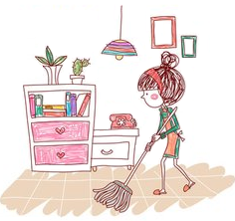 B.

（ ）2.I like autumn best. A.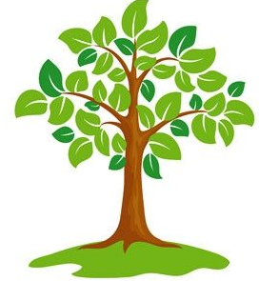 B. 

（ ）3. We’ll go to the Great Wall. A.  B. 
（ ）4.Three Planting Day is in March. A.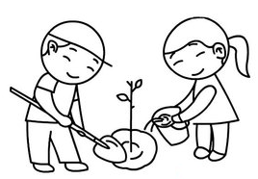 B. 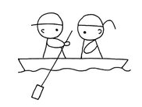
（ ）5. I can go swimming every day. A.  B. 
四、Read and write. 读一读，选词填空。（10分）
What Why Which When What’s

- ______season do you like best?
- ______ your favourite season.
- ______ do you like winter best?
- ______ do you go to school?
- ______ do you often do on the Weekend?
五、Fill in the blanks. 读句子，填入合适的月份(其中一项多余) 。（10分）
1． Teacher’s Day is in ________.
- June
- September
- October
- November
- December
- August
2． China’s National Day is in________.
3． American Thanksgiving Day is in________.
4． Christmas is in_________.
5． Children’s Day is in__________.

六、Read and choose. 读一读，选句子补全对话。（10分）
A: Hello, Zhang Peng. 1___________
B: I’m fine, thank you.
A: Today is Sunday. 2___________
B: I often play sports. Sometimes I read some books . 3___________
A: Usually I go for a walk. 4___________
B: We can play sports together next Sunday.
A: 5 ___________

- What do you do on the weekend ?
- Sometimes I play sports, too.
- How are you?
- Good idea!
- What about you ?
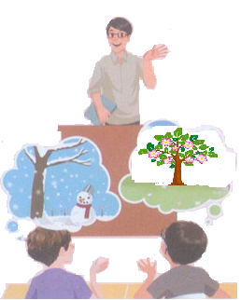
七、 Look and fill. 看图完成短文。（5分）
Mr Jones: Do you like music, children?
Mike: Yes. It’s very beautiful. What is it?
Mr Jones: The Four Seasons. Today we’ll draw the 1_________. Which season do you like 2_____,Mike?
Mike: 3__________. I like snow.
Mr Jones: I like 4_____, too. Which season do you like
best, Wu Yifan?
Wu Yifan: 5_______.It’s pretty.
Mr Jones: Yes, it is.
八、 Choose and write.选一选，仿照例子写句子。（9分）
1. The teacher is nice. _______
The | teacher | is | short
The | chicken | is | fresh
The | fish | is | cheap
The | shirt | is | nice
2. ____________________________
3. _______________________
4. _____________________________

九、 Read and choose. 阅读短文，选择正确的答案。(10分)
My name is Amy. I'm from Canada. I usually have Chinese class on Tuesdays. I often go for a walk on the weekend. I like spring best. It's windy and warm. We can go on a picnic with my family. And I like winter, too. Because my birthday is in December, and I can play in the snow. My mother’s birthday is in February. My father’s birthday is in April.
( ) 1. Amy usually has ________ class on Tuesdays.
A. English B. Chinese C. music
( ) 2. Which is Amy's favourite season?
- Spring. B. Winter. C. Spring and winter.
( ) 3. —Why does Amy like winter? —Because_______.
A. her birthday is in December B. she can play in the snow C. A and B
( ) 4. Is Amy's mother’s birthday in August?
A. Yes, it is. B. No, it isn't. C. Yes, she likes spring.
( ) 5.When is Amy’s father’s birthday?
- It’s in April. B. It’s in July. C. It’s in November.
十、 Read and fill.阅读下面的短文，找出与划线部分读音相同的单词，然后在四线三格中写出了。每空至少写出一个单词（5分）
In winter I get up at night
And dress by yellow candlelight.
In summer, quite the other way,
I have to go to bed by day.
I have to go to bed and see
The birds still hopping on the tree,
Or hear the grow-up people’s feet
Still going past me in the street.
And does it seem hard to you,
When all the shy is clean and blue,
And I should like so much to play,
To have to go to bed by day?

class plate cheap fish green

十一、Read and write. 根据提示，完成短文。(9分)
提示：我的生日在二月。我妈妈的生日在四月。我爸爸的生日在五月。我弟弟的生日在九月。我爷爷的生日在三月。我奶奶的生日在十一月。今天是我爷爷的生日。我制作一张我家人的生日图表。你能帮我吗？
My birthday is in . My birthday is in April. My ______birthday is in . My brother’s birthday is in . My grandpa’s birthday is in . My grandma’s birthday is in . What’s the date today？It is September 12th. Oh, it’s my birthday today. I want to draw a chart（图表） of my family. Can you help me?

2017-2018学年度第二学期期中质量检测五年级参考答案
一、Read and judge. 判断下列每组单词的划线部分读音是否相同,相同的划“√”，不同的划“×”。(10分) 1~5 √ × × √ ×
二、Read and choose.选出句子的最佳答案。（12分）
1~6 B CC BA B
三、Read and choose. 读一读，选一选。（10分）
1.A 2.A 3.B 4.A 5.B
四、Read and write. 读一读，选词填空。（10分）
1.Which 2.What’s 3.Why 4. How 5.What
五、Fill in the blanks. 读句子，填入合适的月份。（10分）
1~5 BCDEA
六、Read and choose. 读一读，选句子补全对话。（10分）
1~5 CAEBD
七、 Look and fill. 看图完成短文。（5分）
1. seasons 2. best 3.winter 4. snow 5. spring
八、Choose and write.选一选，仿照例子写句子。（9分）
2. The chicken is cheap.
3. The fish is fresh.
4. the shirt is nice.
九、Read and choose. 阅读短文，选择正确的答案。(10分)
1~5 B A C B A
十、 Read and fill.阅读下面的短文，找出与划线部分读音相同的单词，然后在四线三格中写出了。每空至少写出一个单词（5分）
clear play much should grow-up
十一、Read and write. 根据提示，完成短文。(9分)
January mother’s father’s May September
March November grandpa’s birthday

