五年级下学期英语牛津英语期中测试卷
听力部分
一、Listen and number.听录音，给图片排序。
A.  B. 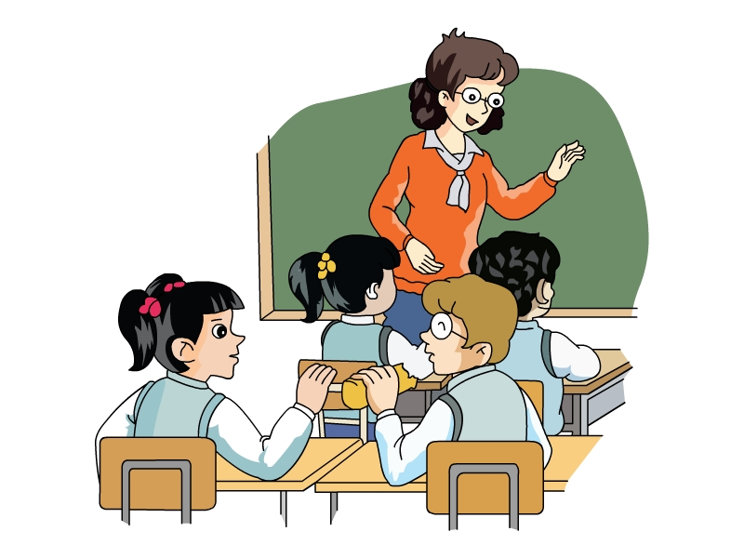 C. 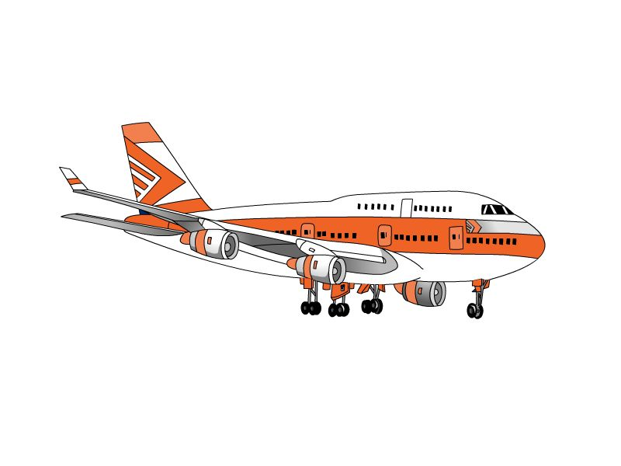 D. 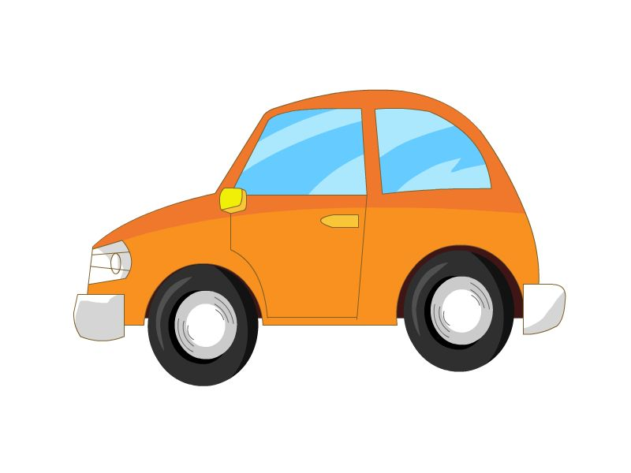 E. 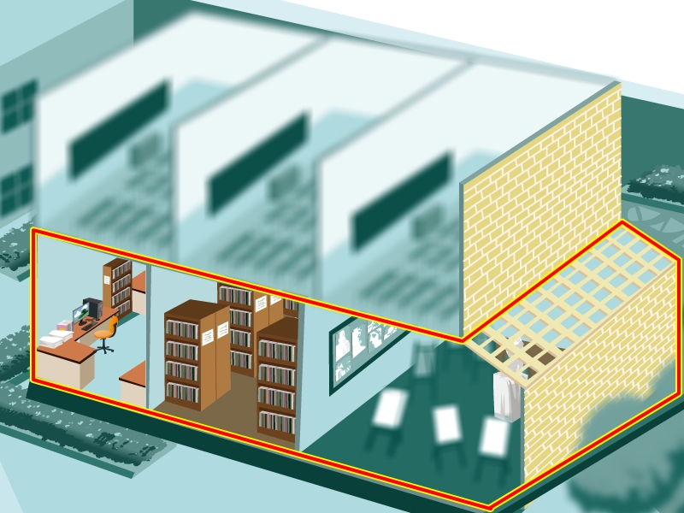 F. 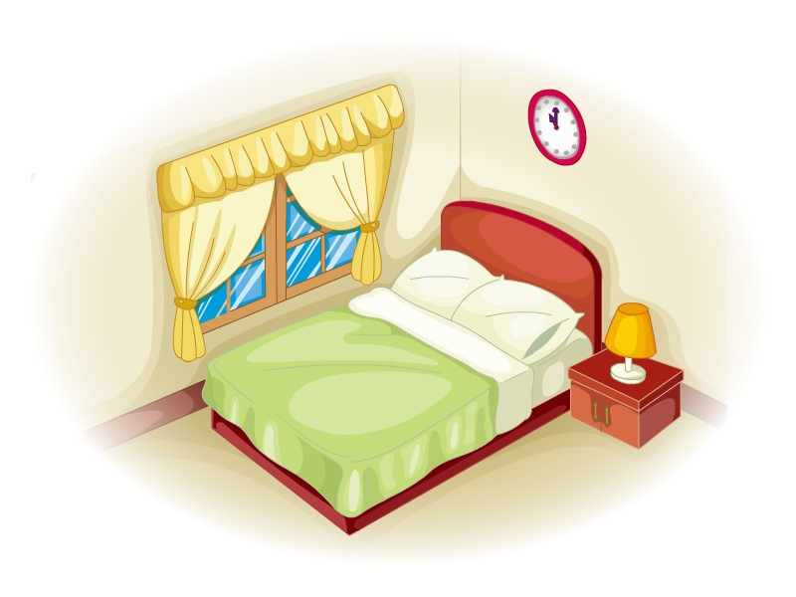
正确顺序为：___________________
二、Listen and choose.听录音，选出听到的内容。
( ) 1. A. theirs B. there’s C. they’re
( ) 2. A. way B. weak C. work
( ) 3. A. in fifteen days B. in a few days C. in fourteen days
( ) 4. A. get up early B. go to bed early C. get up late
( ) 5. A. There are a lot of different kinds of fishes and butterflies.
B. There is a lot of seafood and yummy fruit in Sanya.
C. There are beautiful beaches with clear water in Sanya.
( ) 6. A. I’m going to stay at home and watch TV with my grandmother.
B. I’m going to stay at home and read storybooks with my sister.
C. I’m going to stay at home and see a film on TV with my sister.
三、Listen and choose.听录音。选出相应的应答句。
( ) 1. A. I take a train. B. I’ll take a train. C. I’ll get there at ten.
( ) 2. A. I will see a film. B. Can I have a holiday? C. That’s great.
( ) 3. A. Yes, they’re hers. B. No, they’re yours. C. Yes, they’re yours.
( ) 4. A. Because it’s fun. B. Because I can read. C. Because I’m weak in it.
( ) 5. A. They fly north. B. They fly south. C. They fly west.
( ) 6. A. No, she won’t. B. Yes, she comes. C. No, she isn’t.
四、Listen and judge.听短文，判断句子正误，用√或×表示。
( ) (1) Mike is a small but strong boy.
( ) (2) Mike is good at painting but weak in music.
( ) (3) Mike doesn’t do exercise often.
( ) (4) In the future, Mike will watch much TV.
( ) (5) Mike will be tall and strong.
( ) (6) Mike won’t be good at painting or music.
五、Listen and choose.听录音，选出正确的内容。
( ) (1) My friends and I are talking about ________.
A. our school B. our home C. our future
( ) (2) Linda will have ________.
A. big eyes B. long hair C. short hair
( ) (3) ________ won’t wear glasses.
A. Linda B. Sally C. Susan
( ) (4) ________ will live in Beijing.
A. Linda B. Sally C. Susan
( ) (5) Susan is ________ now.
A. tall B. small C. strong
( ) (6) ________ will be a nurse in the future.
A. Linda B. Sally C. Susan
笔试部分
一、Read and judge.判断下列各组单词划线部分的发音是否相同，相同的用√表示，不同的用×表示。
( ) 1. A. school B. chocolate
( ) 2. A. girl B. thirsty
( ) 3. A. head B. speak
( ) 4. A. bear B. wear
( ) 5. A. park B. past
( ) 6. A. theirs B. newspaper
二、Think and write.想一想，在空格上填上和划线部分同类的词，完成句子。
1. These pencils are not ________ or ________ They are mine.
2. You can’t sleep on the bed. You can ________ on the chair or ________ beside the
sofa.
3. The children are going to play football, ________ boats and ________ bicycles in the park.
4. There are storybooks, ________ and ________ in the library.
三、Read and choose.选择填空。
( ) 1. I can’t draw well. I am ________ drawing.
A. good at B. weak in C. am good at
( ) 2. —Is this ball ________?
—No, it’s ________.
A. yours; mine B. yours; yours C. mine; yours
( ) 3. I ________ sport, so I get tired easily.
A. like B. can’t do C. don’t like
( ) 4. Little Lucy will have two children ________.
A. in two years B. in the future C. in two months
( ) 5. This study is big and quiet. You can ________ in it.
A. read and write B. cook nice food C. play ball games
( ) 6. Can you ________ the socks ________ the bed?
A. put; in B. put; down C. put; on
( ) 7. The room is dirty and messy. Mum is ________.
A. tidying up B. tidying it up C. tidying them up
( ) 8. Alice wants to ________ at home this evening.
A. fly a kite B. watch TV C. ride a bicycle
( ) 9. Our bedroom is on ________.
A. the floor B. the second C. second floor
( ) 10. We’ll have a holiday in Beijing and we’ll stay there for ________.
A. an hour B. ten years C. ten days
四、Rewrite the sentences.按要求改写下列句子。
1. Peter will buy some flowers for his mother. (另写一句，意思不变)
_____________________________________________________________________
2.1 will have long hair and big eyes. (改为否定句)
_____________________________________________________________________
3. My sister will be a doctor. (对划线部分提问)
_____________________________________________________________________
4. We like seafood because it’s yummy. (对划线部分提问）
_____________________________________________________________________
5. No, they aren’t theirs. (写出问句)
_____________________________________________________________________
6. What are you going to do this weekend? (回答问题)
_____________________________________________________________________
7. Wang, will, week, stay, Mr., a, in, Hangzhou, for, (.) (连词成句)
_____________________________________________________________________
五、Think and write.用正确的介词填空。
1. Wild geese fly from one place ________ another every year.
2. Kitty will love her job ________ the future.
3. There are many beautiful pictures ________ this book.
4. I want to know more ________ my future.
5. They have a good plan ________ the weekend
6. Sanya is in the south ________ China.
7. We will go to Sanya ________ plane.
六、Read and write.读一读，用正确的单词填空。
build stay until student machine change
(1) My mother always says, ‘‘Don’t wait tomorrow.”
(2) In ten years, we will all ________ a lot. We will have white hair. We won’t see clearly.
(3) My sister Lucy likes sport and parties. She likes to go out, she doesn’t like to at home.
(4) My son is a good ________ in Rainbow School. All the teachers like him.
(5) My father says we are going to ________ a new house next year. It will have two
floors.
(6) I like having juice for breakfast, and I make juice with this ________ every morning.
七、Read and judge.阅读短文，判断句子正误，用√或×表示。
Hi, everyone. My name is Andy. I’m eleven years old this year. I’m short and thin. My hair is short and my eyes are not big. I’m good at English but weak in sport. I like reading and playing games on the computer. I live with my parents now. In the future I will be tall and strong. I will have big eyes. I will be an English teacher and I will live in Beijing. There will be a big study in my home and there will be many books in it. I will read books in the study in the evening. I will be good at sport. I will play basketball well.
( ) (1) Andy will be fifteen in five years.
( ) (2) Andy does not have big eyes now.
( ) (3) Andy will have a big study in the future.
( ) (4) Andy will teach English in Beijing.
( ) (5) Andy will be good at badminton in the future.
八、Writing.书面表达。
写一写你的未来将是怎样的，如长得怎样?从事怎样的工作?不少于5句。
_____________________________________________________________________
_____________________________________________________________________
_____________________________________________________________________

参考答案
听力部分
听力材料
一、
1. Look at the classroom. What a mess! Let’s tidy it up.
2. Linda likes her new bedroom because it has a big window.
3. I’m good at Math but I’m weak in English.
4. Sally’s going to row a boat this Saturday.
5. Jill’s family will go to Sanya for a holiday and they are going to get there by plane.
6. The hotel has five floors. Our room is on the second floor.
二、
1. These magazines are theirs, not ours.
2. Linda is weak in music. She doesn’t like it at all.
3. We are going to come back in fourteen days.
4. I often go to bed late and get up late too.
5. There is a lot of seafood and yummy fruit in Sanya.
6. I’m going to stay at home and see a film on TV with my sister.
三、
1. How will you get to Beijing?
2. What is your plan for the holiday, Alice?
3. Are these pink socks yours, Linda?
4. Why do you like reading?
5. Where do wild geese fly in autumn?
6. Will your mother come back home this evening?
四、
My name is Mike. I am a small and thin boy. I am good at painting but I’m weak in music. I don’t like singing. I don’t do exercise often. I like to stay at home and watch TV. I usually get up late so I am often late for school. I get tired easily too. In the future, I will do more exercise. I usually get up late so I am often late for school. I get tired easily too. In the future, I will do more exercise. I won’t watch too much TV. I will be tall and strong. I’m going to go to bed early and get up early. I will be good at music too.
五、
My friends and I are talking about our future. Linda is going to be tall and beautiful. She will have long hair. She will live in Beijing. She wants to be a teacher. Sally is going to have big eyes. She won’t wear glasses. She is going to be a doctor and she will live in Shanghai. Jenny is going to be tall and thin. She will have short hair. She is going to be a policewoman. She will live in going to be a policewoman. She will live in ten years she will be tall and pretty. She will have round eyes. She will be a nurse and she will love her job.
听力答案
一、
1-6 CAEFDB
二、
1-6 ABCCBC
三、
1-6 BABABA
四、
(1)-(6) ×√√×√√
五、
(1)-(6) CBBABC
笔试部分
一、
1. × 2. √ 3. × 4. √ 5. √ 6. ×
二、
(略)
三、
1. B 2. B 3. C 4. B 5. A 6. C 7. B 8. B 9. B 10. C
四、
1. Peter is going to buy some flowers for his mother.
2. I won’t have long hair and big eyes
3. What will your sister be?
4. Why do you like seafood?
5. Are they theirs?
6.（略）
7. Mr. Wang will stay in Hangzhou for a week.
五、
1. to 2. in 3. in 4. about 5. for 6. of 7. by
六、
(1)-(6) until change stay student build machine
七、
(1)-(5) ×√√√×
八、
I will be a tall man in the future. I will be and strong. I will have short hair and big eyes. I won’t wear glasses. I will be a policeman, and I will live in Shanghai. (供参考)

