2017-2018学年度第二学期小学期中知识竞赛
学校__________________ 班级______________ 姓名______________ 座号____________
----------------------密--------------- 封---------------线---------------内.---------------请---------------不---------------要---------------答---------------题 ----------------------
六年级英语试卷 2018年5月
（满分：100分，检测时间：60分钟）
题号 | 一 | 二 | 三 | 四 | 五 | 六 | 七 | 八 | 九 | 十 | 十一 | 十二 | 总分
得分
听力部分（40分）
一、听音，选择你所听到的单词（5分）更多免费资源下载绿色圃中小学卷
( ) 1.A.old B. older C. 11
( ) 2.A.bigger B. smaller C. stronger
( ) 3.A.side B. tall C. size
( ) 4.A.stay B. saw C. slept
( ) 5.A. rode B. went C. hurt

二、听录音，用阿拉伯数字给下列图片排序号。（5分）
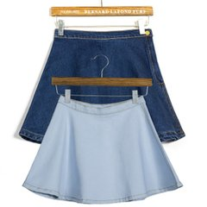

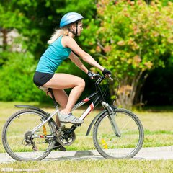
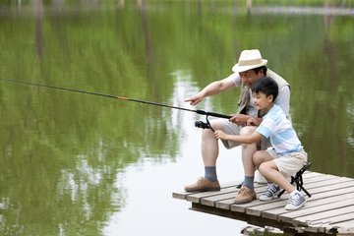
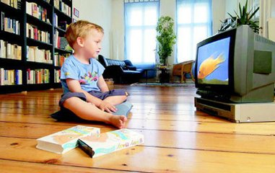

( ) ( ) ( ) ( ) ( )

三、听问句，选择恰当的答语（10分）
( ) 1.A.I often go swimming on the weekend. B. I cleaned my room.
C. I’m going to see a film.
( ) 2.A. Yes , they did.. B. Yes, they do.
C. They played football last Sunday.
( ) 3.A. She went there by bus. B. She watched TV .
C. She went to a nature park.

( ) 4.A. He did homework. B. He went there by bike.
C. He was happy.
( ) 5.A. I’m 45 kilograms. B. I’m 145 cm. C. I’m 12 years old.
四、听录音，填写所缺单词，每空一词（10分）
1. My schoolbag is than .
2. Your feet are than mine .
3. Sarah last night
4. I my last weekend.
5. Zhang Peng yesterday?

五、听短文，判断下列句子与短文内容是否相符，相符的写 “T” ，不相符的写“F”,短文听两遍。（10分）

( ) 1.There are seven days on National Day.
( ) 2. I went to Hainan with my friends.
( ) 3. I swam and went fishing in Hainan.
( ) 4. The seafood was delicious.
( ) 5. I was tired .

读写部分 （60分）
六、找出下列单词中划线部分读音不同于其他两个的单词。（5分）
( ) 1. A, how B, row C, down
( ) 2. A, too B, good C, food
( ) 3. A, kite B, ride C, swim
( ) 4. A, happy B, yellow C, funny
( ) 5. A, pear B, year c, ear
七、根据给出的话题词，选择相关的单词。（10分）

( ) 1.age A. 11cm B. 11 C.11kg
( ) 2.weekend A. Monday B. Sunday C. Tuesday
( ) 3.took A. look B. cook C. ate
( ) 4.place A. hospital B. pictures C. bike
( ) 5.holiday A. Chinese B. before C. May Day

八、 读句子，用所给的词的适当形式填空。（5分）

1. What (do) you do yesterday ?

2. Amy is (young) than Sarah.

3. How (is) your last weekend?

4. I’m going to (ride) a horse next week.

5. He often (wash) his clothes on the weekend.

九、读短文，从方框中选择合适的词补全短文。（10分）
A. holiday B. saw C. shopping D. second E. bought
F. took G. had H. went I. plane J. visited
I went to Hangzhou over my . I went there by .On the first day, I the West Lake with my parents. We many pictures . On the day, we .I some gifts for my friend. On the third day, we went to the zoo. We many animals. I a lot of fun on my holiday.

十、把相应的答句的序号填写在问句的括号内（5分）

1. ( ) How did you go to Beijing？ A, I went there with Lily.
2. ( ) Did you do anything else? B, She is 160cm.
3. ( ) Who did you go with? C. Yes, we did.
4. ( ) How tall is Jane? D. By plane.
5. ( ) What did they do ? E. They went swimming.
十一，根据汉语提示补全句子，每空一词。（10分）

1.My sister （看电影）last night.
2.Her dog is （瘦的）than mine.
3.Mr Li （野营）last month.
4.I （使受伤） my feet。
5.Chen Jie （感冒）yesterday.

十二，阅读短文，判断下列句子的正误，正确的写“T”，错误的写“F”（10分）
It was a cold day last Saturday. Amy went camping with her friend Sarah. On the way to camping, they saw an old woman. The old woman wanted to see her son. He had a bad cold in hospital. But she didn’t know the way to hospital. Amy asked a policeman, she went with the old woman to the hospital and Sarah went camping by herself. Forty minutes later, the old woman saw her son. And then Amy went to a park to go fishing. She did not wait for their thanks, but she felt happy.

( ) 1, The weather was warm last Saturday.
( ) 2, The old woman wanted to see her son.
( ) 3, Sarah went camping by herself.
( ) 4, The old woman know the way to hospital.
( ) 5, Amy felt happy last Saturday

十三、作文：以“Last May Day”为题，写写假期期间，你去了哪 ，怎么样去的，和谁去，都做了些什么等等，不少于5句话。 （5分）

六年级英语参考答案：
一、1.A 2.A 3.C 4.B 5.C
二、4、3、1、5、2
三、1,B 2,A 3,C 4,B 5,A
四、1,heavier yours 2.bigger 3.watched TV 4.washed clothes 5,Did buy gifts
五、1 T, 2 F, 3 T, 4 T ,5 F.

六、1.B 2.B 3.C 4, B 5.A

七、1.B 2.B 3.C 4.A 5.C

八、did younger was ride washes

九，A I J F D H C E B G

十,1 D . 2 C. 3 A 4 B. 5 E .

十一，1,saw a film 2, thinner 3,went camping 4,hurt 5, had a cold

十二，1，F,2，T,3，T,4，F,5，T

十三，略。

