六年级英语期中自查卷

班别： 姓名： 卷面分：（共3分） 成绩：
听力部分（满分43分）
一、你将听到一个句子，根据你所听到的内容，选择相符合的一项，并将其字母编号写在题前的括号里。（每小题1分，共10分）

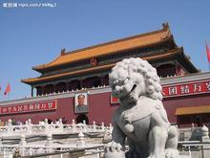
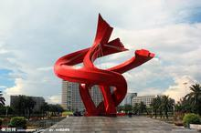
( ) 1. A. B. C.
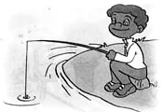

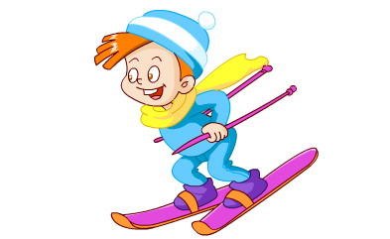
( ) 2. A. B. C.

( ) 3. A. rowed B. read C. red
( )4. A. heavier B. heavy C. bigger
( ) 5. A. washed B. wash C. watched
( ) 6. A. saw B. see C. sea
( ) 7. A .first B. third C. fourth
( ) 8. A. climb B. climbed C. climbing
( ) 9. A. tired B. angry C. happy
( ) 10. A. were B. went C. was
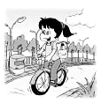
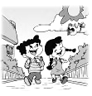
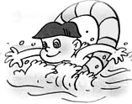
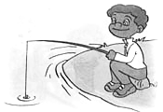
二、你将听到一个句子或一组对话，根据所听到的内容, 在每小题的大图中圈出相符的图片。 (每小题1分，共10分)
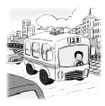
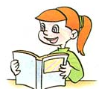
- 2.

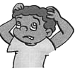
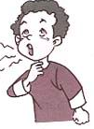

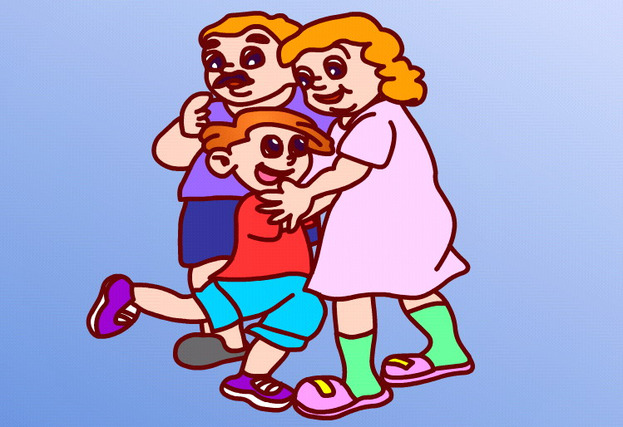
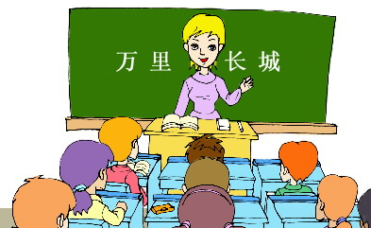

3. 4.


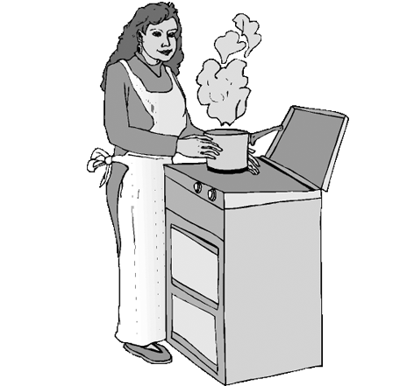
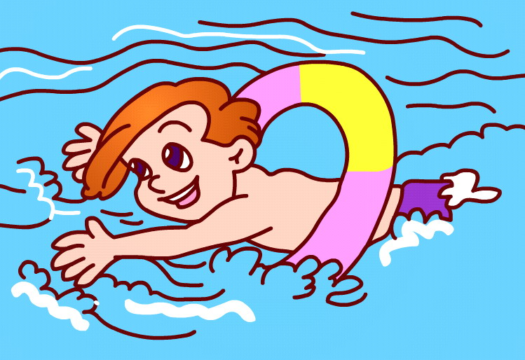
- 6
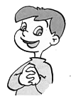
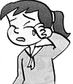
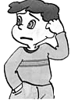
.

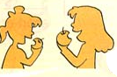
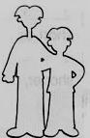

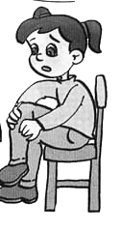
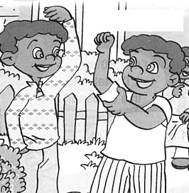
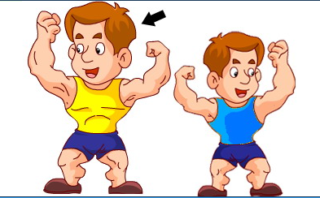
7.
8.

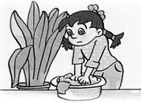
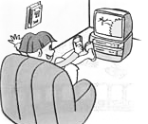
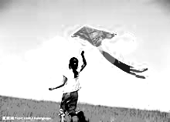
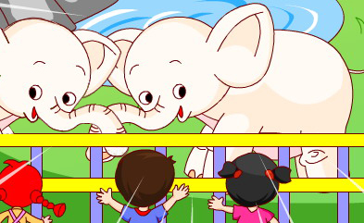
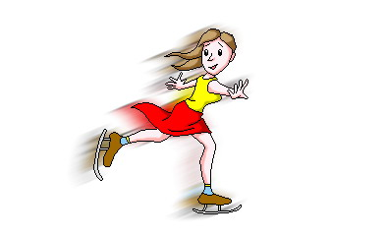
.9. 10.
三、你将听到一个问题，根据问题选择最合适的答句，并将其前面的字母编号填到题前的括号里。（每小题1.5分， 共9分）
( )1. Ａ. I was happy. B.It was fun. C. I went by bike .
( )2. A.I am 155cm B. I’m 12. C.I’m 50kg .
( )3. A. I have a fever . B. She has a cold . C. He has a sore throat .
( )4.A. I often play chess. B.We bought presents. C. He rowed a boat.
( )5.A. Yes, she is bored. B. No, he is angry. C. She feels excited .
( )6. A. I went by plane. B. I went to Hangzhou. C. I read a book.
四、你将听到四组对话，根据对话内容填写下列句子中所缺的单词，使句子完整，每空一词。（每空1分，共5分。）
1. Amy got a new dress . She is so ____________.
2. John is much taller and than Amy.
3. Did you _____________ the clothes last night? Yes , I did .
4. What did your mother do last___________？She ________in the river .
五、听录音，判断句子的对错,对的写“√”，错的写“×”。
( )1. Jack went to the park on foot in the morning.
( )2. Jack read books and did sports in the park.
( )3. Jack cleaned the room and washed clothes in the afternoon.
( )4. Sarah and Jack studied math together in Jack’s home.
( )5. Jack went shopping and watched TV in the evening.
笔试部分（满分54分）
六、根据上下文，从所给的七个句子中选择六个，将对话补充完整，并将该选项前面的字母编号填在相应的横线上（每句1.5分，共9分）
A. Where did you go? B. the Great Wall C. went fishing
D. How was your holiday? E. the West Lake
F. Did you have a good time? G .How did you go there?
H. May I have a look at your pictures?

Sam:_____________________________?
Jim: It was so happy.
Sam: We took a long trip last summer holiday.
Jim: Wow! ________________________?
Sam: We went to Beijing.
Jim: ____________________________?
Sam: I went there by train. We read books on the train.
Jim: What did you do on your holiday?
Sam: We visited __________and bought many clothes.
Jim: What else?
Sam: We rowed a boat and took many beautiful pictures in Beihai Park. We ate good food, too.
Jim: It’s so wonderful!
Sam: ____________________?
Jim: Sure, here you are .
Sam: _____________________?
Jim: Yes , we had a good time in Beijing.
七、阅读（每小题1.5分，共15分)
（一）根据短文内容，判断下列句子的对错, 对的写“√”，错的写“×”。
My name is Peter. I’m 11 years old. I’m 140cm. I like winter very much, because I can make a snowman and play with the snow. It’s very interesting. My friend Mike is 1 year younger than me, but he is 5cm taller than me. He likes winter ,too because he likes ice-skating. Next winter holiday, We’re going to Harbin to see the snow in north of China. It would be very cold, and we can play with snow every day!
( )1.Mike is 11 years old .
( )2.Mike is 145 cm tall
( ) 3.Harbin is in north of China .
( )4.Peter went to Harbin last winter holiday .
( ) 5. It is cold in Harbin in winter .
(二)、阅读理解，根据短文内容选择合适的答案，将编号填在括号里。
Last holiday, I took a big trip with my aunt. We went to Australia by plane. It was in August. We left Beijing on August 3rd. It is winter in Australia. But in Beijing, it was summer. I like there, because I like playing with snow. I went ice-skating there and took many pictures. I bought many presents for my friends, too. I was excited , but I was tired, too. I should relax to go back to school.
( )1. Who did you go on a big trip with?
A. My parents. B. My aunt.
( )2. When did you take a big trip ?
A. Last summer. B. Last fall .
( )3. Did you go to Beijing on August 3rd ?
A. Yes, I did . B. No, I didn’t .
( )4. How did you go there?
A. I went by subway. B. I went by plane.
( )5. How did you feel in the end (最后) ?
A.I was excited, but so tired. B.I was so bored.
八、短文填空：（用所给的单词填空，每词只准用一次）(每个空1分，共10 分)
( is, go, had, sang, took, playing ,climbed, have, ate, went, yesterday, tomorrow ,cousin, restaurant , park , played )
John _____fun with his ____last week. On Monday they _____to a ______. They _______good food there. On Tuesday They went to a park .They _____and danced in the park .On Wednesday they ____ping-pong .He likes ______sports very much. On Thursday they ______a mountain. They _____many pictures . _______ he is going to _____home . He is going to _____a good time .
九 根据图片所给的提示，提出相应的问句，让对话合理、通顺。（10分）
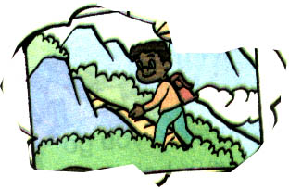
- A: _______________________________________？
B: Tom climbed mountains last weekend.
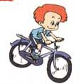
2. A: ?

B: No，he rides a bike to school .
3. A: ?
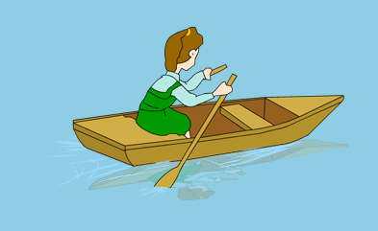
B: Sarah has a sore throat.
4. A: __________________________________________?
B: Yes , Chen Jie went hiking last Sunday.
5. A: ____________________________________?
B: I’m 160 cm tall. 160cm
十 小练笔。根据图片提示，用英语写一写你的身高和体重各是多少，你上个周末去了哪里，干了什么事情，心情怎样？不少于5句话。（10分）
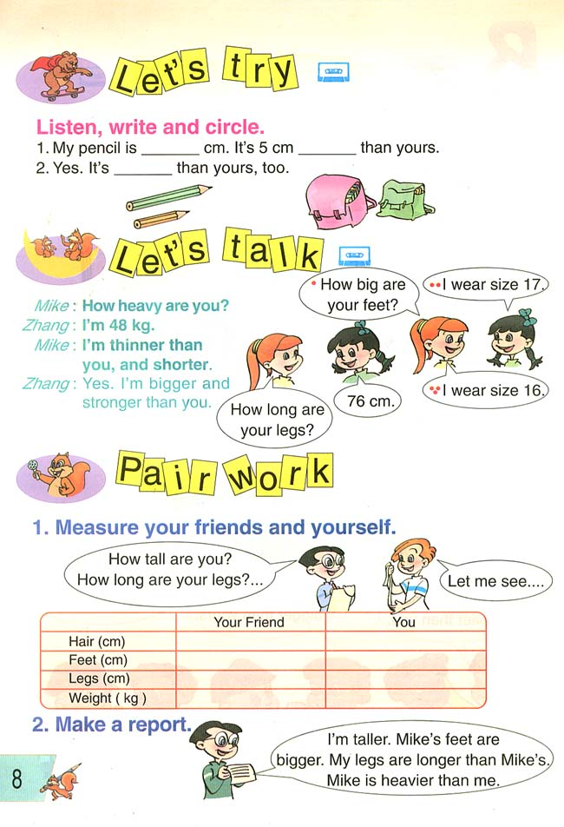


160cm
50kg

2011—2012 学年度第二学期

实验小学六年级英语期中自查卷听力材料

一、你将听到一个句子，根据你所听到的内容，选择相符合的一项，并将其字母编号写在题前的括号里。（每小题1分，共10分）
1.Where did you go on your holiday? I went to Dongguan.
2.Did you go skating , Mike ? No, I went skiing .
3. Mary read a book last night .
4. How heavy are you ? I’m 45 kg .
5. My mother washed many clothes yesterday morning.
.6.I saw elephants at the zoo last weekend .
7.When did John go to Harbin ? On February the first .
8.Look！ The panda is climbing mountains .
9.Are you excited ? No, I’m very angry .
10.Tom went swimming with Mike last Saturday .
二、你将听到一个句子或一组对话，根据所听到的内容, 在每小题的大图中圈出相符的图片。 (每小题1分，共10分)
1.I often go to school by car . But yesterday I went to school by bus .
2.Did your sister row a boat last Monday ? No, she went fishing .
3.What’s the matter with you ? I have a sore throat .
4.What did John do on his summer holiday ? He learned Chinese .
5. What are you doing ? I’m washing clothes .
6.Is Alice happy ? No, she is very sad .
7. Look ! My father is much stronger than my uncle .
8 What’s the matter with LiuYun ? Her leg hurts .
9.What did Amy do in the park ? She flew kites .
10.Did you make a snowman in Xinjiang ? No , I went ice-skating .
三、你将听到一个问题，根据问题选择最合适的答句，并将其前面的字母编号填到题前的括号里。（每小题1.5分， 共9分）
1. How was your trip to Yunnan ?
2.How tall are you ?
3.What’s the matter with ZhangPeng ?
4.What did you do in the supermarket yesterday ?
5.Is your brother excited ?
6.Where did you go on your holiday ?

四、你将听到四组对话，根据对话内容填写下列句子中所缺的单词，使句子完整，每空一词。（每空1分，共5分。）
1. Amy got a new dress . She is so _happy ___________.
2. John is much taller and stronger than Amy.
3. Did you ___wash__________ the clothes last night? Yes , I did .
4. What did your mother do last__weekend_________？She _swam in the river .
五、听录音，判断句子的对错,对的写“√”，错的写“×”。
Jack was busy last weekend. His parents were not at home. He walked to the park in the morning , he read English books and did sports there. Then he took a bus back home. He had to clean the room and washed clothes before 12:00. After finishing these things, he had lunch in the canteen. Then he went to Sarah’s home, and studied math with her. They played many math games together. In the evening, Jack went to the supermarket and bought many food back home. When he came back, his parents were at home, too. They watched TV together .Then Jack went to bed .
( √ )1. Jack went to the park on foot in the morning.
( √ )2. Jack read books and did sports in the park.
( × )3. Jack cleaned the room and washed clothes in the afternoon.
( × )4. Sarah and Jack studied math together in Jack’s home.
( √ )5. Jack went shopping and watched TV in the evening.

