湖北汉川市2017-2018学年度下学期期中质量测评
六年级英语试卷
题号 | 一 | 二 | 三 | 四 | 五 | 六 | 七 | 八 | 九 | 十 | 总分
得分
听 力 部 分（40分）
一、听录音，选出所听句子中包含的那个单词。听两遍。（10分）
( )1.A.taller B.longer C.bigger
( )2.A.board B.bought C.boat
( )3.A.tigers B.pandas C.dinosaurs
( )4.A.licked B.picked C.thanked
( )5.A.stayed B.slept C.read
二、听录音，判断所听内容与图片是（T）否（F）相符。（10分）
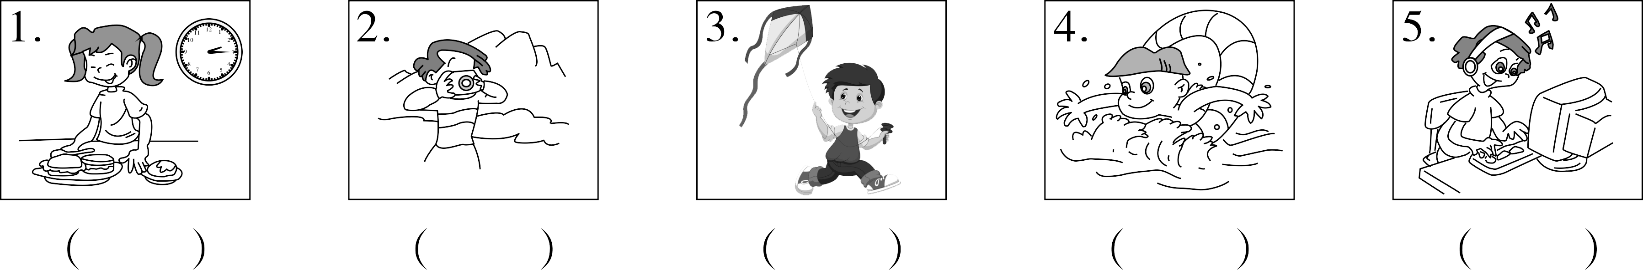
- 听录音，选择与所听内容相符的图片。听两遍。（10分）
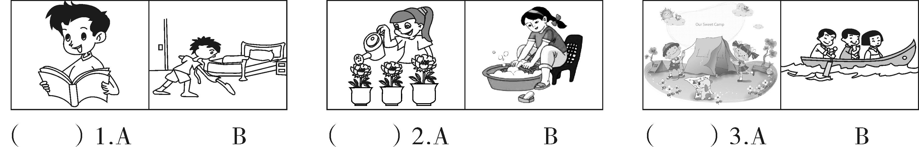
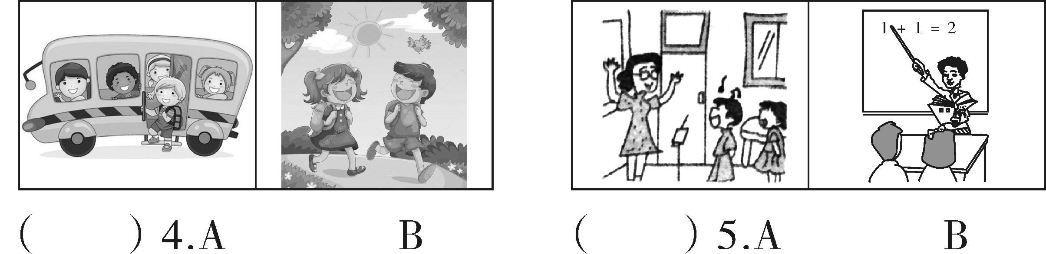
四、听问句，选择正确答案。听两遍。（10分）
( )1.A.She is 12. B.She’s 155 cm tall. C.She is 45 kilograms.
( )2.A.Yes,she is. B.Yes,I am. C.Yes,he is.
( )3.A.I go hiking. B.I went hiking. C.I’ll go hiking.
( )4.A.Tomorrow. B.Last weekend. C.With my friends.
( )5.A.No, I didn’t. B.Yes,I eat. C.No,I don’t.
笔 试 部 分（60分）
五、找出不同类的单词。（10分）
( )1.A.teacher B.worker C.lower
( )2.A.fatter B.older C.taller
( )3.A.enjoyed B.played C.saw
( )4.A.eat B.ran C.drink
( )5.A.skating B.jumping C.cooking
六、选择填空。（12分）
( )l.—How your winter vacation? —It was good,thanks.
A.were B.did C.was
( )2.I’m 1.60 meters.May is l.56 meters.May is than me.
A. short B. taller C. shorter
( )3.— is older,Miss King or Miss Green? —Miss King.
A.Who B.Whose C.What
( )4.—Did he a cold last Wednesday? —Yes,he did.
A.has B.have C.had
( )5.—What did you do last Sunday? —I all day.
A.slept B.sleep C.sleeping
( )6.Mike went with his father yesterday morning.
A.fish B.fishing C.shoping
七、看图片，写单词，完成句子或对话。（8分）
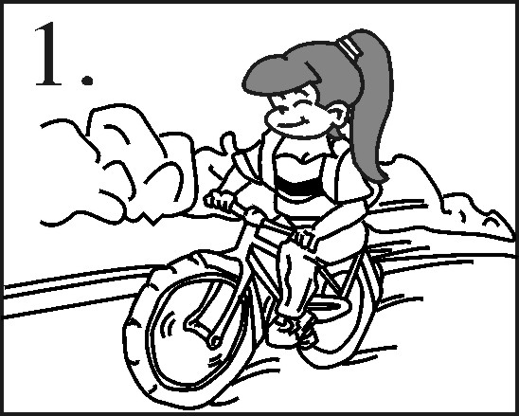
1. did she go to work yesterday morning?
She to work by bike.

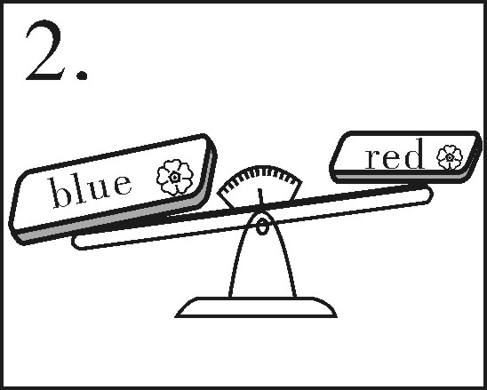
2.The blue box is and than the red box.

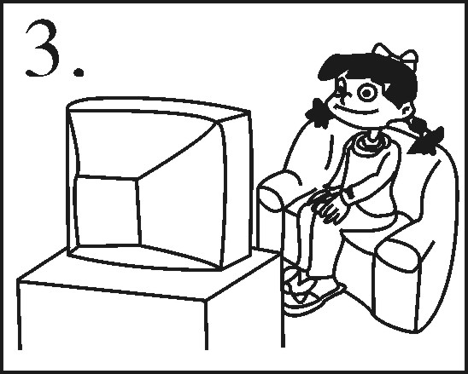
3. you go outside yesterday?
No.I stayed at home and TV.

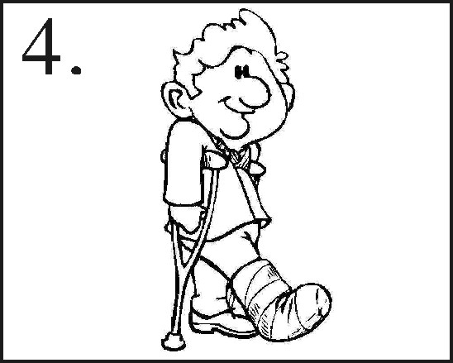
4.Did Mr Brown hurt his arm that day?
No,he .He his right foot.

八、从方框中选择正确的句子补全对话。代号填在横线上。（10分）
A:Hi,John.Come and look at my photos from the Labour Day holiday.
B:1.
A.Did you go there by train?
B.How was the beach?
C.What else did you do there?
D.Did you go swimming?
E.Where did you go?
A:I went to Sanya with my family.
B:Really?2.
A:No.Sanya is far from here.We went by plane.
B:Did you like Sanya?
A:Yes,the weather was so warm.
B:3.
A:It was so beautiful.
B:Sounds great!4.
A:Sure!The water was clean and the air was fresh .
B:5.
A:We ate a lot of fresh seafood and I also rode a bike.
B:I think you had a good time there.
A:Of course!
九、读短文，按事情发生的先后顺序给图片排序（1-5）。（10分）
Li Dong had a busy day last Sunday.He got up at seven twenty.Then he read his English book.After he had his breakfast,he did his homework and washed his clothes.In the afternoon,he went to the supermarket with his mother. He bought some gifts for his friends.In the evening,he went to visit his grandparents with his parents.
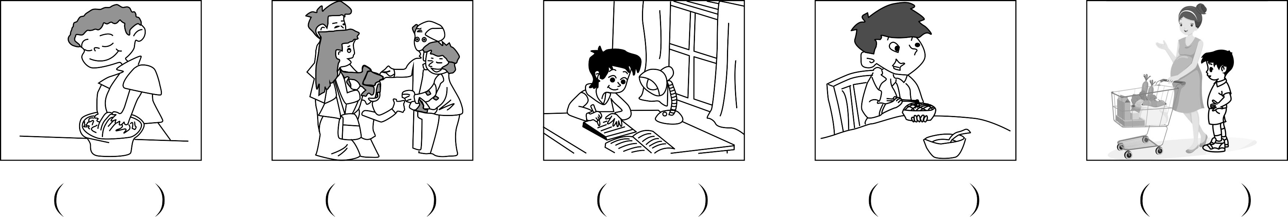
十、读短文，判断句子正（T）误（F）。（10分）
Hello!I’m Frank.I didn’t go to school last Saturday.I got up at 7:50 in the morning.Then at 8:10 I had some vegetable noodles for breakfast.After that I went outside to play.I rode my bike in the yard.In the afternoon,I went to the zoo with my friends.We saw a lot of animals in the zoo.I went back home at 4:30.I had dinner at 6:00.After dinner,I played the violin and then studied English.I had a very good and happy day!
( )1.There was no school last Saturday.
( )2.Frank got up at eight ten last Saturday morning.
( )3.Frank ate some vegetable noodles for breakfast.
( )4.Frank rode his bike at the zoo.
( )5.Frank played the violin in the afternoon.
湖北汉川市2017—2018学年度下学期期中质量测评
六年级英语试卷
笔试部分：
五、1—5 CACCA
六、1—6 CCABAB
七、1.How;went 2.bigger;heavier 3.Did;watched 4.didn’t;hurt
八、1—5 EABDC
九、3 5 2 1 4
十、1—5 TTTFF

